PRODUCT: WIRELESS MUSICAL HEADSET
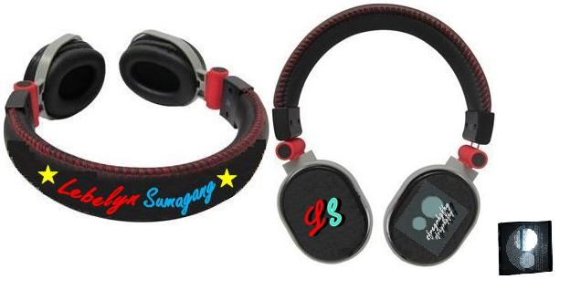

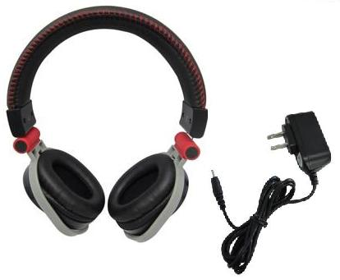

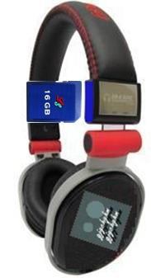

Features:
- Rechargeable Battery
- Storage Capacity: 16 GB
- With Volume Control
- High Quality
- Stylish Design
- Wireless Headphone

Battery Specifications:
- Standard battery, Li-Po 1100 mAh (BP-6M)
- Stand-by: Up to 48 hours

