Sorghum
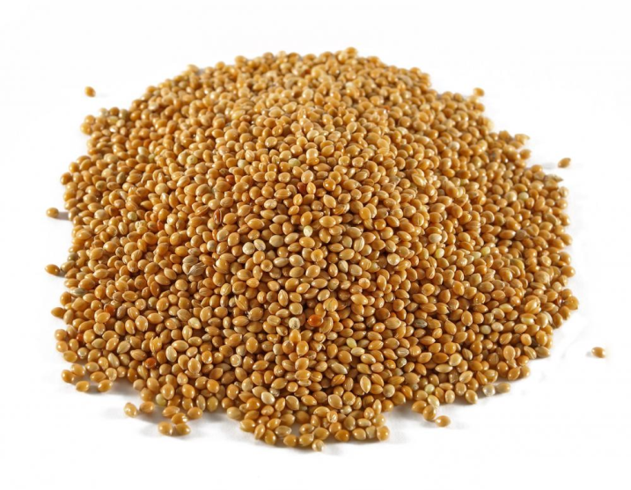
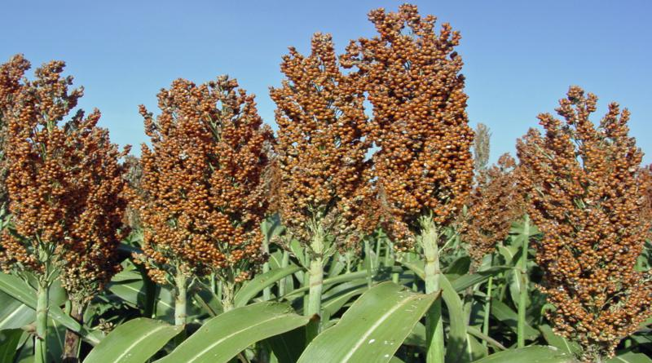

Nutritional attributes

Sorghum bran and milling offal
Sorghum bran and sorghum milling offal have a chemical composition close to maize bran, with moderate protein content (about 12% DM), moderate fibre (ADF about 12% DM) and residual oil (6% DM). It contains slightly more lignin than maize bran (5 vs 2% DM). The composition of sorghum bran depends on the relative proportion of milling residues: pericarp, germs and endosperm particles.

Sorghum brewers' grains
Like other spent grains from the brewing process, sorghum brewers' grains are relatively rich in protein (26% DM) and contain a good amount of fibre (ADF 25% DM). The composition is quite variable: in Africa, beer is produced by a variety of processes, from village units that produce traditional beers to large industrial breweries. Also, sorghum many not be the only grain and maize or barley can be included.

Sorghum distillers' grains
Sorghum distillers' grains have typically a higher protein protein than corn distillers (33 vs 30% DM), more fibre (19 vs 14%) and a slightly lower fat content 9 vs 11% DM). Due to the higher protein content, sorghum DDGS contains more amino acids (especially lysine and branched amino acids) than maize DDGS

.

Sorghum gluten feed
There is little information available about this product. It seems to have slightly more protein than corn gluten feed (25 vs 22% DM). Sorghum gluten feed has a bitter taste and should be mixed with a more palatable ingredient such as molasses.

Sorghum gluten meal
Sorghum gluten meal is mainly a protein source but with a much lower protein content than corn gluten meal (48 vs 67% DM).

Sorghum germ meal
Like maize germ meal, products traded under this name seem to cover extremely large range of chemical composition. A product from Sudan has a relatively low protein content (about 12% DM) and contains a lot of oil (18 to 30% DM). Other sorghum germ meals have a much higher protein content (28% DM) and less oil (9% DM) (CIRAD, 2008) while others have an intermediate composition.
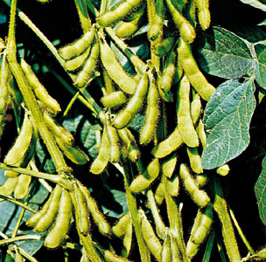
Soybean
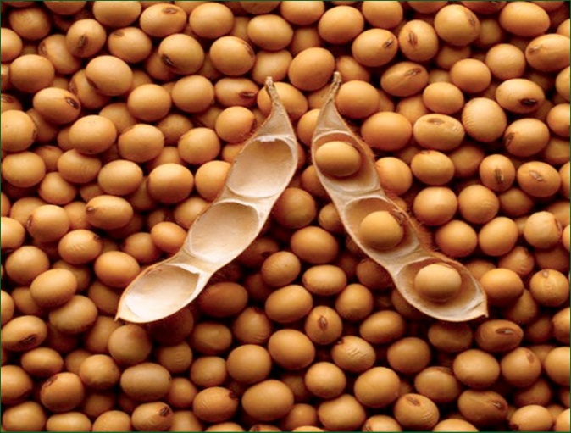

Soybean Meal
A highly palatable feedstuff, soybean meal is characterised by a high protein content (from 43 to 53%) and a low crude fibre (less than 3% for the dehulled soybean meals). It has a very good amino acid balance and contains high amounts of lysine, tryptophane, threonine and isoleucine that are often lacking in cereal grains. However, the concentration of cystine and methionine are suboptimal for monogastric animals and methionine supplementation is necessary (McDonald et al., 2002). Amino acid digestibility is also very high (more than 90 for lysine in pigs and poultry).
Soybean meal contains oligosaccharides such as raffinose and stachyose that cannot be digested by monogastric animals due to the lack of a specific endogenous alpha-galactosidase. Raffinose and stachyose can cause flatulence and diarrhoea that may increase digesta passage rate and decrease digestion and absorption of dietary nutrients. In poultry, these oligosaccharides have been shown to decrease nitrogen-corrected true metabolizable energy, fibre digestion, and transit time. Low-oligosaccharides soybean meals are now available.
About 60-70% of phosphorus in soybean meal is bound to phytic acid, which is nutritionally unavailable to monogastric animals and reduces the availability of P and other minerals. Supplementation with inorganic phosphorus is required and the addition of the enzyme phytase may alleviate the problem. Low-phytate soybeans are under development but their productivity is still poor.
Soybean meal is a poor source of B vitamins and lack of vitamin B supplementation in soybean meal-based diets may cause reproductive and performance problems in sows, older pigs and hens.

Cattle
Soybean meal is a staple of the diets of high-producing dairy and beef cattle in developed countries. In dairy cows, it has positive effects on feed intake, milk yield and milk protein content. In steers, supplementation of soybean meal on prairie diets resulted in higher forage intake and nutrient digestibilities. In calves younger than 3 months, methionine, lysine and tryptophan are the 3 first limiting amino acids of soybean meal and this deficiency disappears after 3 months.

Goats
In goats, adding 1.6% urea to soybean meal based diet allowed a reduction of soybean meal by 12% (from 25% to 13% inclusion level) resulting in lower feed costs. In countries where such practice is allowed, soybean meal can also be replaced by meat offals or poultry meal without altering animal performances.

Pigs
Soybean meal is the preferred source of protein in pig diets due to its content of highly digestible essential amino acids (lysine, but also threonine, tryptophan and isoleucine). It is a good complement to cereals that contain lower levels of those amino acids but higher levels of the sulphur amino acids, particularly methionine, that are limiting in soybean meal. Cereal-soybean meal diets are thereby typical in pig farms located in countries where soybean meal is affordable. Soybean meal can feed all classes of pigs and the inclusion levels generally used are about 30% in growing, finishing pigs and sows, and slightly lower (20-25%) in piglets. However, newly weaned pigs prefer dried milk products (whey or skim milk) as a protein source.

Poultry
Soybean meal is major protein source for all types of poultry, due to the amount and quality of its protein and amino acids. A diet based on maize and soybean meal provides a good balance on all essential amino-acids but methionine, but this problem can be solved by inclusion of synthetic methionine. Soybean meal inclusion levels range from 25% in chicks to 30-40% in broilers, breeders and laying hens.
Ipil-ipil
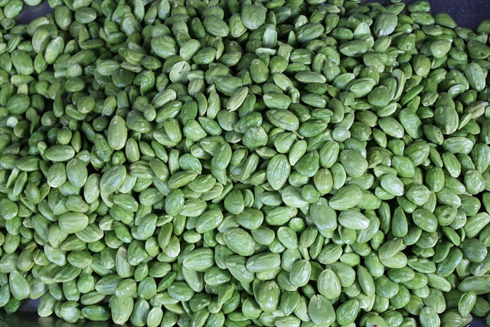
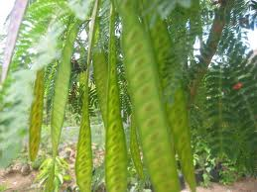

Ipil-ipil leaves
Its nutritional value is comparable with that of alfalfa with high ß-carotene content. The content in condensed tannins (2.6 %) in the leaves and stems reduce DM digestibility but enhances by-pass protein.
Leucaena leucocephala can survive for decades under heavy cutting or grazing. It provides high quality forage during dry season and is highly palatable to cattle, sheep and goats. Moreover, it grows well in association with many sub-tropical and tropical grasses.

Cattle
When leucaena pasture is used as a supplement during dry or winter season, it substantially improves live weight gain compared to pure grass pasture, particulary if the pasture is of low quality (Jones, 1979). When the diet contains high amounts of Leucaena leucacephala without clinical impact on animals, animals perform better than on pure pasture or grass/legume pasture (twice that of grass/siratro in same soil condition). Live weight gains range from 0.36 kg/head/day (on a 315-day period) to 1.1 kg/head/day (on a 90-day period). When cattle is able to detoxify DHP, live weight gains are even higher (1,442 kg/ha/year = 0.64 kg/head/day).
Feeding dairy cows on cut-and-carry leucaena foliage increases milk production by 14% on average and also increases milk fat and protein contents.

Sheep
Leucaena leaf meal or fresh leaves can also replace concentrate or ammoniated rice straw since it increases DM intake, protein intake, N retention and thus growth performance.

Goats
Leucaena foliage is a very promising feedstuff for goats when compared to other legumes such as alfalfa, Lablab purpureus and Gliricidia sepium. It supplies high nutrient content, resulting in better DM intake, weight gain and reproductive performance, 50 to 75% of leuceana foliage can be included in a grass-based diet and 30% when it replaces concentrate , without affecting growth and milk production. Fresh or wilted leucaena gives better DM intake, growth rate and N utilization than dried leucaena leaves.

Pigs
It is possible to feed pigs with low levels of Leucaena leucocephala: 5 to 10 % leucaena leaf meal are recommended in growing and finishing pigs. Treating leucaena with acetic acid (30 g/kg) or zeolite (5%) improves N retention and up to 20% leucaena leaves or leaf meal can be used.
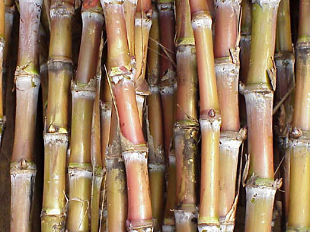
Sugarcane
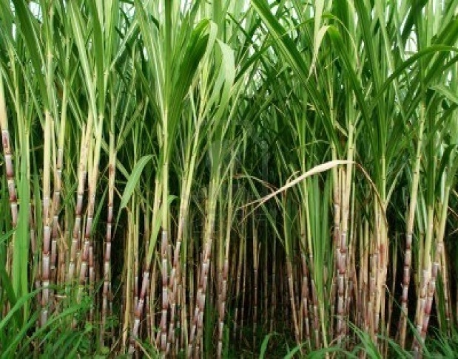

Sugarcane Juice

Nutritional attributes
Sugarcane juice is a highly digestible ingredient and a viable alternative energy source for pigs and poultry in tropical regions when sugar prices are low. It can also be fed to other livestock including beef cattle, dairy cows and other ruminants. The dry matter of sugarcane juice (16-20%) contains mainly sucrose and reducing sugars like glucose and fructose. Other organic components (about 17%) include protein, chlorophyll, tannins, wax and fibre (Xandé et al., 2008). It main nutritional limitation is its neglible protein content (lower than 1% DM): one feature of feeding sugarcane juice is that practically all the protein must come from the supplement and the amino acid balance will be that of the supplement. Sugarcane juice is very palatable to livestock due to its high sugar content. The composition of sugarcane juice varies within limits according to the variety, age and health of the sugarcane, environment, agricultural planning (maturation, harvest period, handling, transportation and storage), pests and diseases.

Beef cattle
Sugarcane juice has been shown to be an excellent source of energy for the growing ruminants, but to ensure that maximum growth rates are achieved it is necessary to supply protein and roughage. Several trials took place in Latin America in the early 1980s. In one experiment in Mexico, beef cattle fed ad libitum a mixture of sugarcane juice (with 0.5% urea), sunflower meal and grass had much better growth performance than animals fed molasses instead of cane juice (average daily gain of 1.32 vs 0.55 kg/d. Gains over 1 kg/d were obtained on Zebu bulls fed sugarcane juice (treated or not with ammonia) supplemented with leucaena foliage and fish meal. In the Dominican Republic, fresh grass and chopped whole sugar cane could be used as roughage sources to increase juice intake for growing cattle. Wheat bran and signal grass (Brachiaria decumbens) were found to be better supplements for a juice-based diet than jackbean forage (Canavalia ensiformis) and sweet potato.

Poultry
Sugarcane juice can make up to 10-25 % of poultry diets but higher inclusion rates have been tested successfully. In broilers, it was possible to substitute 40% of the diet with sugarcane juice by diluting the juice with water, and up to 60% by providing pure juice in a drinking trough. The birds consumed 491 g of juice and 79 g of a protein supplement (for a total DM intake of 169 g/day) and a daily weight gain of 46 g/day (from 1.1 kg to 2.1 kg).

Sugarcane press mud
Filter cake has a highly variable composition due to the different technologies involved. The nature of precipitation or flocculation aids, temperature and the fineness of the filtration process are all factors that influence its composition. The product may be fresh (60-80 % water) or dried. Protein content and sugars are both in the 5-15 % DM range. It can also contain important amounts of fibre (probably due to the 15-30 % of fine bagasse). Ash content is comprised between 9 and 20 %, but some press cakes may contain up 60 % mineral matter, a large part of it being silicium. Calcium content is comprised between 1 and 9 %. The content of protein, sugar and fibre makes filter press mud a potential feed ingredient, but actual feed trials are scarce.
In India, a filter press cake containing more than 30 % Ca (which is a highly unusual value) was proposed as a potential Ca source for livestock.

Rice
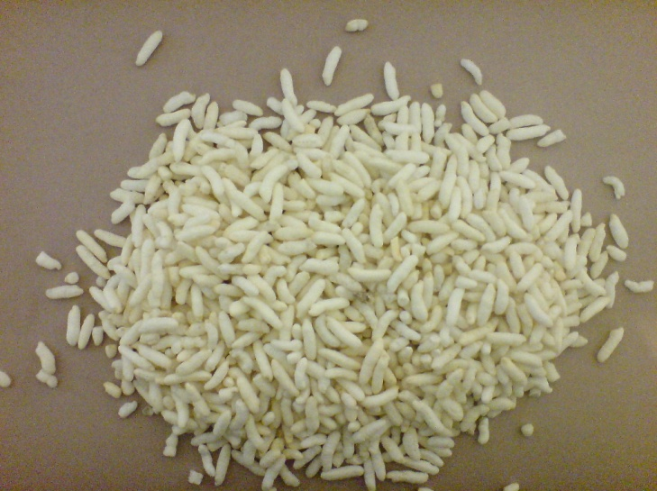
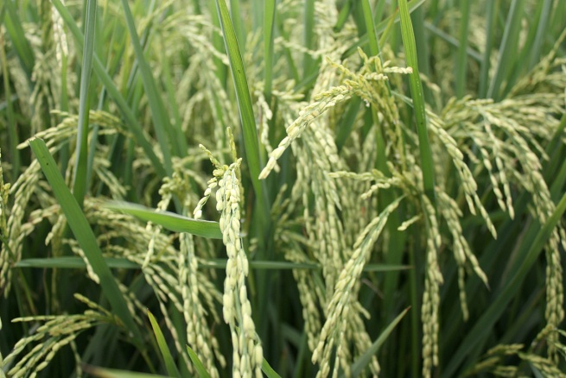

Rice Bran

Nutritional attributes
Rice bran is a good source of B vitamins and is fairly palatable to farm animals. The oil has a marked softening effect on body fat and on the butterfat in milk. With attention to the oil content, rice bran is a valuable feed for all classes of livestock. Rice pollards are used in the same way and with the same limitations as rice bran. It should be noted that rice milling by-products do not follow strict naming conventions. Many products called "rice brans" are mixtures of by-products obtained at different stages of the milling process, resulting in large variations in chemical composition.

Cattle

Full-fat rice bran
In dairy cows, full-fat rice bran has been recommended as a source of fat. However, cattle and finishing cows supplemented with full-fat rice bran do not perform as well as animals supplemented with maize, soybean hulls or wheat bran.
Heifers fed maize or soybeans hulls as energy-based supplements gained more body weight than heifers fed rice bran but this product had no effect on calf birth body weight and weaning body weight.
In steers, full-fat rice bran has proved to increase DM intake when supplementing hay-based diets, green forage-based diet or sugarcane bagasse-based diets. However, at low inclusion levels it had no effect on carcass yield or carcass weight.

Defatted bran
In dairy cows, a mixture of defatted rice bran and molasses can sustain the same milking yield as maize concentrate.
Grazing cows or cows fed on hay-based diet are worth supplementing with defatted rice bran as it enhances hay DM digestibility, hay NDF digestibility and total DM digestibility but also body weight, milk yield or milk fat content.
However, when defatted rice bran is compared to other brans such as maize bran, wheat bran or maize, it gives the poorest results: lowest milk yield, lowest digestible OM intake.
Defatted rice bran increased energy intake and fibre digestibility in steers, suggesting that fat content is detrimental to NDF digestibility. Calves supplemented with defatted rice bran gained more body weight than non-supplemented calves. In other studies, defatted rice bran gave similar body weight gain than wheat middlings but lower than those obtained with maize or full-fat rice bran.

Sheep
In sheep, supplementing basal diets with full-fat rice bran seems to have positive effects, however, recommended inclusion levels vary from less than 20% to more than 40% depending on the basal diet.

Goats
In lactating goats, substitution of wheat bran with rice polishings (25%) reduced the feed cost of goat rations.

Pigs

Full-fat rice bran
Thanks to its interesting chemical composition and particularly high lysine and methionine content, full-fat rice bran is often used as a basal diet in pigs.
Adding enzymes to rice bran may enhance ileal digestibility of non starch polysaccharides. Zn mineral supplementation is useful at 60% rice bran inclusion to prevent parakeratosis (Bauza et al., 1990). On the contrary, feeding rice bran with phytase lowers the need for mineral P supplementation in maize-soybean meal-based diet.

Corn
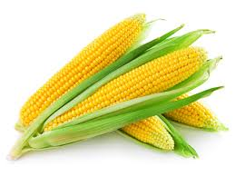
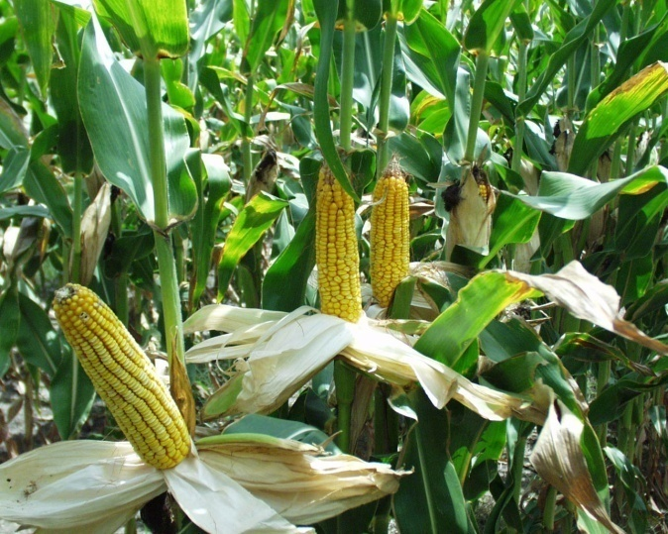

Corn Gluten Feed
Corn gluten feed is a relatively high fibre, medium-energy, medium-protein product that is essentially fed to ruminants. Its fibre is highly digestible by ruminants and corn gluten feed can be substituted for grains, such as maize grain, to reduce the starch load in the rumen. The high fibre content may help to prevent rumen acidosis. Corn gluten feed is low in lysine and amino acid supplementation could be considered if dietary lysine concentration is a concern.

Nutritional attributes
Corn gluten feed is a major feed ingredient in ruminant diets, particularly for beef and dairy cattle. Wet corn gluten feed contains 40 to 60% DM while the dry product contains about 88% DM. Corn gluten feed is a moderately high source of protein: it contains about 20-25% DM of protein, more than cereal grains and milling by-products but less than corn gluten meal, distillers' grains and most oil meals. Corn gluten feed is much richer in cell wall constituents than maize grain (crude fibre 6-10% DM, NDF 31-49% DM, ADF 8-13% DM and a low lignin content about 1.2 %DM) which tends to limit its use in pig and poultry diets. The crude fat content is usually lower than 4% DM. Corn gluten feed contains relatively high and quite variable amounts of residual starch, from 11% to more than 30% DM. Ash content is also important (about 7% DM).
The composition of corn gluten feed is influenced by the proportion of steep liquor, which contains more energy and protein than the bran. The ratio of steep liquor to bran is generally 1/3 to 2/3 and differences in nutritive value between products containing low or high levels of steep liquor can be important. Corn gluten feed varies in color from yellow-light brown to dark brown, depending on the amount of steep liquor, drying temperature and drying time. Dried corn gluten feed generally darkens with increased drying temperature or time. Extremely dark corn gluten feed with a "burned" smell may be heat damaged and have reduced protein digestibility.
Corn gluten feed is low in calcium but has relatively high levels of phosphorus and potassium. The problem of excess sulfur for cattle has been described in Potential constraints.

Nutritional value

Energy value
In vivo OM digestibility values found in the literature for dried corn gluten feed vary from 70 to more than 80%. Differences in composition (steep to bran ratio, starch and fibre content) as well as processing conditions (drying temperature and drying time) may explain this variability. Corn gluten feed has slightly lower OM digestibility in sheep than in cattle (72% vs. 75%). Published ME values vary from 11.4 to 12.2 MJ/kg DM (NRC, 2001 and Sauvant et al., 2004) while NE for lactation values range from 6.9 (NRC, 2001 at 3 x maintenance) to 7.4-7.5 MJ/kg DM at 4 x maintenance).
Drying corn gluten feed reduces its energy. For instance, wet corn gluten feed contained more NE for gain (estimated from animal performance) than dried corn gluten feed when fed to finishing cattle. This could be partially explained by the loss of volatile compounds in the steep fraction during extensive drying (over 60°C). Also, fibre in wet corn gluten feed is somewhat more digestible than in the dry form, permitting greater intakes of wet vs dry corn gluten feed (Schroeder, 2010). In beef cattle, wet corn gluten feed contained more NE (estimated from animal performance) than dry-rolled maize grain when fed in growing diets (Stock et al., 1999) and 90 to 100% the NE of maize grain in finishing diets.

Protein value
Ruminal escape of the protein of corn gluten feed is about 24-30%. Values for wet gluten feed are in the lower range (25%; Schroeder, 2010). As a consequence, the inclusion of corn gluten feed should be minimized in diets that contain dietary ingredients with high soluble protein concentrations, such as silages.

Phosphorus availability
Absorbable phosphorus content in corn gluten feed is about twice that in maize grain (Sauvant et al., 2004). It tends to exceed P requirements in cattle, which may lead to the formation of urinary calculi and to P accumulation in urine and manure.

Palatability and feeding behaviour
Corn gluten feed has a bitter taste that affects palatability and results in lower intake until animals adapt to it. For instance, steers fed a diet containing 40% wet corn gluten feed spent less time at the feeding bunk than animals fed the control diet (Parsons et al., 2007). Corn gluten feed has a low mean particle size (less that 10% of its dry matter is retained by a 1 mm screen aperture), which is not favourable to chewing. Rumination time, chewing activities and rumen pH were negatively affected when 18% and 25% dry corn gluten feed were substituted for corn silage. The inclusion of chopped alfalfa hay to dairy cows diets rich in wet corn gluten feed increased ruminal mat consistency and rumination activity resulting in greater ruminal digestion of NDF.

Dairy cows
Numerous trials in North America have investigated the effects on dairy performance of replacing forages or concentrates with dry and wet corn gluten feed. Generally, it was found that high levels of wet corn gluten feed could be included in the diet of dairy cows. Cows fed 20 to 35% (DM basis) wet corn gluten feed produced energy-corrected milk more efficiently than controls. Milk protein and lactose yields increased when corn gluten feed was fed while percent milk fat was lower and fat yield remained unaffected. Another trial found that diets may be formulated to contain as much as 37.5% wet corn gluten feed (DM basis) and the increase in total milk yield compensated the reductions in milk fat concentration, maintaining total milk fat yield. DM intake, milk yield and milk composition were not significantly affected by replacing concentrate with wet maize gluten feed at up to 34% of DM intake. Dried corn gluten feed could support milk production levels equal to diets based on maize grain and soybean meal when fed to dairy cows in midlactation at 22% of DMI. In Brazil, the inclusion of 16% of dried corn gluten feed resulted was found economically profitable.
Not all studies have been entirely favourable. A linear decline in DM intake and milk yield was observed with maize silage-based diets when 0 to 40% (diet DM) wet corn gluten feed was added . A similar decrease in milk yield was noted when more than 15% wet corn gluten meal was included in the diet (Schroeder, 2003). It has been suggested that the optimal inclusion level for corn gluten feed depends upon the feedstuffs being substituted for, as well as on the other ingredients contained in the ration . An optimally formulated wet corn gluten feed product could replace up to 100% of the concentrate and at least 45% of the forage in diets for lactating dairy cows containing 54% forage, which would translate into nearly 70% of the total ration DM .

Beef cattle
A considerable amount of research has been dedicated to investigate the use of corn gluten feed in North American feedlot diets.

Wet corn gluten feed
Relatively high levels of wet gluten feed can be admitted in feedlot diets, with often positive (but variable) effects on performance. This positive response is likely due to reduced ruminal acidosis, increased DM intake, and also to a reduction in negative associative effects of ruminally fermentable starch on fibre digestion. However, due to potential sulfur toxicity, corn gluten feed should be limited to 50% or less of the total DM intake.
Wet corn gluten feed replacing various levels of dry-rolled maize grain had a positive effect on average daily gain (up to 15% higher) and on feed efficiency (up to 5% higher). Feed efficiency was generally improved by the addition of wet corn gluten feed to dry-rolled maize finishing diets. Wet corn gluten feed could substitute up to 25 or 50% of dietary DM without negative effects on feedlot performance, digestibility of nutrients, or carcass characteristics (Hussein et al., 1995). 40% (diet DM) wet corn gluten feed replacing steam-flaked maize increased DM intake daily gain but decreased feed efficiency. The same amount of wet gluten feed increased digestibility of organic matter and NDF. Wet corn gluten feed could be used at up to 35% (diet DM) without adversely affecting performance. Wet corn gluten feed (25 to 35% diet DM) could be used as a source of energy in finishing diets based on steam-flaked corn and, as a source of fibre, partially fulfilled roughage requirements.
In limit-fed diets the value of wet corn gluten feed relative to steam-flaked maize might be increased with increased concentrations (30% vs 10-20% DM) of alfalfa hay. Restricting feeding during growing may be a strategy that improves the utilization of corn gluten feed at high inclusion rates.
Carcass quality can be altered by wet corn gluten feed supply: steers fed fine-rolled grain contained more fat than steers fed 50% wet corn gluten feed.

Dried corn gluten feed
Dried corn gluten feed could completely replace finely ground maize in finishing diets without affecting negatively feed efficiency and Net Energy (Pereira et al., 2007). Replacement of barley with dried corn gluten feed increased ruminal pH, which could help to prevent excessive post-prandial pH decrease. Substituting dry corn gluten feed for maize grain reduced feed efficiency and gain due to the lower digestible energy content of corn gluten feed.

Modified corn fibre
Modified corn fibre is a by-product produced by a secondary fermentation of maize bran which would enable maize processors to more fully recover ethanol from maize grain. This product has about the same protein content as corn gluten feed but is considerably richer in fibre (ADF 45% DM). Feeding this product (15% dietary level) to growing heifers resulted in poor performance, suggesting a limited feeding value because of the high acid detergent insoluble nitrogen content (2.5% DM vs 0.17% DM in corn gluten feed) and slow protein digestion.

Sheep
Inclusion of corn gluten feed in sheep diets (high or low energy rations for wethers) had no effect on DM intake (Possenti et al., 1998; Bowman et al., 1988). However, increasing levels of corn gluten feed affected the digestibility of all nutrients.
In growing ewes, corn gluten feed included at 10 or 20% dietary level in a rice straw/concentrate diet resulted in higher animal performance. Daily gain and feed efficiency were higher at 10% inclusion. Different forms of corn gluten feed (wet, dry or ensiled) were included at up to 50% dietary level in high–concentrate lamb diets and they compared favourably with diets based on maize-urea or maize-soybean meal.

Goats
Supplementing goats fed on cocksfoot hay (Dactylis glomerata) with corn gluten feed did not change total DM intake, nutrient digestibility, final weight and average daily gain. Carcass dressing was slightly enhanced compared to goats fed hay only (Moore et al., 2002). Dairy goats fed corn gluten feed had higher milk protein than goats fed on other protein sources such as faba beans, sunflower meal or cottonseeds.

Pigs
Corn gluten feed contains more protein than maize grain but its dietary fibre content is also much higher, resulting in a lower energy value. For growing pigs, the Net Energy of corn gluten feed is about 60 % that of maize grain. In adult sows, who can better digest dietary fibre, the Net Energy of corn gluten feed is 10% higher than for growing pig.. Another limitation of corn gluten feed in pig nutrition is its low lysine and tryptophan content, combined to standardized ileal amino acid digestibility values that are 15% lower than for maize grain to the higher dietary fibre.
The bulkiness of corn gluten feed is a limiting factor at physiological stages with high dietary energy requirements, notably starter pigs, grower pigs and lactating sows. In addition, corn gluten feed has a medium palatability: the increase in feed intake reported in growing pigs is mainly due to the fact that pigs fed diets including corn gluten feed tend to increase feed consumption in order to maintain energy intake. Up to 20% of corn gluten feed can be used in diets formulated for weaning piglets and for growing pigs. In finishing pigs, corn gluten feed can be incorporated at up to 30% with no loss of performance. In sows, corn gluten feed can be used to dilute energy during gestation in order to reduce hunger and improve welfare, health status and reproductive performance. Corn gluten feed can be fed to gestating sows at high inclusion rates (50-70%) with tryptophan supplementation without affecting reproductive performance.

Poultry
Corn gluten feed is not a very good ingredient for poultry, as its protein and energy content cannot meet the high requirements of poultry production. As a consequence, maximum recommended levels are rather low for broilers (about 10%) and higher for laying hens, who have lower energy requirements. Up to 20-25% of corn gluten feed can be included in balanced diets for laying hens without reducing performance. Corn gluten feed may be a good ingredient in induced molt programs for layers.

Rabbits
Corn gluten feed is a typical ingredient of rabbit diets in Western Europe, particularly in Spain (de Blas et al., 2010). It is used without any problem, mainly as a protein source (even tough it is deficient in sulfur amino acids) and as a source of digestible fibre . However, its very low lignin content is a limiting factor for its inclusion (5% lignin is recommended to maintain digestive health; Gidenne et al., 2010), and a supplementary source of lignin must be provided in the diet. The usual inclusion rate of corn gluten feed in rabbit diets is 2 to 10% , and up to 20% in some diets. In experimental studies, it has been possible to include as much as 50% without problem.

Fish

Tilapia (Oreochromis niloticus)
Corn gluten feed has been used as fish meal replacer in diets of fry and sub-adult tilapias. In fry diets, a better feed efficiency was obtained in diets containing 67% of corn gluten meal (28% total dietary protein) than in diets containing 30% of gluten feed (32% dietary protein). In sub-adult diets, inclusion could range between 13 and 19% dietary level. Corn gluten feed was reported to have a high feed efficiency and resulted in cost effective rations without impairing fish growth.

Cassava
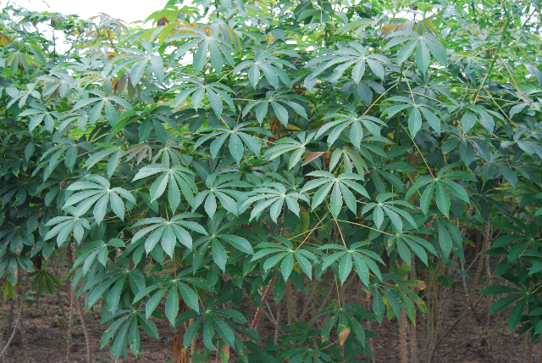
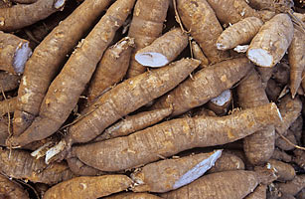

Cassava peels

Cassava peels can be used as a roughage and as an energy feed in ruminant diets. However, sun drying, ensiling and fermentation should be used to prevent HCN poisoning when using bitter cassava varieties. Cassava peels should not be fed alone, as their protein and mineral content cannot support optimum rumen function and productivity in ruminants, and their optimal utilization requires sources of readily fermentable protein and by-pass protein as well as micronutrients including sulphur, phosphorus, and B vitamin. Cassava peels are then a valuable feed, and significant increases of animal performances have been reported when they are added to ruminant diets.
Cassava peels have a low protein content (< 6% DM) and a high and variable fibre content (crude fibre in the 10-30% DM range).

Cassava pomace
Cassava pomace is a highly variable by-product as its composition is driven by the starch extraction technology used in the processing plant. Its protein content is very low (< 4% DM, sometimes as low as 1%). Starch content can vary between 15 and 50% DM and NDF content is higher than 35 % DM. Fresh cassava pomace contains mostly water (75-85%).

Cattle
In Ghana, weight gains of 0.29 or 0.33 kg/day (vs 0.07 kg/day for the control diet) were recorded with cross-bred bullocks grazed and supplemented with dried or ensiled peels (Larsen et al., 1976). In an experiment with bulls in Vietnam, total DMI increased with the amount of cassava peels (total DMI = 0.009 DMI of the peels in kg/100 kg LW/d) while grass DMI decreased (grass DMI= -0.017 DMI of the peels in kg/100 kg LW/d + 2.15) . Because of their high degradability, cassava peels have been also used as a energy supplement in cattle: cassava peels could partly replace (30% of total DMI) energy concentrates, with no influence on the intake, digestibility, microbial efficiency, and nitrogen retention.

Sheep
Many trials have been carried out with sheep in subsaharan Africa. In Ghana, Djallonké lambs lost weight after consuming only cassava peels: supplementation with Ficus exasperata leaves resulted in weight gains and in a significant increase in cassava peels DMI (from 44 to 58 g W^{0.75}) (Baah et al., 1999). In Cameroon, sheep fed 0, 35, and 70% of the diet as cassava peels (and respectively 70, 35 and 0% Pennisetum purpureum), with cottonseed cake as the protein source, gained respectively 45, 107 and 227 g/d. Dry matter intake, digestibility and growth rate increased linearly with increasing dietary levels of cassava peels. Sheep may use ensiled cassava peels better than sun-dried peel: in Nigeria, sheep fed a diet containing 80% ensiled cassava peels had higher daily gains (81 vs 59 g/d) than those fed sun-dried peels.

Goats
In Nigeria, a 60:20:20 ensiled mixture of grass-legume (guinea grass and tropical kudzu Pueraria phaseoloides), cassava peels and poultry excreta fed to In West African Dwarf goats resulted in favorable consumption and digestibility, as well as normal rumen and blood metabolites, and it was recommended to use cassava peels as an energy supplement in anticipation of dry-season feeding. In Red Sokoto goats, ensiling cassava peels with Pennisetum purpureum had beneficial effects on silage properties, intake and digestibility, and it was proposed that cassava leaves form at least 30% of silage made from Pennisetum purpureum to improve productivity during the dry season.

Pigs

Cassava peels
Cassava peels are a good feed for pigs, but they must be supplemented with sources of protein and lipids in order to improve their palatability and digestibility. The fibrous nature of the feed may also limit its inclusion in pig diets. Most studies on the use of cassava peels in pig diets have been carried out in Nigeria.
Several methods have been tested to enhance the feeding value of cassava peels for pigs. In pigs fed a diet containing 30% cassava peels, adding an enzyme cocktail enhanced diet utilization, resulting in better performance comparable to pigs fed with the maize-based control diet. Biodegradation of cassava peels with Trichoderma viride resulted in a higher protein content (16%) but was not found to be more expensive without significantly improving performance.

Cassava pomace
Cassava pomace is extensively used for pigs in Southeast Asia, where it is regarded as a valuable feed (Göhl, 1982). Its energy value is quite good but highly variable and depends on the processing technology (ME 9.6 to 12.9 MJ/kg DM; Kosoom et al., 2009a; Tonsing et al., 2008).

Poultry

Cassava peels
Cassava peels can be used for poultry feeding after sun-drying, as well-processed peels contains HCN levels that are acceptable for poultry (Osei et al., 1989; Nwokoro et al., 2005b). Fermentation of cassava peels has been tested by several authors, either to lower HCN or fibre content (Osei et al., 1988) or to increase crude protein content (Buitrago, 1990), but the results are inconclusive.

Rabbits

Cassava peels
Dried cassava peels could be introduced up to 30% in balanced growing rabbit feeds as source of energy and replace the corresponding amount of maize grain. Because the detoxification of cyanogenic glucosides requires the presence of methionine, balanced feeds that include cassava peels must content enough sulphur aminoacids.
Fermentation or ensiling seem to be as efficient as sun-drying (or even more efficient) to detoxify cassava peels and the resulting products can be used safely to feed growing rabbits. Water-soaking fresh peels for 1 to 5 hours before sun-drying them also significantly reduced cyanogenic glucosides in amounts proportional to soaking duration. Water-soaked cassava peels allowed growth and slaughter performance identical or significantly better than those obtained with the 20% maize control diet.
On the other hand, extrusion of a diet based on dried cassava peels (totally replacing maize) was inefficient in all indices of measurement, as growing rabbits fed on this diet showed poor performance compared to those fed the non-extruded diet.

Cassava sievate
Cassava sievate introduced up to 18-20% in growing rabbit diets (replacing the corresponding amount of maize grain) resulted for all inclusion rates in growth performance similar to or slightly better than that obtained with the maize-based control diet. A higher inlusion level (40%) reduced growth rate by 9% in comparison with the maize-based control diet, but the unit cost of feed to weight gain remained in favour of sievate utilisation (Ngodigha et al., 1995).

Cassava meal residue
Cassava meal residue is a mixture of cassava roots unsuitable for human consumption and of root tips from the pre-processing cleaning stage. Its composition is close to that of the roots, with a high starch level (64%). It was reported that cassava meal residue may be added up to 26% to the diet of growing rabbits from weaning to slaughter, replacing completely digestible energy of maize without any impairment in performance and carcass quantitative characteristics (Scapinello et al., 2005)
Coconut
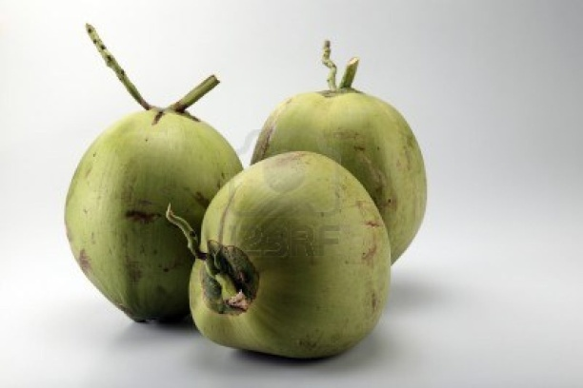
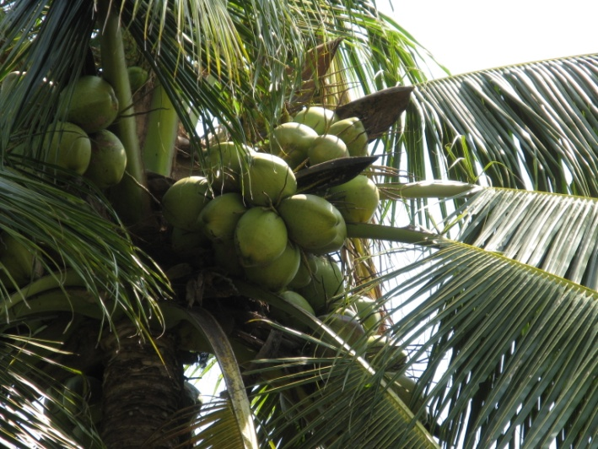

Copra meal is a common feed ingredient, particularly for ruminants. It contains 20-25 % DM of crude protein and relatively high quantities of cell wall constituents (NDF > 50 % DM, ADF about 30 % DM), so that its nutritive value is inferior to that of the other major oil meals, notably soybean meal, groundnut meal and cottonseed meal. Unlike those by-products, copra meal is often obtained from mechanical extraction only and its oil content is generally quite high (about 10 % DM, in the 5-15 % range with values higher than 20 %). The oil content makes it a valuable energy source, particularly in areas where such sources are scarce. The less common solvent-extracted copra meal contains less oil (about 3 % DM) and a little more protein (Feedipedia, 2011). Coconut oil is different from other common vegetable oils because it contains over 60% of medium-chain fatty acids (C8-C12), notably 46-50% of lauric acid.
A particularity of copra meal is its high non-starch polysaccharides content, and notably its levels of mannan and galactomannan (25-30 %), which are known to have antinutritional properties in monogastric species (Sundu et al., 2009). These constituents are also the cause of the low bulk density (0.56 g/cm³ vs 0.75 for soybean meal) and high water holding capacity (4.14 g water/g feed vs 2.77 for soybean meal) of copra meal, and those physical properties tend to limit intake. However, copra meal can absorb up to half its own weight of molasses, which can be a useful property in compound feed manufacturing.
Copra meal is poor in essential amino acids, notably lysine and sulphur amino acids. Lysine may be partly destroyed by the heating during oil extraction (Pascoal et al., 2006). Amino acid supplementation may be therefore required.

Ruminants

Copra meal
Copra meal is a valuable feed for ruminants and can be used as a protein supplement for grass-fed animals, either alone or in combination with other protein sources. While theoretically inferior to other common oil meals due to its lower protein content, it is often a better feed resource than other local products such as cocoa by-products or brewer’s grains (Aregheore et al., 2003). It found to be as effective as cottonseed meal for growth performance despite of having half of the protein content, and it has been advanced that the protein quality of copra meal has a higher biological value (Gulbransen et al., 1990).

Digestibility and energy values
In vivo digestibility of OM of copra meal has been measured several times, particularly in the studies comparing the in vitro, in sacco, the nutritive value of copra meal with other ingredients. Due to the low level of lignification of its cell wall, the digestibility of NDF in copra meal is high, comparable to that of maize by-products and soybean hulls. As a consequence, in vivo OM digestibility of copra meal is good (75-85 %) considering its fairly high NDF content. Higher values have been proposed for solvent-extracted meal than for expeller meal (85 % vs 79 %). For the expeller meal, an OMD value of 76 % (12.1 MJ/kg DM) has been proposed recently.

Protein value
The fraction of rapidly fermentable N in the rumen of coconut meal is low, with values ranging from 19 %, 20.1 % , to 22.4 % . Therefore, if transit is taken into account, the effective degradability of copra protein is fairly low, about 50% . The intestinal digestibility of copra meal by-pass protein, about 90 %, is rather high compared to other feed ingredients (Woods et al., 2003c; Sauvant et al., 2004; Carvalho et al., 2005; Pereira et al., 2010).

Palatability
There are conflicting reports about palatability of copra meal. It was found to be very palatable and readily accepted by cattle but other authors observed that it decreased voluntary intake. In one experiment with dairy cows, copra meal was not palatable initially and required about two weeks training to achieve satisfactory intakes, which then started to decrease. The susceptibility of copra meal to rancidity after prolonged storage could cause such palatability issues, even when no obvious signs of rancidity are noticed (Oliveira et al., 2010; Ehrlich et al., 1990).

Dairy cows
Copra meal is a good ingredient of dairy rations and provides energy and by-pass protein. 1.5-2 kg/d have been recommended as the maximum safe amount (Göhl, 1982) but cows have been fed more than 3 kg/d without adverse effects (Ehrlich et al., 1990). Copra meal has been shown to be a suitable supplement for cows grazing tropical pastures in Fiji and adding 1.8 kg/day of copra meal to the diet increased milk production by 70% (McIntyre, 1973). Cows grazing Napier grass (Pennisetum purpureum) and copra meal providing 300 g/d of protein increased production by at least 1 kg/day (Muinga et al., 1993). Less impressive results have been obtained on richer pastures, but copra meal could still replace sorghum grain and increase the fat content of the milk (Ehrlich et al., 1990). Earlier research suggests that copra meal makes butterfat harder, lending it a pleasant flavour, but that large quantities of copra meal may result in tallowy butter (Göhl, 1982).

Beef cattle
Copra meal is a good supplement for grazing steers. Animals fed up to 1 kg/day of pelleted copra meal had a much higher growth rate than unsupplemented animals (0.41 vs 0.11 kg/d). In growing steers grazing on giant stargrass (Cynodon plectostachyus), supplementation with copra meal gave higher growth rates than supplementation with soybean meal (Ramos et al., 1998). Steers grazing Imperata cylindrica supplemented with copra meal, alone or treated with molasses and urea also had higher growth rates. Average daily gains of 0.99 kg/day and diet intake of 3.2 kg/day were recorded on grazing buffaloes fed a supplement containing 70 % copra meal. While these performances were satisfactory, they were lower than those obtained with a maize/soybean meal supplement and a 70% palm kernel meal supplement, possibly due to the lower palatability of copra meal (Oliveira et al., 2010). Copra meal at a daily rate of 500 g/head, and with rumen soluble nitrogen from urea, was found to be an effective supplement for improving growth of steers fed hay made from low quality forage (Hennessy et al., 1989).
Using copra meal in growing heifers resulted in decreased performance compared to a barley-soybean meal diet supplemented with copra oil. It was as efficient in reducing CH₄ production as this control diet but the environmental benefit was cancelled by a longer finishing time (Jordan et al., 2006).

Sheep
Copra meal can be a suitable supplement for sheep and other ruminants consuming tropical pastures. Copra inclusion at 7.5 % of the diet MS does not have negative effects on digestibility but decreases voluntary intake due to its poor palatability or other unknown effects (Camacho Diaz et al., 2006). Pelleted copra meal given to pregnant ewes increased birth weight of twin lambs, milk yield and ewe live weight after lambing (Bird et al., 1990).

Goats
Copra meal is often used as a protein supplement for grass-fed goats. Supplements containing up to 75 % copra meal have been used successfully in goats fed Napier grass. Substituting 50 % of copra meal with leucaena hay increased daily gain and diet digestibility, and it could be replaced by 75 % of dried brewer’s grains.
Copra meal could replace up to 50 % of soybean meal goats fed corn silage while a 75 % reduced performance.

Pigs
Copra meal may be an economical and valuable local feed for pigs that can be used to partially replace costly imported feeds such as soybean meal. However, the high fibre content of copra meal restricts its use in pig feeding. The slow digestive passage rate of fibre results in decreased feed intake, lower availability of organic matter, protein, and energy in the diet and poorer growth performances. Its low content in essential amino acids, combined to the depressing effect on amino acid digestibility, makes amino acid supplementation necessary (particularly lysine, methionine+cystine and threonine) if high levels of copra meal are to be fed.
Maximum recommended inclusion levels are about 20-25 % of the diet while optimum should be around 10%. This level of inclusion yielded a gain of 500 g/d daily in growing pigs in Tanzania. Inclusion rates higher than 50 % depress the feed conversion ratio, but if growth performance at such rates is considered acceptable, the low cost of copra meal may decrease the cost per kg liveweight.
Feeding pigs on copra meal has no deleterious effect on meat quality parameters such as fatty acids or dressing percentages. It produces firm fat in pigs (Göhl, 1982).
There is little literature on improving the nutritive value of copra meal for pigs. The addition of an enzymatic complex failed to improve it. Expander processing of a diet containing 15 % of copra meal did not affect growth performance (O'Doherty et al., 2001).

Poultry
The amino-acid profile is not optimal for poultry due to a relative lack of lysine and sulphur amino-acids. The energy value of copra meal is low because of the high fibre content though it can be increased by the high content of residual oil in expeller meals. In this case, the energy value can be estimated by combining the values of defatted copra meal and copra oil. There seem to be a difference between ME value for young chicks and older animals or hens.
The low feeding value in poultry is also partly due to physical properties of copra meal. The high water holding capacity and bulk tend to decrease intake, particularly in young animals. There is a significant effect of copra meal on the DM content of excreta. This can be a problem in some conditions for the sanitary quality of poultry litter.

Rabbits
Copra meal is also a good source of energy for rabbits and its gross energy crude protein and oil are quite digestible. Copra meal can have a positive effect on rabbit meat quality: at 25% inclusion, copra meal lowers the palmitic acid content of rabbit meat without significantly affecting other fatty acids and may thus have an hypocholesterolaemic effect in humans.

