Predatory Mites
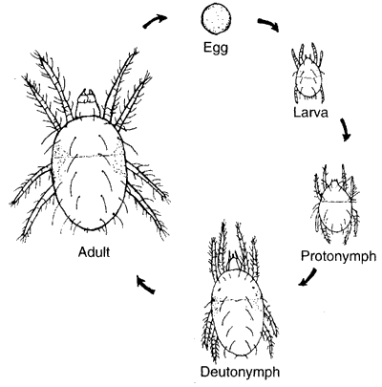
Life Cycle

Predatory mites have five stages in their life cycle—egg, six-legged larval stage, protonymph, deutonymph, and adult. Most beneficial species have a life cycle very similar to what is outlined below.
Eggs are oval, clear, larger than spider mite eggs (which are round), and typically laid on the underside of leaves. They are laid individually and the larvae hatch in 2-3 days
Larvae have three pairs of legs (six total) and begin-feeding on prey immediately after hatching. After feeding on one or two prey for one or two days they molt to the protonymph stage.
Protonymphs and deutonymphs are first and second stage nymphs, respectively, that increase in size and have four pairs of legs (eight total). Each stage consumes prey over one or two days, getting slightly larger and eventually molting to adulthood.
Adult females consume about two prey per day for about five to six weeks. They deposit an average of 33 eggs during that time. Males consume about one prey per day for about four to five weeks. Predatory mites have multiple generations per year and develop from egg to adult in 6 – 12 days. Western predatory mites go into diapause (dormancy) when there are less than 11 hours of daylight. There are, however, non-diapausing strains that can be used effectively in greenhouses during short winter days. Adults overwinter in protected places, such as bark, leaves or soil debris.

Green Lacewing
Reproduction
After mating, females lay dozens to hundreds of small eggs underneath leaves, each stuck on the end of a fine hairlike shaft that keeps it up off the surface of the leaf. They lay their eggs on plants with infestations of aphids to serve as food for the hatchlings.
Life Cycle
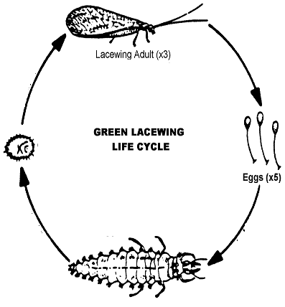

Lacewings go through complete metamorphosis (egg, larva, pupa, adult) and have at least two generations per year. The life cycle takes about 4 weeks depending on temperature. A female lacewing can deposit over 200 eggs. In 4 to 5 days, the eggs will hatch into small alligator-like larvae.
Lacewing larvae are brownish and can have dark reddish-brown stripes and spots (Fig. 3). They have large jaws for grasping prey and injecting a paralyzing venom. Lacewing larvae, sometimes called aphid lions, typically feed on soft-bodied insects such as aphids, mealy bugs, thrips, mites, leaf hoppers, whiteflies, caterpillars, other immature insects, and sometimes each other. The larvae develop three instars in 2 to 3 weeks, and are 9.5 mm long when full grown. Larvae will spin a silken pale cocoon that is loosely attached to foliage. During the pupal stage they develop wings and reproductive organs.
After 5 to 7 days the adult will emerge from the cocoon and begin to mate. Adult lacewings have chewing mouthparts, are about 8- 9 mm long, and feed mostly on nectar and pollen. They can survive for about 5 to 6 weeks and are considered weak flyers. Lacewings are often found in crops highly infested with aphids, such as sweet corn, potatoes, cole crops, tomatoes, peppers, eggplants, asparagus, leafy greens, apples, strawberries, and alfalfa. Adults are also highly attracted to lights at night.

