Philippine weeds
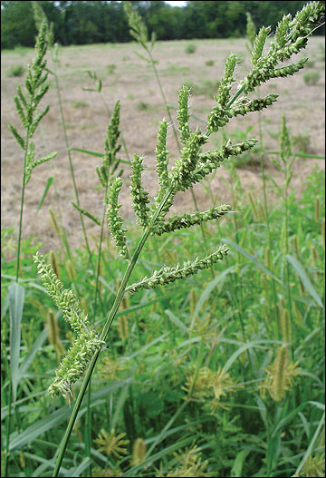
1. Scientific Name: Echinochloa spp.
English Name: Barnyard grass, Water grass
Local Name: Balbas Kalabaw, Bayakibok, Gabing Uwak
Family: Poaceae
Annual or perennial: annual
Grass, sedge or broadleaf: grass

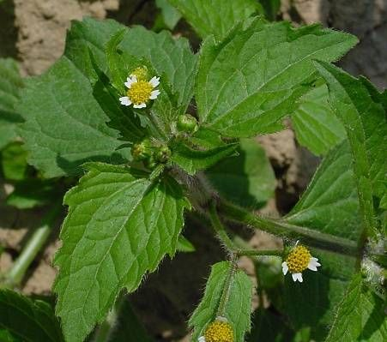
2.
Scientific name: Galinsoga ciliata
English Name : Hairy galinsoga, shaggy soldier
Local Name:
Family: Asteraceae
Annual or perennial: annual
Grass, sedge or broadleaf:

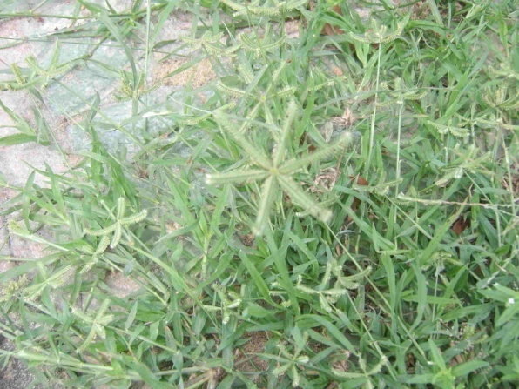
3.
Scientific name: Dactyloctenium aegyptium
English Name : Crowfoot grass
Local Name: krus-krusan, damung-balang
Family: Poaceae
Annual or perennial: annual
Grass, sedge or broadleaf: grass
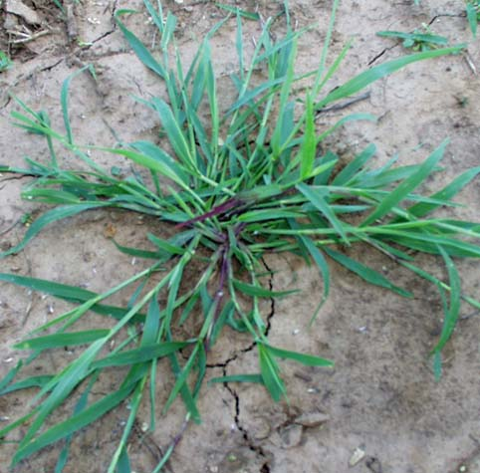
4.
Scientific name: Digitaria spp.

English Name : Crabgrass
Local Name:
Family: Poaceae
Annual or perennial: annual
Grass, sedge or broadleaf: grass

5.
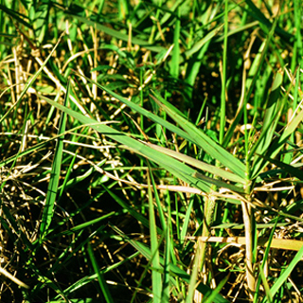
Scientific name: Panicum repens

English Name : Torpedo grass
Local Name:
Family: Poaceae
Annual or perennial: Perennial
Grass, sedge or broadleaf: grass

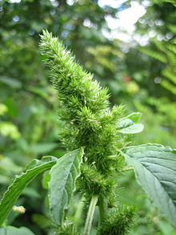
6.

Scientific name: Amaranthus retroflexus

English Name : Pigweeds
Local Name:
Family: Amaranthaceae
Annual or perennial: annual
Grass, sedge or broadleaf: broadleaf
7.

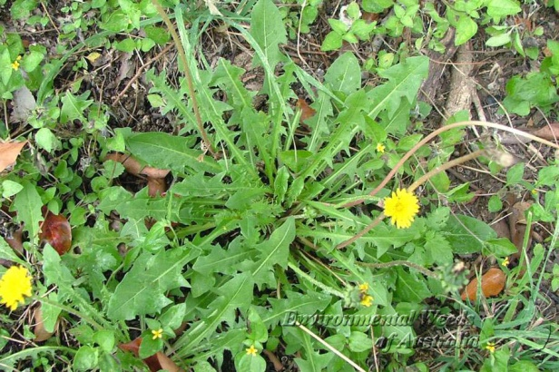
Scientific name: Taraxacum officinale

English Name : Dandelion

Local Name:
Family: Asteraceae
Annual or perennial: perennial
Grass, sedge or broadleaf: broadleaf

8.

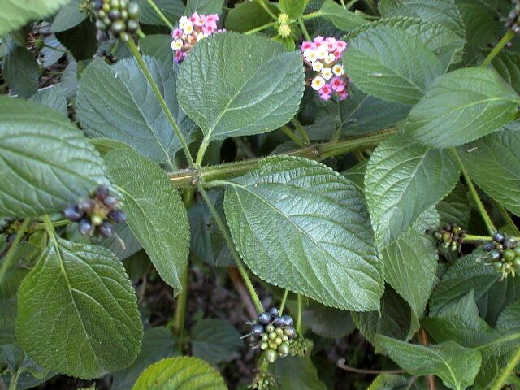
Scientific name: Lantana camara

English Name : Lantana

Local Name: kantutay, koronitas
Family: Verbenaceae
Annual or perennial: perennial
Grass, sedge or broadleaf: broadleaf

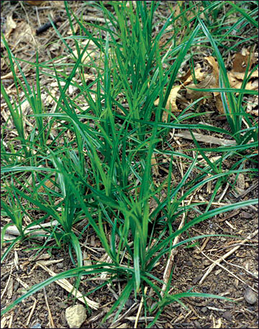
9.

Scientific name: Cyperus rotundus

English Name : Nut grass, coco-grass

Local Name: boto-botones, mutha
Family: Cyperaceae
Annual or perennial: perennial
Grass, sedge or broadleaf: sedge

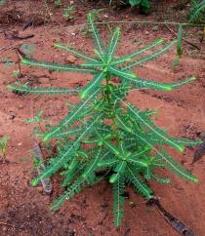
10.

Scientific name: Phyllanthus niruri

English Name :stonebreaker or seed-under-leaf

Local Name: Sampa-sampalukan, Taltalikod
Family: Phyllanthaceae
Annual or perennial:
Grass, sedge or broadleaf:

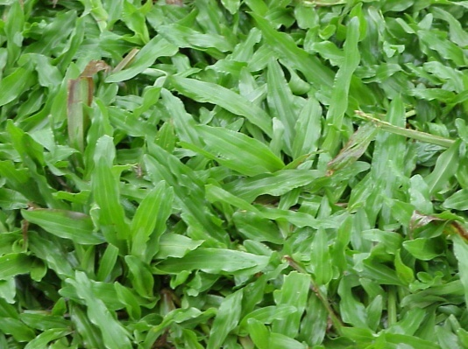
11. Scientific name: Paspalum conjugatum

English Name : Buffalo grass, T-grass, carabao grass

Local Name: Laua-laua
Family: Poaceae / Gramineae
Annual or perennial: perennial
Grass, sedge or broadleaf: grass
12.
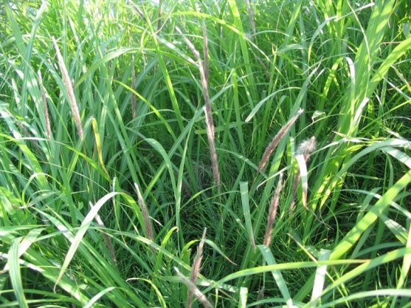
Scientific name: Imperata cylindrica

English Name : cogongrass

Local Name: kugon
Family: Poaceae
Annual or perennial: perennial
Grass, sedge or broadleaf: grass

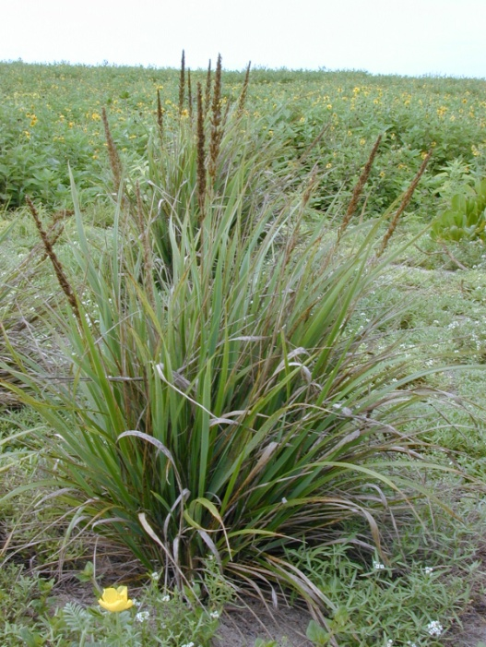
13.
Scientific Name: Chrysopogon aciculatus

English Name : love grass, lesser spear grass

Local Name: Marisekos, Amor-seko
Family: Gramineae
Annual or perennial: perennial
Grass, sedge or broadleaf: grass

14.
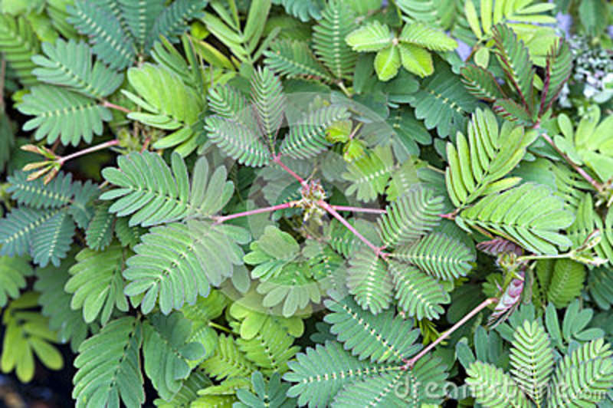
Scientific Name: Mimosa pudica

English Name : sensitive plant, sleeping grass

Local Name: Makahiya, bain-bain
Family: Fabaceae
Annual or perennial: annual/perennial
Grass, sedge or broadleaf:

