ORNAMENTAL PLANTS
- Bougainvillea
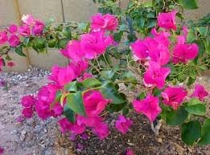
English Name: Bougainvilla
Local Name: Bogambilya
Scientific Name: Bougainvillea spectabilis
Methods of Propagation: Bougainvillea may be propagated by seed, cutting, laying or tissue culture.

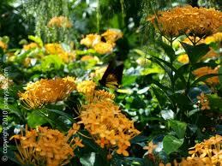
2. Santan
English Name: Ixora, jungle geranium,
flame of the woods, and jungle flame

Local Name: Santan

Scientific name: Ixora coccinea Linn.
Methods of Propagation:
Propagated by cutting in spring, preferably with 3 to 4 nodes, with bottom heat. Can also be propagated by seed when produced.
Growth habit:
I. coccinea is a dense, multi-branched evergreen shrub, commonly 4–6 ft (1.2–2 m) in height, but capable of reaching up to 12 ft (3.6 m) high. It has a rounded form, with a spread that may exceed its height.
3.Chrysanthemum

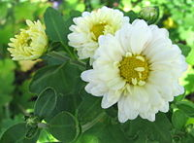
English Name: Chrysanthemum
Scientific Name: Dendranthema x grandiflorum (formerly Chrysanthemum morifolium)

Methods of Propagation: Chrysanthemums can be propagated from seeds, cuttings, or plant division.
Growth Habit: Chrysanthemums are incredibly popular ornamental plants. Native to Eurasia, they have probably been in cultivation for thousands of years. Today there is a great diversity of cultivars, with a wide range of flower colors and forms. Most often grown as annuals in cold climates, they are known for their ability to remain in flower late into the autumn.
4. Carnation
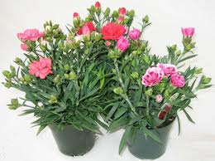
English Name: Carnation, Clove Pink
Scientific Name: Dianthus caryophyllus

Methods of Propagation: may be propagated by seeds or rooted cuttings
Growth Habit: It is an herbaceous perennial plant growing to 80 cm tall. The leaves are glaucous greyish green to blue-green, slender, up to 15 cm long.
5. Sunflower
English Name: Sunflower
Scientific Name: Helianthus annuus
Methods of Propagation: Propagating Sunflower by Seed
Sowing Time: - Indoors March to April. Outdoors from early to mid spring.
Growth Habit: Sunflower is an annual, erect, broadleaf plant with a strong taproot and prolific lateral spread of surface roots.
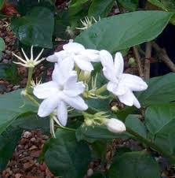
6. Sampaguita
English Name: Arabian jasmine
Local Name: Sampaguita
Scientific Name: Jasminum sambac
Methods of Propagation: It can be propagated also by leaf cuttings.
The plant cuttings are easy to root and they are suitable in any type of soil, provided there is optimum plant growth factors.
Growth Habit: It is a small shrub or vine growing up to 0.5 to 3 m (1.6 to 9.8 ft) in height. It is widely cultivated for its attractive and sweetly fragrant flowers. The flowers are also used for perfumes and for making tea.
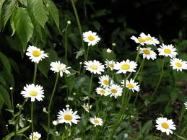
7. Daisy
English name: English Daisy
Local Name: Daisy
Scientific Name: Bellis perennis

Methods of propagation:
Propagation is easy, by sowing seeds in early spring or summer or by division in early spring, before flowering or in autumn, after flowering. You may want to deadhead the plants to prevent self-seeding. Growth Habit: It is a herbaceous plant with short creeping rhizomes and small rounded or spoon-shaped evergreen leaves that are from 3/4 to 2 inches (approx. 2–5 cm) long and grow close to the ground.
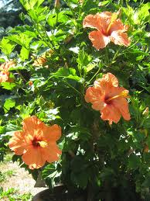
8. Gumamela
English Name: China rose, Hibiscus
Local Name: Gumamela
Scientific Name: Hibiscus rosa-sinensis Linn
Method of Propagation:
Seed - sow early spring in a warm greenhouse. Germination is usually fairly rapid. Cuttings of half-ripe wood, July/August in a frame
Growth Habitat : The genus includes both annual and perennial herbaceous plants, as well as woody shrubs and small trees.
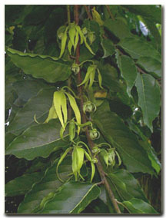
9. Ilang-ilang
English Name: cananga tree, ilang-ilang
Scientific Name: Cananga odorata
Methods of Propagation: Propagation from seed
Growth habit: Cananga odorata is a fast-growing tree of the custard-apple family, Annonaceae, that exceeds 5 m (15 ft) per year and attains an average height of 12 m (40 ft). It grows in full or partial sun, and prefers the acidic soils of its native rainforest habitat.
10. Yellow Bell
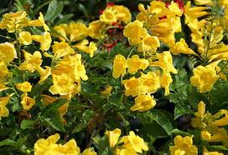
English Name: Yellow Bell, Golden Trumpet or Buttercup Flower
Scientific Name: Allamanda
Methods of Propagation:
The yellowbell is easy to propagate using cuttings. In the late spring or summer, remove a section of a stem that is 4 to 6 inches long. Remove any lower leaves from this stem and plant it in moist soil.
Growth Habitat: A woody, evergreen shrub with vigorous growth, Allamanda may reach a free-standing height of 2 metres or more. The leathery leaves are lancelike, pointed, and may either be opposite or in whorls of three or four.
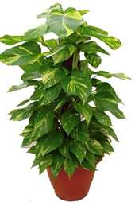
11. Money Plant
English Name: Money plant , Pothos
Scientific Name: Scindapsus aureus
Methods of propagation: Propagate it from stem cuttings, from sections of main stems.
12. Poinsettia
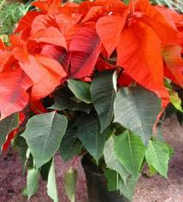
English name: Poinsettia
Scientific name: Euphorbia pulcherrima
Methods of Propagation: Poinsettias are almost always propagated vegetatively by stem cuttings.
Growth Habit: Euphorbia pulcherrima is a shrub or small tree, typically reaching a height of 0.6 to 4 m (2 to 16 ft). The plant bears dark green dentate leaves that measure 7 to 16 cm (3 to 6 inches) in length.
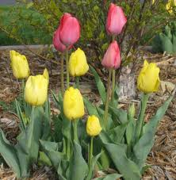
13. Tulip
English Name: Tulip
Scientific name: Euphorbia pulcherrima
Methods of propagation: Tulips can be propagated through bulb offsets, seeds or micropropagation.
Growth Habbit: Euphorbia pulcherrima is a shrub or small tree, typically reaching a height of 0.6 to 4 m (2 to 16 ft). The plant bears dark green dentate leaves that measure 7 to 16 cm (3 to 6 inches) in length.
14. Palmera
English Name: Areca palm, golden feather palm, yellow cane palm, Butterfly palm
Local Name: Palmera
Scientific Name: Chrysalidocarpus lutescens
Methods of Propagation: Propagation is done from seeds. It can also be done from the base suckers.
Growth Habit: The plant procudes clusters of reedlike stems that carry arching fonds on 2 feet long stalks. The fronds of a 5 feet high area palm can be 3-4 feet lond and could be divided into many stiff, glossy, yellowish green segments up to 2 feet long and 1/2 inch wide. Older stems are marked, like bamboo canes, with notches where fronds were attached to them.
Growth is very slow. The spread is however very wide. If it is to be planted in the garden, the distance of planting should be at least 4 feet from each other.
15. Bermuda Grass
English Name: Bahama Grass, Devil's Grass, Couch Grass, Wire Grass, Indian Doab
Local Name: Bermuda Grass
Scientific Name: Cynodon dactylon

Method of Propagation : Bermuda grass reproduces through seeds and through runners and rhizomes.
Growth Habitat: The blades are a grey-green colour and are short, usually 2–15 cm (0.79–5.9 in) long with rough edges. The erect stems can grow 1–30 cm (0.39–12 in) tall. The stems are slightly flattened, often tinged purple in colour.
16. Water Lilies
English Name: Water lily
Scientific name: Nymphaeaceae
Methods of Propagation: Propagating water lilies by dividing them in the spring is explained here with tips on things to avoid.
Growth habitat: Water lilies grow completely within water, with their blossoms flourishing on top of or above the water’s surface. They typically grow to suit the size of the area in which they are placed, spreading their leaves across the surface of the water and filling it with color.

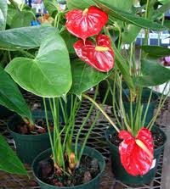
17. Anthurium
English Name: Anthurium, Flamingo Lily
Scientific Name: Anthurium andraeanum
Methods of Propagation:
The easier methods of propagation of Anthuriums are by stem cuttings, layering and division of offsets or suckers that sprout laterally from the base of the plant. It can also be propagated by seeds which are rarely available and commercially, by tissue culture.
Growth habit: Anthurium grows in many forms, mostly evergreen, bushy or climbing epiphytes with roots that can hang from the canopy all the way to the floor of the rain forest. The stems are short to elongate with a length between 15 and 30 cm. The simple leaves come in many shapes; most leaves are to be found at the end of the stems, although terrestrial plants show less of this pachycaul tendency.
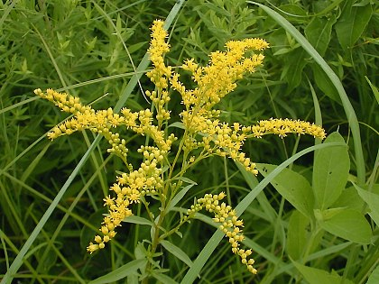
18. Yellow top
English Name: Goldenrod, Early goldenrod, Yellow top
Scientific Name: Solidago juncea
Methods of Propagation: Propagation is by wind-disseminated seeds or by spreading underground rhizomes which can form colonies of vegetative clones of a single plant.

Growth Habit: This native perennial plant is unbranched and up to 3' tall. The central stem is slightly ridged, hairless, and green or reddish. The alternate leaves are up to 8" long and 1½" across, becoming much smaller as they ascend up the stem.
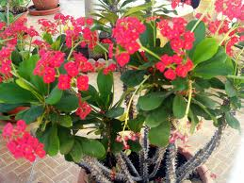
19. Euphorbia
English Name: Crown-of-thorns or Christ Plant
Scientific Name: Euphorbia milii

Methods of Propagation: SEED PROPAGATION:
Since all the hybrids in cultivation, especially ours, are complex crosses, they never come true from seed; indeed, give extremely variable seedlings.
Growth of Habit: It is a succulent climbing shrub growing to 1.8m tall, with densely spiny stems, the straight, slender spines up to 3 cm long, which help it scramble over other plants.
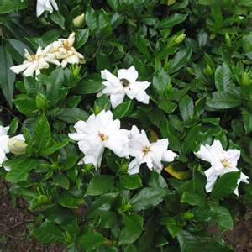
20. Rosal
English Name: Common gardenia, cape jasmine or cape jessamine
Scientific name: Gardenia jasminoides
Methods of Propagation: From softwood cuttings and by simple layering
Growth habitat: Gardenia jasminoides is a shrub with greyish bark and dark green shiny leaves with prominent veins. The white flowers bloom in spring and summer and are highly fragrant. They are followed by small oval fruit
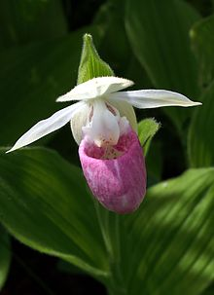
21. Showy Lady's-slipper
English Name: Pink-and-white Lady's-slipper or the Queen's Lady's-slipper
Scientific Name: Cypripedium reginae
Growth habitat: Cypripedium reginae grows in calcareous wet lands, open wooded swamps, with tamarack and black spruce. Contrary to many garden tips, C. reginae thrives in neutral to basic soils and prefers growing in fens. Despite growing in mildly acidic environments, its roots can penetrate the mossy layers down to more neutral water sources. It forms clumps by branching of the underground rhizomes. It forms aerial roots in the swampy bog conditions. It is eaten by white-tailed deer.
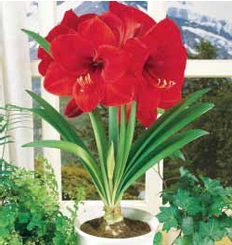
22. Amaryllis
English name:
Scientific Name: Hippeastrum
Method of Propagation:
Amaryllis Bulbs Propagation Through Seeds
Growth habit: The amaryllis is a large, tender flowering bulb native to the Andes Mountains of Chile and Peru. It is generally planted in the fall for winter bloom and can be particularly refreshing during the holidays. The large flowers and ease with which they can be brought into bloom make amaryllis popular worldwide. Bulbs can be brought into bloom from late fall until early spring, blooming about 6-8 weeks after planting.
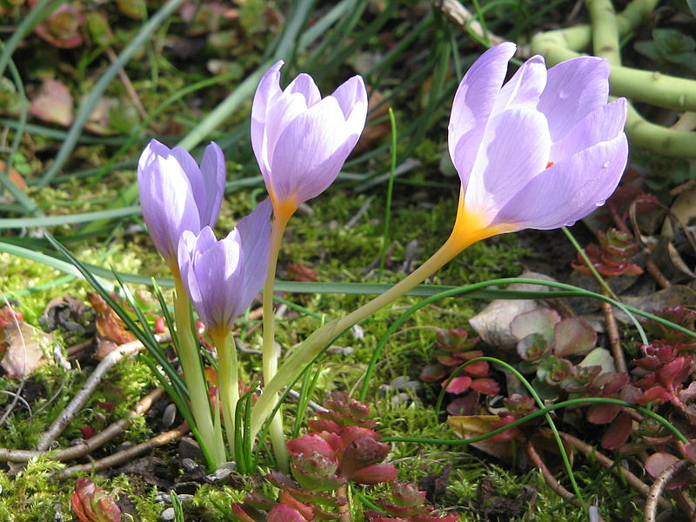
23. Autumn Crocus
English Name: Autumn Crocus, Meadow Saffron or naked lady
Scientific Name: Colchicum autumnale
Methods of propagation:
Autumn Crocuses can be increased during the dormant period in early summer. Their corms can be divided or the cormlets can be detached and replanted. However, divide the plants only when they become overcrowded. Seeds may also be sown in sandy loam and leaf mold. Cover the seeds with a half an inch of soil.
Growth Habitat:
Autumn crocus has a preference for a fertile soil that is well-drained and located in a sunlit position. This herb has the aptitude to endure shade, but is loathe to arid soil.

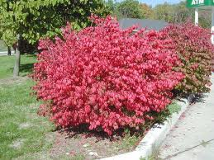
24. Burning bush
English name: Winged Spindle, Winged Euonymus or Burning Bush
Scientific Name: Euonymus alatus
Method of Propagation:

Propagation by Cuttings
Cutting type: stem tip
Time of year to take cuttings: Summer
Cutting maturity: semi-hardwood, hardwood
Rooting hormone: IBA Quick Dip 2000 PPM
Rooting environment: intermittent mist
Soil temperature for best rooting: 75-80 degrees F
Time to rooting: 4-8 weeks
Comment: Also propagated from hardwood cutting during Winter.
Growth Habitat: The shrub grows to 2.5 m tall (8.2 feet), often wider than tall. The stems are notable for their four corky ridges or "wings." The word alatus (or alata, used formerly) is Latin for winged, in reference to the winged branches.
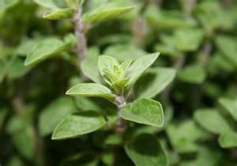
25. Oregano
English Name: Oregano
Scientific Name: Origanum vulgare

Methods of Propagation: The method of propagation is where a plant is rooted from a cutting.
Growth Habit: Oregano is a perennial herb, growing from 20–80 cm tall, with opposite leaves 1–4 cm long. Oregano will grow in a pH range between 6.0 (mildly acid) and 9.0 (strongly alkaline) with a preferred range between 6.0 and 8.0. The flowers are purple, 3–4 mm long, produced in erect spikes.

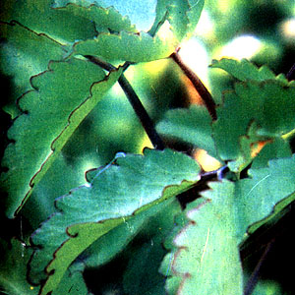
26. Kataka-taka
English Name: Air Plant, Life Plant, Miracle Leaf, Goethe Plant
Local Name: Kataka-taka
Scientific name: Kalanchoe pinnata
Methods of Propagation: Easily propagated and widely distributed in the Philippines, found in thickets and open places. Also cultivated, flowering from December to March. Probably of prehistoric introduction.
Growth Habit: Kataka-taka is an erect, more or less branched, smooth, succulent herb, 0.4 to 1.4 meters in height. Leaves are simple or pinnately compound, with the leaflets elliptic, usually about 10 centimeters long, thick, succulent, and scalloped margins.
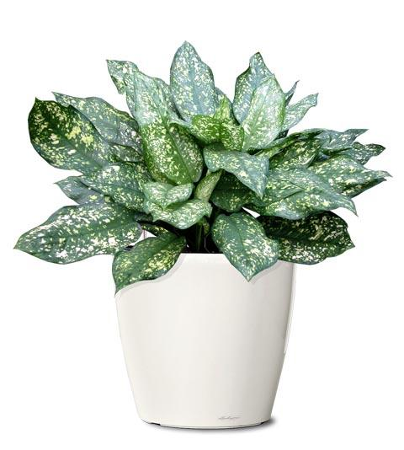
27. Gold Dust Evergreen
English Name: Gold Dust Evergreen
Scientific Name: Aucuba japonica
Method of Propagation: Aucuba japonica is very easily propagated from cuttings and from seed when available. Cuttings taken in the spring and treated with a rooting hormone should root in about 3 weeks. Cuttings placed in water will root in 2-3 weeks.
Growth Habit: is an attractive broadleaf evergreen shrub native to eastern Asia and Japan. They are slow to moderate growers and will reach a height of 4-12 feet (1.2-3.7 m) with a spread of 4-6 feet (1.2-1.8 m). Leaves are opposite, elliptical to elliptical-lanceolate 3-7 inches (8-18 cm) long and 1-3 inches (2.5-7.6 cm) wide.
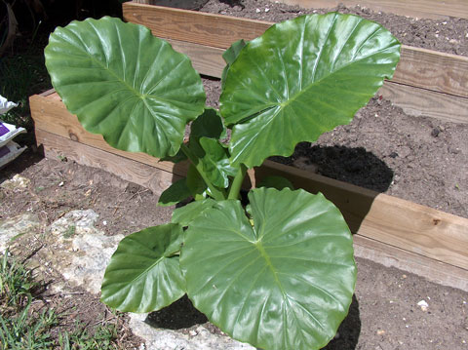
28. Elephant's ear plant
English Name: Elephant's ear plant
Scientific Name: Alocasia 'Calidora'
Method of Propagation: Division. Divide rhizomes in spring and pot in separate containers. Keep the top surface of the rhizome above the soil line so that the growing stems don't rot at soil level.
29. Monkey Puzzle tree
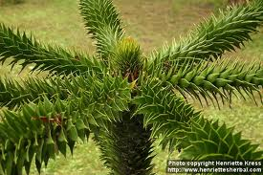
English Name: Monkey Puzzle Tree or monkey tail tree
Scientific Name: Araucaria araucana
Growth Habitat: Its native habitat is the lower slopes of the Chilean and Argentinian south-central Andes, typically above 1,000 metres (3,300 ft). Juvenile trees exhibit a broadly pyramidal or conical habit which naturally develops into the distinctive umbrella form of mature specimens as the tree ages.^{[3]} It prefers well drained, slightly acidic, volcanic soil but will tolerate almost any soil type provided it drains well.
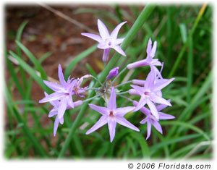
30. Society Garlic
English Name: Society Garlic
Scientific Name: Tulbaghia violacea
Propagation: Propagate society garlic by dividing off pieces of rhizome while the plant is dormant.

Growth Habitat: Society garlic is a clump-forming herbaceous perennial with narrow, grayish green leaves and large clusters of lavender or lilac flowers. The plant looks like an especially showy garlic or garlic chives plant. Society garlic has just 4-9 grasslike leaves, each about a foot long and a half-inch wide.
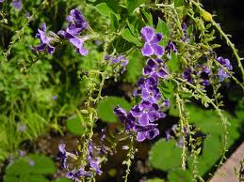
31. Golden Dewdrop
English Name: Golden Dewdrop , Pigeon Berry, and Skyflower
Scientific Name: Duranta erecta
Growth Habitat: Duranta erecta is a sprawling shrub or (infrequently) a small tree. It can grow to 6 m (20 ft) tall and can spread to an equal width. Mature specimens possess axillary thorns, which are often absent on younger specimens. The leaves are light green, elliptic to ovate, opposite, and grow up to 7.5 cm (3.0 in) long and 3.5 cm (1.4 in) broad, with a 1.5 cm petiole.
Propagation: Propagate from seeds or from semi-hard stem cuttings.
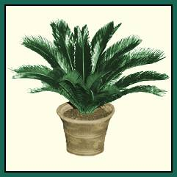
32. Sago Palm
English Name: Sago Palm or King Sago Palm
Scientific Name: Cycas revoluta
Method of Propagation: Very easily propagated from seed, as well as from offshoots or "pups"

33. Night Blooming Jasmine
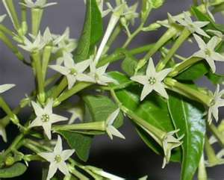
English Name: night-blooming cestrum, Hasna Hena, lady of the night, queen of the night, night-blooming jessamine and night-blooming jasmine
Scientific Name Cestrum nocturnum
Method of Propagation: From herbaceous stem cuttings
From seed; stratify if sowing indoors
By air layering
Growth Habit: It is an evergreen woody shrub growing to 4 metres (13 ft) tall. The leaves are simple, narrow lanceolate, 6–20 cm (2–8 in) long and 2–4.5 cm broad, smooth and glossy, with an entire margin.
34. Zinnia
English Name: Zinnia
Scientific Name: Zinnia peruviana
Propagation: It’s easy to save seed from spent blooms after the petals have faded and the remaining flower heads have dried out.

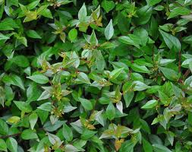
35. Glossy Abelia
English Name: Glossy Abelia
Scientific Name: Abelia × grandiflora
Method of Propagation: Root tip cuttings in early spring or late summer.
Growth Habit: This is a rounded, semi-evergreen shrub to 10 feet tall and 12 feet wide with glossy, dark green leaves.
36. Butterfly Bush
English Name: Butterfly Bush
Scientific Name: Buddleia davidii
Propagation: This attractive shrub can be easily propagated by seeds, cuttings, and division.
Growth Habit: Are large, shrublike herbaceous perennials for the landscape
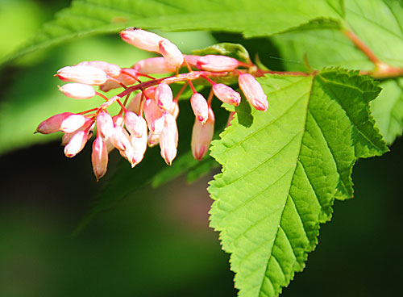
37. Chinese Neillia
English Name: Chinese Neillia
Scientific Name: Neillia sinensis
Propagation: Chinese neillia is easy to propagate from divisions or stem cuttings, and grows rapidly and adapts quickly to new growing locations
Growth Habit: Shrub
38. Downy Rose Myrtle
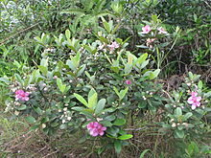
English Name: Downy Rose Myrtle
Scientific Name: Rhodomyrtus tomentosa
Propagation: In cultivation the shrub is normally propagated through cuttings.
Growth Habit: Rhodomyrtus tomentosa is an evergreen shrub growing up to 4 m-12 feet tall.
39. Double File viburnum
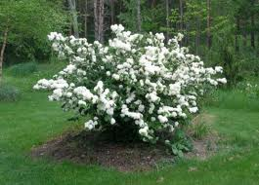
English Name:Double File Viburnum
Scientific Name: Viburnum plicatum var. tomentosum
Propagation: From softwood cuttings
From semi-hardwood cuttings
From seed; direct sow outdoors in fall
From seed; winter sow in vented containers, coldframe or unheated greenhouse
From seed; stratify if sowing indoors
Growth Habit: Shrubs
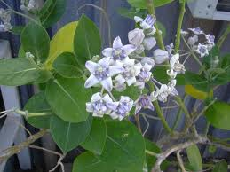
40. Crown Flower
English Name: Crown Flower
Scientific Name: Calotropis gigantean
Propagation: can be propagated by cuttings
Growth Habit: It is a large shrub growing to 4 m tall. It has clusters of waxy flowers that are either white or lavender in colour.
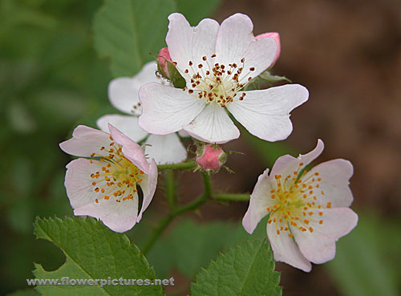
41. Prairie rose
English Name: Prairie Rose, Climbing Rose
Scientific Name: Rosa setigera
Propagation: By Cutting, By Seed and Grafting
Growth Habit: deciduous vine

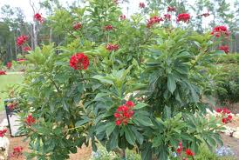
42. Peregrina
English Name:Peregrina, spicy jatropha
Scientific Name: Jatropha integerrima
Propagation: Seeds or cuttings in spring
Growth Habit: Peregrina is an evergreen shrub or small tree with glossy leaves and clusters of star shaped bright scarlet or vermilion flowers. Small trees to 20 feet, generally up to 7 feet high (2.1 m) in Phoenix
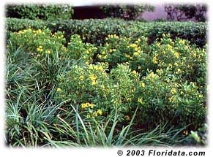
43. Thryallis
English Name: Thryallis, Golden thryallis, Shower of Gold
Scientific Name: Galphimia glauca
Propagation: By seeds. Also by cuttings taken in the summertime.
Growth Habit: Thryallis is a small evergreen tropical shrub that grows to a maximum height of about 6 ft (0.6 m) and about as wide.

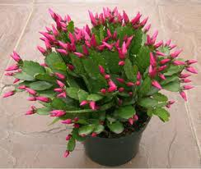
44. Spring Cactus
English Name: Spring Cactus, Easter Cactus
Scientific Name: Rhipsalidopsis gaertneri
Propagation: Mature pads, or phylloclades, are harvested from stock plants or from plants that have been pinched (leveled or twisted). These cuttings can be propagated immediately after removal from the stock plant, or they may be stored for several months at 52-57° F.
45. Madagascar palm
English Name: Madagascar PALM
Scientific Name: Pachypodium lamerei
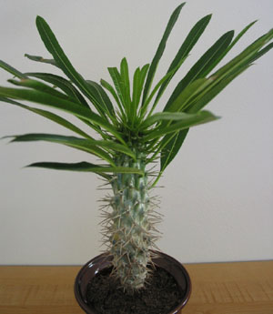
Method of Propagation:
From herbaceous stem cuttings
Allow cut surface to callous over before planting
From seed; sow indoors before last frost
Growth Habit: Pachypodium lamerei has a tall, silvery-gray trunk covered with sharp 6.25 cm spines. Long, narrow leaves grow only at the top of the trunk, like a palm tree. It rarely branches. Plants grown outdoors will reach up to 6 metres. When grown indoors it will slowly reach 1.2-1.8 m tall.

46. Painted Petals
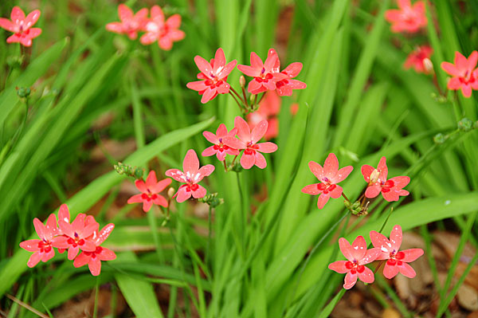
English Name: Painted Petals, Anometheca, False Freesia
Scientific Name: Freesia laxa, Anomatheca laxa
Propagation: By dividing rhizomes, tubers, corms or bulbs (including offsets)
From seed; sow indoors before last frost

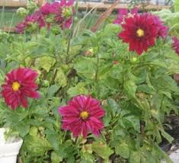
47. Dahlia
English Name: Dahlia
Scientific Name: Dahlia x hybrid
Growth habit: Dahlia is a genus of bushy, tuberous, herbaceous perennial plants.
Propagation: Propagation by Cuttings
Propagation by Tuber Clump Division
Propagation by Seed

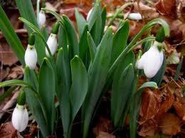
48. Spring Snowflake
English Name: Spring Snowflake, Summer Snowflake or Loddon Lily
Scientific Name: Leucojum aestivum
Propagation: By dividing rhizomes, tubers, corms or bulbs (including offsets)
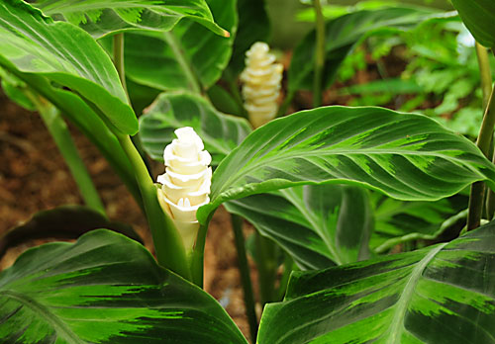
49. Calathea
English Name: Calathea, Zebra plant
Scientific Name: Calathea warscewiczii
Propagation: By dividing rhizomes, tubers, corms or bulbs (including offsets)
Growth Propagation: This herbaceous plant is native to Costa Rica and Nicaragua and produces lanceoate leaves that have a dark green background and an attractive fishtail pattern on the upperside of the leaves.

50. Spanish bluebell
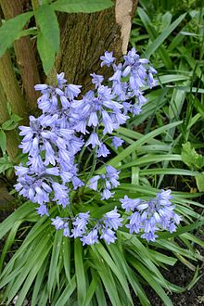
English Name: Spanish Blue Bell. Wood Hyacinth
Scientific Name: Hyacinthoides hispanica
Growth Habit: Easily grown in average, medium, well-drained soil in full sun to part shade. Plant bulbs about 3-4” deep and 4-6” apart in the fall. Naturalizes well by both bulb offsets and self-seeding in optimum growing conditions. Plants go dormant by early summer.
Propagation: By dividing rhizomes, tubers, corms or bulbs (including offsets)

