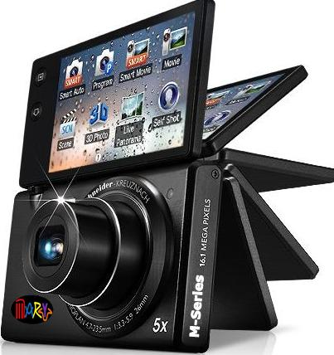
PRODUCT: M-Series Digital Camera with Netsurfing
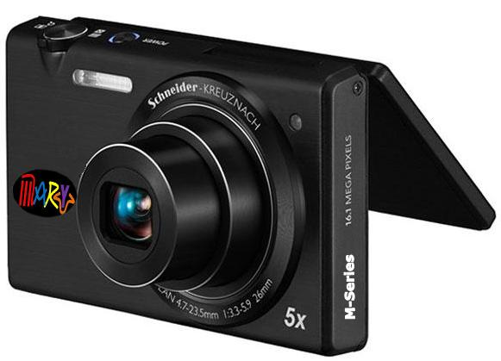

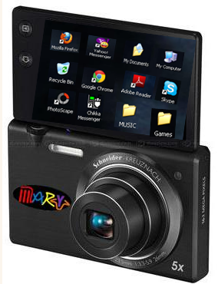
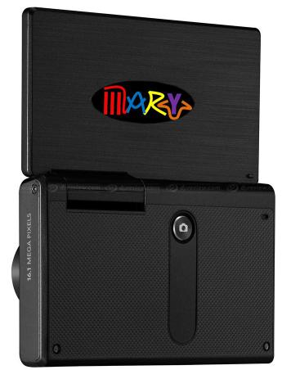

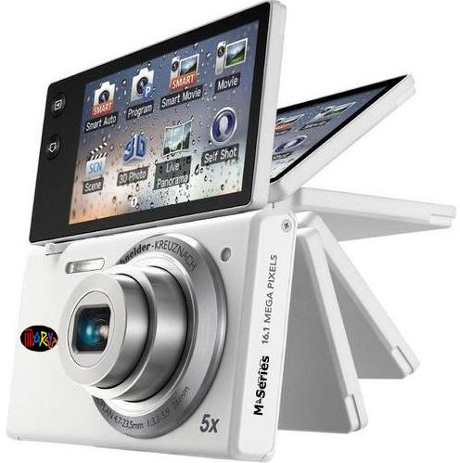
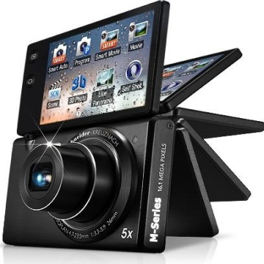
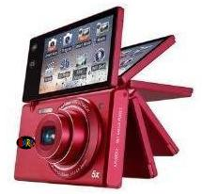
Available in Different Colors:

Hibiscus Pink Glossy White Gunmetal Black

“Try the latest digital camera of your own desire. Even the most difficult angles – you can easily flip into its screen to 30°, 90°, 120°and even 180° angles. This is the camera you almost want it – the M-Series Digital Camera with Netsurfing. Live life and take clear photos all the time.”

Features:
- Shoot Every View From Any Angle
- Groundbreaking Adjustable LCD Screen
- Crisp, Colorful Images and Video
- Sleek and Stylish
- Can connect to internet
- Play music (any format)
- Self-timer photo shooting
- Can upload photos directly to internet
- Speaker
System Requirements: PC with processor better than PentiumⅣ 3.2 GHz / AMD Athlon FX 2.6 GHz or higher Minimum 512MB RAM(1GB recommended) , Windows XP SP2/ Vista/ 7,250MB of available hard-disk space (Over 1GB recommend) ,USB port,CD-ROM drive nVIDIA Geforce 7600GT or later / Ati X1600 series or later 1024×768 pixels, 16-bit color display compatible monitor (1280x1024, 32-bit color display recommended) Microsoft DirectX 9.0c or later
Image sizes • 16M: 4608 x 3456
• 14MP: 4608 x 3072
• 12M: 4608 x 2592
• 10M: 3648 x 2736
• 5M: 2592 x 1944
• 2M 1920 x 1080
• 1M 1024 x 768
Movie MPEG-4 (H.264) • 1280 x 720 (30fps / 15fps)
• 640 x 480 (30fps / 15fps)
• 320 x 240 (30fps / 15fps)
Scene modes • Magic Frame
• Beauty-Shot
• Object Highlight
• Night
• Landscape
• Text
• Sunset
• Dawn
• Backlight
• Beach & Snow
• Pose Guide
• Funny Face
• Intelligent portrait
LCD monitor • 3.0" touch-sensitive WQVGA
• Articulated screen with 180 degrees of rotation
Self-timer • 10 or 2 seconds
• Double 10 then 2 seconds
Storage • Micro SD (16GB max) / SDHC (64 GB Max)
Power • BP70 Lithium-Ion rechargeable battery (supplied)
• 700mAh
• USB Charging
• Included Charger

