LEGUMES
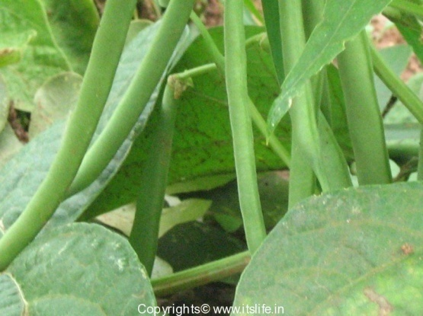
1. String bean (Phaseolus vulgaris)
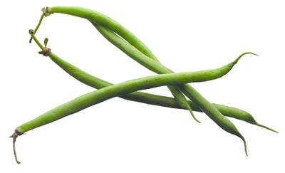

String beans are the unripe fruit of specific cultivated varieties of the common bean. Green bean varieties have been bred especially for the fleshiness, flavor, or sweetness of their pods. Haricots verts, French for "green beans", may refer to a longer, thinner type of green bean than the typical American green bean. Green beans are found in two major groups, bush beans and pole beans.
Bush beans are short plants, growing to approximately two feet in height, without requiring supports. They generally reach maturity and produce all of their fruit in a relatively short period of time, then cease to produce. Gardeners may grow more than one crop of bush beans in a season.
Pole beans have a climbing habit and produce a twisting vine . Runner beans have a similar habit but are a different species of bean.
Nutritional Value:
- Fresh green beans are very low in calories (31 kcal per 100 g of raw beans) and contain no saturated fat. Nevertheless, the lean vegetables are a very good source of vitamins, minerals, and plant derived micronutrients.
- They are very rich source of dietary fiber (9% per100g RDA) which acts as a bulk laxative that helps to protect the mucous membrane of the colon by decreasing its exposure time to toxic substances as well as by binding to cancer-causing chemicals in the colon. Adequate amount of fiber has also been shown to reduce blood cholesterol levels by decreasing reabsorption of cholesterol-binding bile acids in the colon.
- Green beans contain excellent levels of vitamin A, and health promoting flavonoid poly phenolic antioxidants such as lutein, zea-xanthin and ß-carotene in good amounts. These compounds help act as protective scavengers against oxygen-derived free radicals and reactive oxygen species (ROS) that play a role in aging and various disease processes.

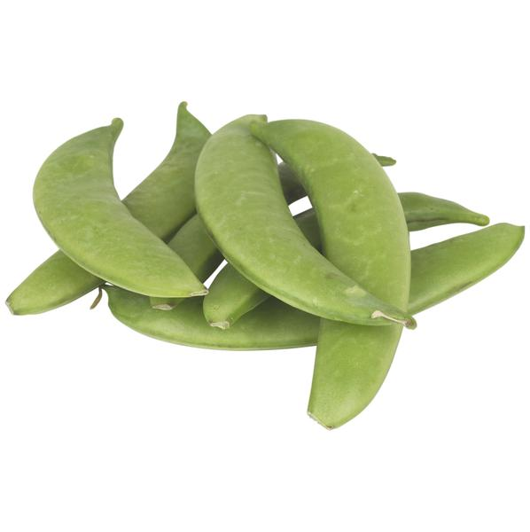
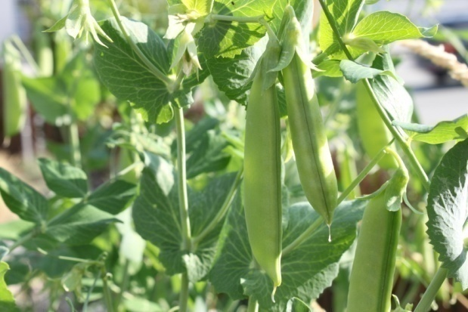
2. Sugar snap pea (Pisum sativum)

They are a cultivar group of edible-podded peas that differ from snow peas in that their pods are round as opposed to flat. The name mangetout (French for "eat all") can apply both to snap peas and snow peas.
Snap peas, like all other peas, are pod fruits. An edible-podded pea is similar to a garden, or English, pea, but the pod is less fibrous, and edible when young. Pods of the edible-podded pea, including snap peas, do not have a membrane and do not open when ripe. At maturity, the pods grow to around 4-8 cm in length, Pods contain three to five peas per pod.
The plants are climbing, and pea sticks or a trellis or other support system is required for optimal growth. Some cultivars are capable of climbing to 2 m high but are more commonly around 1-1.3 m for ease of harvest.
Nutritional Value:
Snap peas feature comparatively lesser calories than green-shelling peas. 100 g pods provide just 42 calories against 81 calories of green peas. However, the snap pods are indeed containing more vitamins, minerals and other plant nutrients than the traditional shelling peas.
Fresh pods have 150% more amounts of vitamin C than in garden peas. 100 g provide 60 mg or 100% of daily-required levels of vitamin C. Vitamin C is a powerful natural water-soluble anti-oxidant. Vegetables rich in this vitamin help the body develop resistance against infectious agents and scavenge harmful, pro-inflammatory free radicals from the body.
Fresh sugar pea pods are an excellent source of folic acid. 100 g provides 42 µg or 10% of recommended daily levels of folates. Folates are one of the B-complex groups of vitamins, required in cellular DNA synthesis. Research studies suggest that adequate folate rich foods in expectant mothers would help prevent neural tube defects in the newborn babies.
Like in garden peas, sugar snap pods are also rich in phytosterols, especially ß-sitosterol. Studies suggest that vegetables like legumes, fruits, and cereals rich in plant sterols help lower cholesterol levels in the body.
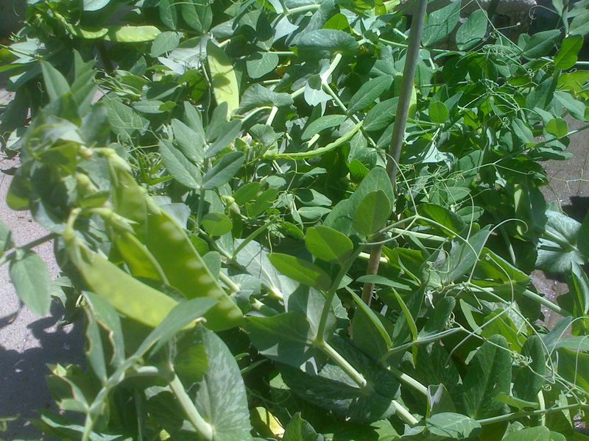
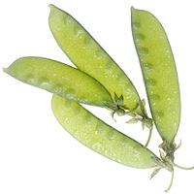
3. Snow pea (Pisum sativum)

The snow pea (Pisum sativum var. saccharatum) is a legume, more specifically a variety of pea eaten whole in its pod while still unripe. The name mangetout (French for “eat all”) can apply both to snow peas and to snap peas.
Snow peas can be grown in open fields during cool seasons and can thus be cultivated during winter and spring seasons.
Storage of the pea with films of polymethylpentene at a temperature of 5°C and a concentration of oxygen and carbon dioxide of 5 kPa increases the shelf life, internal and external characteristics of the plant.
Nutritional value
One-half cup of fresh peas contains 62 calories, 4 grams of protein, 11 grams of carbohydrates, and 4 grams of fiber. While canned peas list no fat content on the USDA Nutrient Database, fresh peas contain 0.2 grams of fat.
The vitamin A count is 534 I.U. with slightly higher figures of B vitamins than the canned peas. Folic acid measures 46.9 mcg; calcium offers 19.2 mg; iron content is 1.3 mg; zinc measures 0.8 mg; potassium content is 134 mg; and magnesium is 23.2 mg.
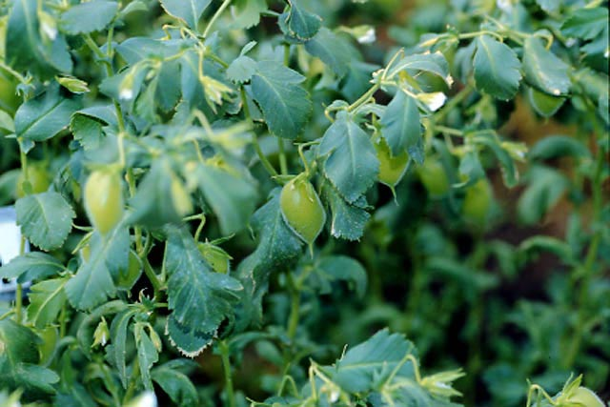
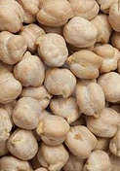
4. Garbanzo beans or chick peas (Cicer arietinum)

The chickpea (Cicer arietinum) is a legume of the family Fabaceae, subfamily Faboideae. Its seeds are high in protein. The plant grows to between 20–50 cm (8–20 inches) high and has small feathery leaves on either side of the stem. Chickpeas are a type of pulse, with one seedpod containing two or three peas. It has white flowers with blue, violet or pink veins. Chickpeas need a subtropical or tropical climate with more than 400 millimetres (16 in) of annual rain.[citation needed] They can be grown in a temperate climate but yields will be much lower
Nutritional value:
Garbanzobeans are high in potassium and calcium, therefore it is beneficial for the bones muscles, heart, teeth and moisture content in the body. It is good if your system is deficient in iodine. Selenium contained in the beans helps to prevent tumors, including cancer. Garbanzobeans are beneficial for people who suffer from nervous and physical exhaustion, anaemia, diabetes, excessive cholesterol, stones of all kinds, blocking the live, spleen diseases.
5. Mung beans (Vigna radiata)
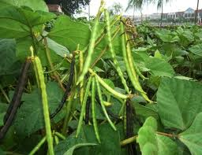
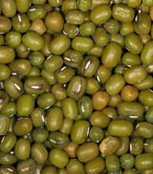

The mung or moong bean is the seed of Vigna radiata, native to the Indian subcontinent, and mainly cultivated in India, China, Thailand, Philippines, Indonesia, Burma, Bangladesh, Laos and Cambodia, but also in hot and dry regions of Southern Europe and the Southern United States. It is used as an ingredient in both savory and sweet dishes. They are small, ovoid in shape, and green in color. The mung bean is one of many species recently moved from the genus Phaseolus to Vigna, and is still often seen incorrectly cited as Phaseolus aureus or Phaseolus radiatus.
Nutritional Value:
Mung beans are a rich source of vitamin A, B, C, E, and K. Vitamin A plays a crucial role in maintaining a healthy vision, and also aids in bone development. It also helps strengthen the immune system. Thiamine or vitamin B1 ensures the proper functioning of the nervous system, and is also involved in the breakdown of carbohydrates to release energy. Riboflavin and Niacin (vitamins B2 and B3 respectively) are important regulators of metabolic processes and various cellular functions. Folate or folic acid helps in the formation and maturation of red blood cells, and also assists in protein metabolism. Vitamin C is involved in the formation of collagen, an important component of connective tissues. Moreover, vitamins A, C, and E act as antioxidants and protect cells or cellular components from free radicals. Vitamin K plays a major role in the formation of proteins required for blood clotting.
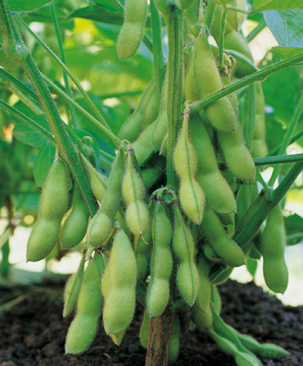
6. Soybeans (Glycine max)

Glycine max, the soybean (also soya- or soja bean, formerly classified as Glycine soja), is an annual herbaceous plant in the Fabaceae (legume or bean family). The soybean plant, which is densely hairy on leaves and stem, can grow to nearly 2 m (6 ft) tall, although commercial varieties are more typically 0.3 to 0.9 m (1 to nearly 3 ft). Leaves are compound, with 3 leaflets. The inconspicuous, stalkless white to purple flowers are borne singly or in small clusters in the axils (where leaf meets stem). The fruit is a broad, hairy, flattened legume or pod, around 10 cm (3 in) long, yellow to brown when fully mature and dried. Pods typically contain up to 4 beans, which vary in size and color depending on cultivar (colors range from white to reddish to black).
Nutritional Value:
Soybeans are very rich in nutritive components. Besides the very high protein content, soybeans contains a lot of fibre and are rich in calcium, magnesium . The soy protein has a high biological value and contains all the essential amino acids.
Soybeans are rich in unsaturated fatty acids and low in saturated fatty acids, which need to be avoided.
7. Sword bean (Canavalia gladiata)
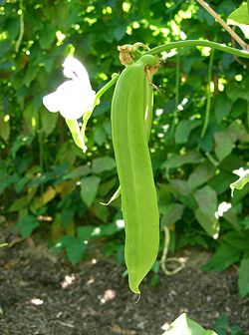
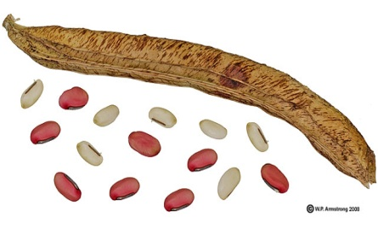

Sword bean, also called "Nata Mame" in Japan. It is native to tropical Asia. The unripe pods are bolied and served as a green vegetable like string beans. The seeds are also boiled and eaten. According to Steve Facciola (Cornucopia II, 1998): In Japan, the young pods are sliced and pickled in soy sauce with radishes, egg plants and lotus. The seeds are boiled and mashed with sugar. Another closely related species with large pods called jack bean (C. ensiformis) is native to tropical America.
Nutritional Value
Sword bean mainly contains amines, such as canavalmine, £^-guanidinooxypropylamine, spermine, and so on; it also contains thiamin and hemogglutinin. There are also protein, fat, sugar, starch, urease, hemagglutination enzyme, calcium, phosphorus, iron, carotene, vitamin C, etc.
Both the foliage and the seeds contain growth-inhibiting protein substances, canavalin and concanavalin A (Con A) and the amino acid, canavanine. Con A has antibody-like properties and it has been reported to provide a beneficial effect to plants possessing it, providing possible protection to the plants from disease microorganisms. However, Con A binds to mucosal cells lining the human digestive tract reducing the ability of the intestine to absorb nutrients. The concentration of these growth-inhibiting substances increases as the plant tissues age and mature. It is for this reason that human consumption is best limited to only the younger foliage and pods of these beans.
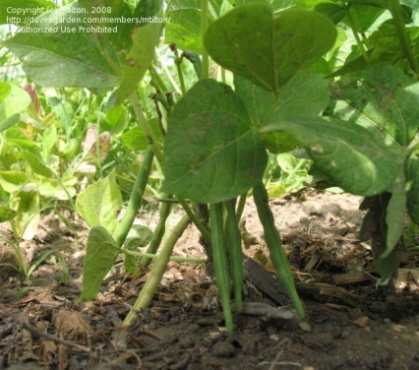
8. Adzuki beans
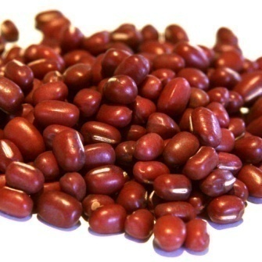

The azuki bean, also known as adzuki or aduki, is an annual vine, Vigna angularis, widely grown throughout East Asia and the Himalayas for its small (approximately 5 mm) bean. The cultivars most familiar in Northeast Asia have a uniform red color. However, white, black, gray and variously mottled varieties are also known. Scientists presume Vigna angularis var. nipponensis is the progenitor.
Nutritional Value:
Adzuki beans are a nutrient-dense food, providing a hefty amount of nutrients compared to their caloric content. They are a good food source of folate, potassium, phosphorus, magnesium, iron, manganese and zinc. Consuming adzuki beans may offer cardiovascular benefits. Adzuki beans, like most starchy beans, are rich in a type of fiber known as soluble fiber. Soluble fiber helps lower blood cholesterol levels. In addition, adzuki beans are rich in folate, magnesium and potassium, which play a role in supporting heart health. Folate helps reduce homocysteine levels in the bloodstream. Elevated levels of this amino acid in the bloodstream may damage the lining of your arteries and increase the risk of blockages in blood vessels. Magnesium and potassium help lower blood pressure, aid in muscle relaxation and improve blood flow.
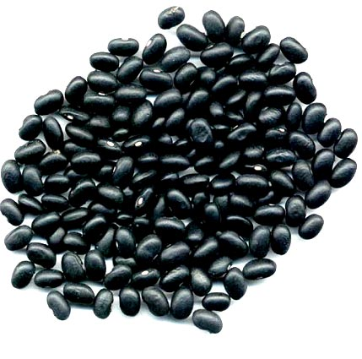
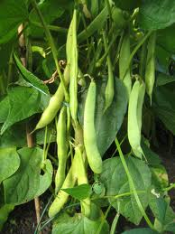
9. Black beans / turtle beans

Black turtle bean is a small, shiny variety of common beans (Phaseolus vulgaris), especially popular in Latin American cuisine, though it can also be found in Cajun and Creole cuisines of south Louisiana. They are often called simply black beans (frijol negro, zaragoza, poroto negro, caraota o habichuela negra in Spanish, and feijão preto in Portuguese), although this can cause confusion with other black beans.
Nutritional Value:
From a single, one-cup serving of black beans you get nearly 15 grams of fiber (well over half of the Daily Value and the same amount consumed by the average U.S. adult in one entire day of eating) and 15 grams of protein (nearly one third of the Daily Value and equivalent to the amount in 2 ounces of a meat like chicken or a fish like salmon).
10. Haricot bean/ Navy bean
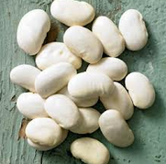
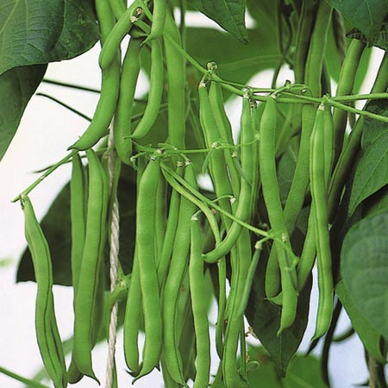

Navy bean or haricot bean is a variety of common beans (Phaseolus vulgaris). Haricot beans are small, oval, plump and creamy-white with a mild flavour and smooth, buttery texture. In the US, they are known as navy beans and are the classic ingredient in Boston baked beans. Haricot beans are widely used in the cooking of countries such as France, Spain, Portugal and South America. With little flavour of their own, they absorb other aromas and flavours easily, which makes them popular beans to use in bean salads, vegetable soups, slow-cooked dishes such as cassoulet or bean purées.
Nutritional value:
The beans are rich in protein, folic acid, iron, B complex, and magnesium,so they are an excellent addition to a healthy diet.
· Combined with whole grains such as rice, navy beans provide virtually fat-free high quality protein
· Dried haricot beans, a small but nutritionally mighty member of the legume family, are a very good source of cholesterol-lowering fiber. Not only can they help lower cholesterol, they are also of special benefit in managing blood-sugar disorders since their high fiber content prevents blood sugar levels from rising rapidly after a meal.
· Dried beans also provide good to excellent amounts of four important minerals, two B-vitamins, and protein--all with virtually no fat.
· Haricot beans, like other legumes, are rich in soluble fiber
· They are a good source of potassium, which may decrease the growth and development of blood vessel plaques and is also good for lowering high blood pressure.

GRASS
Guinea grass
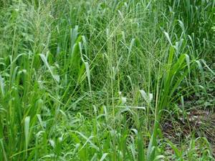

Guinea grass (Megathyrsus maximus (Jacq.) B. K. Simon & S. W. L. Jacobs) is a large tufted, fast-growing perennial grass. It has a broad morphological and agronomic variability, ranging in height from 0.5 to 3.5 m, with stems of 5 mm to 10 mm diameter. There are two main types: a tall/medium tussock type, taller than 1.5 at flowering, and a short tussock type (Cook et al., 2005). The root is a short creeping rhizome; culms are erect, hirsute at the nodes. Leaves are blade-shaped, glabrous to pubescent up to 35 mm broad. Inflorescence is a panicle, 15 to 50 cm long. Spikelets are 3-4 mm green to purple (Ecoport, 2009).
Guinea grass is one of the major pantropical grasses and is suitable for pasture, cut-and-carry, silage and hay. Many Guinea grass cultivars have been developed for different purposes and agronomic situations (FAO, 2009).
Nutritional value:
Steers can graze Guinea grass (Difante et al., 2009). As grass rest-period affects animal performances, a good rest-period is 2.5 leaves/tiller (Candido et al., 2005) and the best organic and dry matter digestibilities are obtained with young regrowth (Peiris et al., 1995). Intercropping or supplementing Guinea grass with legumes is a good strategy: it increases Ca, P, Na and Fe solubility (Ajayi et al., 2009) as well as DM intake (Akinlade et al., 2005) and does not alter meat quality (Jaturasitha et al., 2009). Guinea grass cv. Monbaca gives higher daily weight gain while cv. Masai allows higher stocking rate (Euclides et al., 2008).
Cows grazing Guinea grass can yield 10 to 12 kg milk/day at 2.5 head/ha with good sward persistence and high forage quality (Lima et al., 2006; Lamela et al., 1995). Dairy heifers register 1 kg daily weight gain (DWG) on cv. Tobiata at 2.3 head/ha (Costa et al., 2001). Supplementing cows or dairy heifers fed on Guinea grass always enhances animal performances. Feed concentrate or feed concentrate + legume give greater milk yields in cows (Goncalves et al., 2005; Razz et al., 2007; Goncalves et al., 2003), higher weight gain (+35 %) in heifers (Rodrigues Filho et al., 2004).
Adding 60 % autoclaved broiler litter to Guinea grass based diet in Zebu heifers increases digestible nutrients intake and heifers body weight gain.

Sheep
Guinea grass can be grazed, dried to make hay or ensiled. When sheep are fed on Guinea grass hay-based diet, urea treatment or supplementation with poultry manure can help to improve feed conversion ratio and growth performances. Exogenous fibrolytic enzyme had no effect on ruminal digestibility of Guinea grass hay.
When Guinea grass is grazed, its nutritive value often depends on cultivar. Cv. Aruana contains more crude protein than cv. Tanzania but none of them meet ewe lambs nutritional requirements. The same deficiency is reported with cv. Gatton during winter (Relling et al., 2001and with a Fiji-native Guinea grass. It is suggested to supplement Guinea grass with a concentrate or with a legume. Ensiled Guinea grass has a good texture and it is possible to mix grass of different ages with no effect on silage quality. Iodinated casein was found to increase rumen potential degradability of Guinea grass.
Calopo
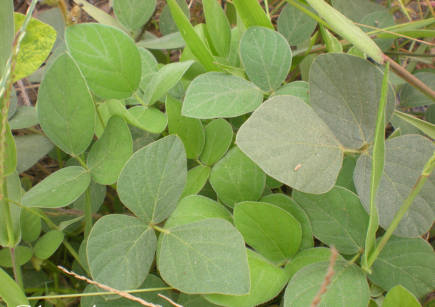

Calopo (Calopogonium mucunoides Desv.) is a vigorous, hairy annual or short–lived perennial trailing legume. It can reach several metres and form a dense, tangled mass of foliage, 30-50 cm deep. The root system is dense and shallow, at most 50 cm deep. The stems are succulent, covered with long, brown hairs. They are creeping in the lower parts, sometimes rooting at the nodes that come in contact with the soil. The upper part of the stem is twining. The leaves are up to 16 cm long, trifoliate. The hairy leaflets are 4-10 cm long x 2-5 cm broad, ovate to elliptical. The inflorescence is a slender hairy raceme that may be up to 20 cm long and that bears 2 to 12 blue or purple small flowers. The Fruits are 3-8 seeded hairy pods, 2-4 cm long.
Nutritional Value:
Like many other legume forages, the nutritive potential of Calopogonium mucunoides lies in its protein content. However, a rather wide range of protein content has been reported, from 5 % to 24 %, depending on the material eaten (full browse or leaves), position on the plant (top of the plant is more nutritious) and stage of maturity.
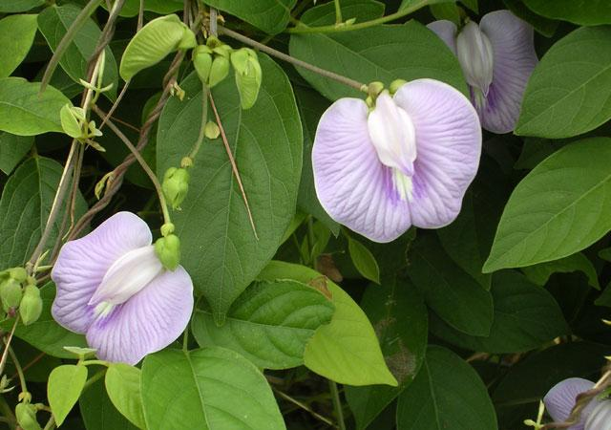
Centro

Centro (Centrosema molle Mart. ex Benth.) is a vigorous twining, trailing and climbing perennial legume. It has a deep root-system with tap roots and lateral roots. Leaves are dark green, trifoliate (Ecocrop, 2009). Leaflets are ovate, 4 cm long x 3.5 cm broad. Flowers, borne in axillary racemes, are bright or pale lilac with violet stripes. Pods are linear, slightly twisted, 7.5 cm to 15 cm long, becoming dark brown when ripe. They contain up to 20 seeds
Nutritional Value
Excellent feeding value. Moderate to high dry matter digestibility (45-65%), highest for young leaf and stem. Crude protein levels are relatively high for a tropical pasture legume and range from 17-26%, again highest in immature forage.
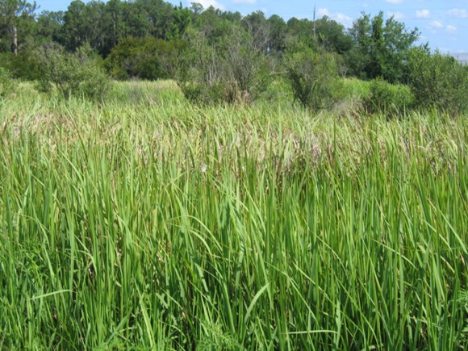
Cogon

It is a perennial rhizomatous grass native to east and southeast Asia, India, Micronesia, Melanesia, Australia, and eastern and southern Africa. It grows from 0.6–3 m (2–10 feet) tall. The leaves are about 2 cm wide near the base of the plant and narrow to a sharp point at the top; the margins are finely toothed and are embedded with sharp silica crystals. The main vein is a lighter colour than the rest of the leaf and tends to be nearer to one side of the leaf. The upper surface is hairy near the base of the plant while the underside is usually hairless. Roots are up to 1.2 meters deep, but 0.4 m is typical in sandy soil.
Nutritional value:
Root: metabolites that have been found on the roots of the reeds ter.diri arundoin, fernenol, isoarborinol, silindrin, simiarenol, kampesterol, stigmasterol, ß-sitosterol, scopoletin, skopolin, p-hidroksibenzaladehida, catechol, chlorogenic acid, isoklorogenat acid, acid p-kumarat, neoklorogenat acid, acetic acid, oxalic acid, malic acid d-, citric acid, potassium (0.75% by dry weight), large amounts of calcium and 5-hidroksitriptamin. From the results of other studies on the roots and leaves was found five kinds of derivatives are derivatives of flavonoid 3 ', 4' 0.7-trihydroxy flavone, 2 ', 3'-dihydroxy-hydroxy kalkon and six flavanol. A possible derivative of flavonoids, including flavone group, the substituted flavonol 3-0H, flavanone or the isoflavones contained in the soluble fraction in ethyl acetate extract of the roots of the reeds. In the fraction of water-soluble extract of the roots of the reeds of the flavonoids found in groups without free OH groups, flavones, flavonols substituted at the 3-0H, flavanone, or isoflavones.
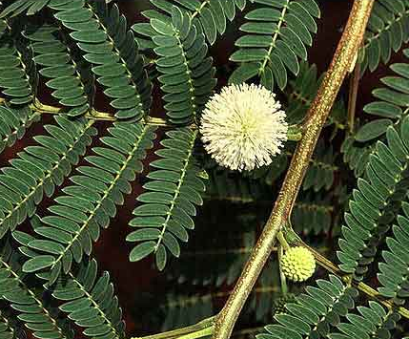
Ipil-ipil

Ipil-ipil is a small tree growing up 8 meters high. Leaves are compound, 15 to 25 centimeters long, with hairy rachis. Pinnae are 8 to 16, and 5 to 8 centimeters long. Leaflets are 20 to 30, linear oblong, and 7 to 12 millimeters long. Heads are solitary, at the axils of the leaves, long-peduncled, globose, and 2 to 5 centimeters in diameter, with many flowers. Flowers are whitish, in dense globue heads, 2 to 3 centimeters in diameter. Fruit is an oblong or linear pod, strap-shaped, 12 to 18 centimeters long, 1.4 to 2 centimeters wide, papery, green turning to brown and splitting open along two edges when mature, and several fruits developing from each flower head. Each pod contains 15 to 25 elliptic, compressed, shining, brown seeds, each 5 to 8 millimeters long, 3 to 5 millimeters wide.
Nutritional Value:
Its nutritional value is comparable with that of alfalfa with high ß-carotene content. The content in condensed tannins (2.6 %) in the leaves and stems reduce DM digestibility but enhances by-pass protein.
Feeding dairy cows on cut-and-carry leucaena foliage increases milk production by 14% on average and also increases milk fat and protein contents. Dairy cows grazing Brachiaria decumbens/Leucaena leucocephala produce higher milk yield than cows fed on the grass only cut-and-carry. Cows fed Leucaena leucocephala eat less concentrate and do not need to be fed on heavy fertilized grasses. They also have higher live weight gain. However, diets containing high amounts of leucaena foliage are detrimental to reproduction in heifers or cows whose rumen is not inoculated with DHP-degrading bacteria: stillborn calves are numerous, calving percentage is poor (66% vs. 88%), and calf weight at birth is lower. It is recommended to inoculate heifers before pregnancy or limit access to leucaena during early pregnancy.

Kikuyu
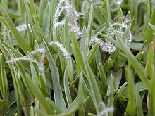

Pennisetum clandestinum is a rhizomatous grass with matted roots and a grass-like or herbaceous habit. The leaves are green, flattened or upwardly folded along the midrib, 10-150 millimetres long, and 1-5 mm wide. The apex of the leaf blade is obtuse.[4] It occurs in sandy soil and reaches a height of between 70 to 150 millimetres. The species favours moist areas and frequently becomes naturalised from introduction as a cultivated alien.[5] Rooted nodes send up bunches of grass blades. It is native to the low-elevation tropics of Kenya and environs, where it grows best in humid heat, such as the wet coastal areas.
Nutritional Value:
Well-fertilised kikuyu produces very high quality feed with over 25% CP and over 70% IVDMD in young leaf. CP levels tend to stay high for 1 or 2 weeks and then decline rapidly, to below 10% within 12 weeks. Digestibility also falls to <50% in the same period. Sodium levels (at 0.02–0.05% Na) can be deficient for lactating cattle, and calcium levels, although optimal for lactating cows, may be inadequate due to “tie-up” with oxalate. P levels change with season, falling as the species became dormant. A fall in P and a rise in Ca content results in a high Ca:P ratio (2.5:1) in spring. Optimum quality coincides with the 4½ leaf stage of regrowth.
For good silage fermentation, kikuyu needs to be wilted first or have extra sugar added because of its low DM and low water soluble carbohydrate content.
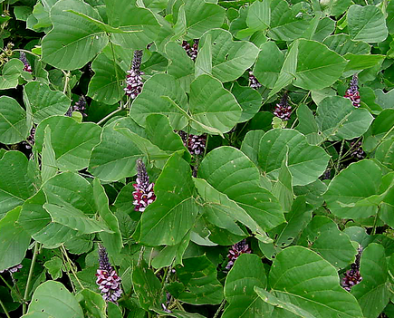
Kudzu

It is a climbing, coiling, and trailing vine native to southern Japan and south east China. Its name comes from the Japanese name for the plant, kuzu (クズ or 葛?), which was written "kudzu" in historical romanizations. Where it occurs as an invasive species, it is considered a noxious weed that climbs over trees or shrubs and grows so rapidly, it kills them by heavy shading.[3] The plant is edible, but often sprayed with herbicides.
Nutritional Value:
Kudzu can be used by grazing animals, as it is high in quality as a forage and palatable to livestock. It can be grazed until frost and even slightly after. Kudzu had been used in the southern United States specifically to feed goats on land that had limited resources. Kudzu hay typically has a 15–18% crude protein content and over 60% total digestible nutrient value. The quality of the leaves decreases, however, as vine content increases relative to the leaf content. Kudzu also has low forage yields despite its rate of growth, yielding around two to four tons of dry matter per acre annually. It is also difficult to bale due to its vining growth and its slowness in shedding water. This makes it necessary to place kudzu hay under sheltered protection after being baled. Kudzu is readily consumed by all types of grazing animals, yet frequent grazing over three to four years can ruin stands. Thus, kudzu only serves well as a grazing crop on a temporary basis.
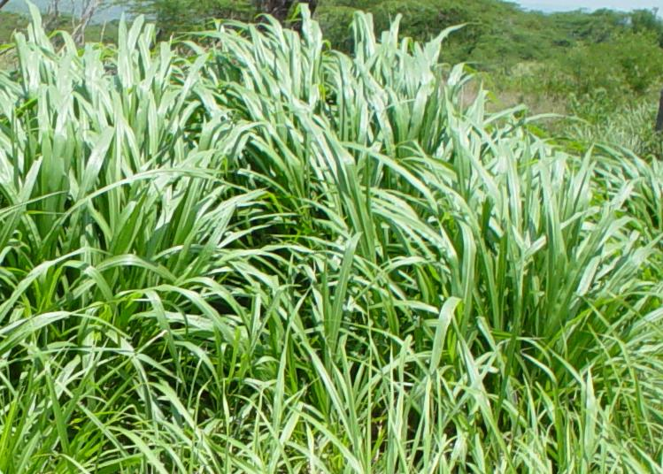
Napier

Pennisetum purpureum is a monocot C4 perennial grass in the Poaceae family.[4] It is tall and forms in robust bamboo-like clumps. It is a heterozygous plant, but seeds rarely fully form; more often it reproduces vegetatively through stolons which are horizontal shoots above the soil that extend from the parent plant to offspring. This species has high biomass production, at about 40 tons/ha/year and can be harvested 4-6 times per year. Additionally it requires low water and nutrient inputs.
Napier can be propagated through seeds, however as seed production is inconsistent, collection is difficult. Alternatively, it can be planted through stem cuttings of the stolons. The cuttings can be planted by inserting them along furrows 75 cm apart, both along and between rows.
Nutritional Value:
Napier grass obtained from cutting at short intervals is palatable and nutritive and animals gain in their live- weight. The chemical composition of the green grass and hay (dry grass) is given in table -1. The fodder tends to get course, hard, fibrous and non-palatable as its cutting is delayed. The culms become thick, woody which are rejected by the cattle and go as waste.
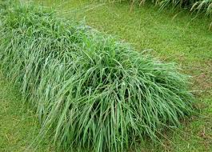
Pangola grass

Pangola grass (Digitaria eriantha Steud) is an extremely variable species, comprising a number of morphologically different former species. They are perennial grass, sometimes stoloniferous or tufted and rhizomatous. The stolons spread over the surface of the ground and develop roots at the nodes. The stolons and stems are hairy but the leaf blades are straight and smooth. The flowering head normally extends above the leaves, topped with six or seven radiating flower spikes. Very few viable seeds are produced.
Nutritive Value:
Pangola grass is one of the higher quality tropical grasses. Crude protein values range from 5 to 14 %, and may exceed 15 % with young regrowth age and high fertilization. Relatively low variation is registered in cell wall content with regrowth age but modifications are observed in cell composition becoming more and more lignified. Like all tropical grasses, chemical and nutritive value of pangola grass vary with several factors like age of regrowth, season, fertilizer and genotype. The regrowth age is the main factor of variation. Pangola grass has relatively high concentrations of Na in its tissues, compared with many other tropical grasses. Large variations are reported for in vivo total tract digestibility: 40-70 %. Large variations of voluntary dry matter consumptions are also reported: 50 to 90 g/W^{0.75} on sheep.
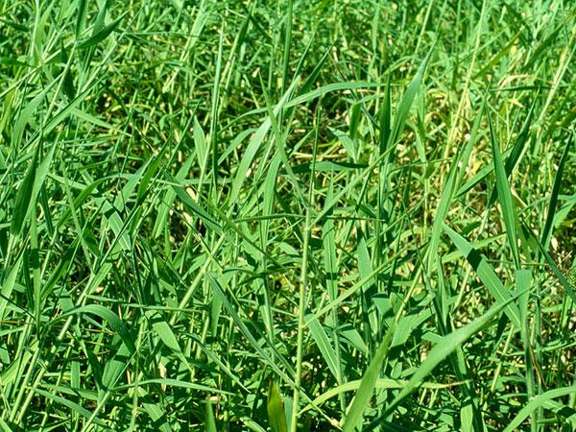
Paragrass

Para grass is a perennial grass up to about 1 m tall. The stems are hollow and robust, creeping in a prostrate growth habit. Stems stand erect towards the ends, and sprout new roots wherever the nodes touch the ground. Leaf blades are hairy and dark green in colour. They are usually up to 15 cm long and less than 1 cm wide, tapering to a long, fine point. The leaf sheaths are also hairy, particularly where they join the stem. Flower heads are up to 18 cm long and are made up of several spikes, each about 5 cm long. Seeds cluster thickly along each of these spikes, although para grass seldom sets seed.
Nutritive Value:
A grass of high nutritive value, although DM intake by grazing stock may be reduced by high water content, including droplets of water held on the hairy leaves and stems. Actively growing para grass can have very high nutritive value, with 14–20% CP, and IVDMD of 65–80% for leafy regrowth and 55–65% IVDMD for whole top growth. Quality declines with maturity to 35–45% IVDMD for tops.

BY-PRODUCTS
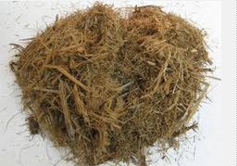
1. Bagasse

Bagasse is the residual fibre resulting from the extraction of sugarcane juice. There are two main types of bagasse.
- Factory bagasse comes from industrial processes involving repeated extraction steps. The bagasse is the fibrous by-product of sugarcane stalks milling for juice extraction. The fibre is passed through sieves to remove fine particles which may be used as a filter aid later in the process, or as a feedstuff (“pith bagasse”). Much of the bagasse provides the energy required for the operation of the factory.
- Pressed cane stalks, or "farm bagasse" is obtained from on-farm or small factory cane fractionation that use only 2 or 3 crushers. Due to the reduced efficiency of extraction process (50% vs 70% extraction rate), it contains higher amounts of sugar-rich juice and is more valuable for ruminants (Preston, 1995).
Like other fibrous materials, dry bagasse is often used as litter for pigs and poultry. The bagasse is then recycled into organic fertilizer. Sometimes, when local regulations authorise it, poultry litter may be incorporated in ruminant diets as a feedstuff rich in non-protein nitrogen.
2. Soybean hulls
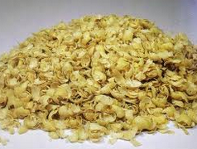

Soybean hulls (seed coats) are a by-product of soybean processing for soybean oil and soybean meal. During processing, soybeans are rolled or cracked to break the whole bean into smaller pieces so that the hulls can be removed. Soybean hulls are separated from the cracked seeds by an air stream. Hulls are usually toasted to destroy the urease activity and ground to the desirable particle size. Grinding the hulls decreases particle size and increases density for mixing and shipping purposes. Bulk density varies with the fineness of grind, usually ranging from 20 to 24 pounds per cubic foot. Pelleted soy hulls, which have a considerably higher bulk density, are also available.
Nutritional Value
The nutritional value of the hulls is quite good. Often hulls, either cottonseed or soybean, are thought of as a roughage feed; however, soybean hulls are superior to cottonseed hulls in nutrient content. As-fed Basis Soybean Hulls Crude protein 11-12% TDN 65-70% Crude fiber 35-40% Calcium .49% Phosphorus .21% Cottonseed Hull Crude protein 4.0-4.2% TDN 40-42% Crude fiber 40-45% Calcium .15% Phosphorus .9% The nutrients in soybean hulls are highly digestible and are considered an energy feed as opposed to a roughage feed. In some studies, the fiber has been shown to be 85 percent digestible, which illustrates a product high in fiber can also be high in energy.
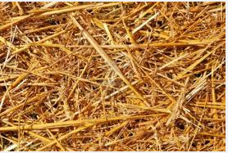
3. Straw, ground

Straw is a valuable low-cost feed that can be used effectively in any beef cow wintering program. It can be a very useable feed in a cow wintering ration but it is important to have a feed test analysis done to know its nutrient value. Once the analysis is completed any additional protein, energy, minerals and vitamins that will be necessary to meet the cow's requirements can be incorporated.
Nutritional value
Straw quality can be improved with little or no loss on grain yield by swathing the crops earlier, rather than waiting for them to completely ripen. Cereal variety selection can influence straw quality for feed purposes, since those varieties that tend to lodge generally tend to be better for feed. Straw is, however, a by-product so crop or variety should determine selection decisions. Straws can range in protein from one to eight per cent and fiber content from 25 to 65 per cent, hence the importance of having your straw supplies analyzed at a feed testing laboratory, followed by ration balancing, to meet the cows' needs during the specific stage of her reproductive cycle.
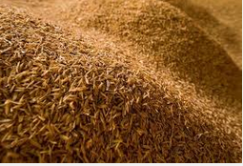
4. Husks

Is a white fibrous material derived from the outer coating of the psyllium seed, like the bran layer of grains. Husk is the outer shell or coating of a seed. It often refers to the leafy outer covering of an ear of maize (corn) as it grows on the plant. Literally, a husk or hull includes the protective outer covering of a seed, fruit or vegetable. It can also refer to the exuvia of bugs or small animals left behind after moulting.
Nutritional value:
Each 1 tbsp. serving of this supplement contains just 15 calories. All of the calories in psyllium husk powder come from carbohydrates. Each 1 tbsp. serving provides 5 g of carbs, which are your body's primary source of energy, so high-carb foods can help fuel athletic activity. This powder is relatively low in carbs, however, so it is unlikely to provide you with much energy.
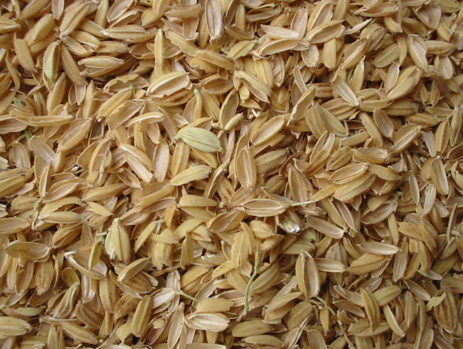
5. Rice hulls

Rice hulls are the coatings of seeds, or grains, of rice. To protect the seed during the growing season, the hull is formed from hard materials, including opaline silica and lignin. The hull is mostly indigestible to humans. Rice hulls are the by-product of rice dehulling. They are used in some countries for poultry litter that can later be fed to ruminants. Numerous publications on uses of rice hulls attest to the many attempts to solve the problem of disposing of this by-product.
Nutritional Value:
Rice hulls can be used in animal feeding in the following ways:
As raw rice hulls. Low-quality roughages like ground rice hulls can be included in small amounts (up to 15%) in high-concentrate diets for feedlot cattle to help furnish bulk, stimulate appetite and decrease incidence of liver abscesses. In areas with a shortage of roughage, ground rice hulls can be used in place of straw or advantageously as a partial replacement for it. The addition of ground rice hulls has been found in some cases to increase the feed intake.
As ammoniated rice hulls. A process developed for making livestock feed from hulls includes the addition of monocalcium phosphate, removal of silica, ammoniation under pressure and toasting. Ammoniated rice hulls have been used in proportions of up to 40% of the total ration for sheep, without digestive or mastication problems.
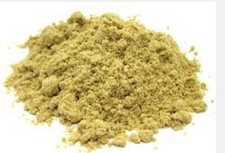
6. Rice Bran

Rice bran is the most important rice by-product. The bran fraction contains 14-18% oil. Rice bran that has not been defatted is a useful binder in mixed feeds. Defatted rice bran can be used at higher levels than ordinary rice bran. Rice bran is often adulterated with rice hulls, as it should have a crude fibre content of 10-15%
Nutritional Value
Rice bran is a good source of B vitamins and is fairly palatable to farm animals. The oil has a marked softening effect on body fat and on the butterfat in milk. With attention to the oil content, rice bran is a valuable feed for all classes of livestock. Rice pollards are used in the same way and with the same limitations as rice bran. It should be noted that rice milling by-products do not follow strict naming conventions. Many products called "rice brans" are mixtures of by-products obtained at different stages of the milling process, resulting in large variations in chemical composition.
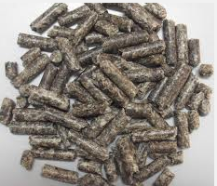
7. Beet pulp, dried

Beet pulp is a byproduct from the processing of sugar beet which is used as fodder for horses and other livestock. It is supplied either as dried flakes or as compressed pellets, but when fed to horses it is usually soaked in water first.
Nutritional Value:
Despite being a byproduct of sugar beet processing, beet pulp itself is low in sugar and other non-structural carbohydrates, but high in energy and fiber. Among other nutrients, it contains 10 percent protein, 0.8 percent calcium and 0.5 percent phosphorus. It has no Vitamin A, so additional forage or supplementation is required to provide complete nutrition.
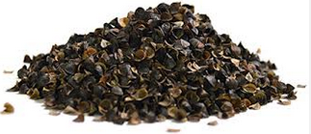
8. Buckwheat hulls

Buckwheat hulls are the hard outer shells that house the seeds of buckwheat grain.The hulls are strong, aromatic and do not retain or reflect heat, making them an ideal allergy-free alternative to feather or synthetic fiber fills for pillows and upholstery.
Nutritional Value
Buckwheat is composed of 75% "complex" carbohydrates. You've undoubtedly heard the recommendation that we should eat fewer "empty calorie" sugar carbohydrates and eat more "complex" starches. Recent dietary goals for the United States specifically call for increasing carbohydrate consumption to 55-60% of our total calorie intake. Only 8-9% of these carbohydrate calories should come from sugar or "simple" carbohydrates. That leaves considerable space for complex carbohydrates like buckwheat that satisfy our appetites and fuel our cells.
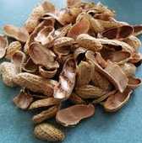
9. Peanut hulls
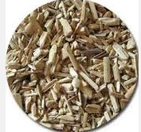

Peanut hulls are the by-product of the peanut shelling process. Extremely bulky and difficult to handle. Availability depends upon proximity to shelling plant. Uses in hay-replacer diets and as an extender in stocker concentrate diets
Nutritional Value:
Are high in tannin (18%) that will negatively impact protein digestibility and may affect palatability, and they are high in fat (22%) that contributes to their energy content but limits the levels that can be fed. Research indicates that peanut skins may be used at up to 20 percent of the total diet of cattle, but protein levels may have to be increased to compensate for the protein binding by the tannin.
10. Whole Cottonseed
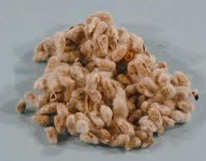

Whole cottonseed is a by-product of processing cotton for fiber. Whole seed can be fed to ruminants or processed for its oil content. In recent years, it has become widely used as feed. It is used heavily in the dairy industry as a source of fiber, protein, and energy.
Nutritional Value:
Cottonseed is high in TDN (90%) and crude protein (22%) and is a good feed for cattle. Supplies are seasonal and prices tend to be lowest in the fall. Feeding cottonseed at a level to meet the supplemental protein needs of growing cattle and beef cows is a common feeding system. Higher levels can be fed if whole seed is priced competitively as an energy supplement.

http://www.gooseberrynaturalfeed.net/index.php?option=com_content&view=article&id=43&Itemid=26
http://pubs.ext.vt.edu/400/400-230/400-230.html

