LEGUMES
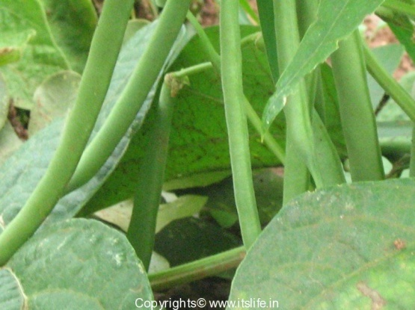
1. String bean (Phaseolus vulgaris)
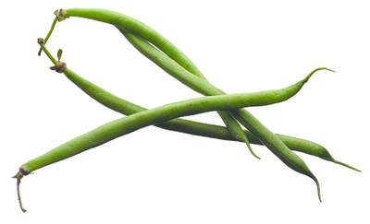

String beans are the unripe fruit of specific cultivated varieties of the common bean. Green bean varieties have been bred especially for the fleshiness, flavor, or sweetness of their pods. Haricots verts, French for "green beans", may refer to a longer, thinner type of green bean than the typical American green bean. Green beans are found in two major groups, bush beans and pole beans.
Bush beans are short plants, growing to approximately two feet in height, without requiring supports. They generally reach maturity and produce all of their fruit in a relatively short period of time, then cease to produce. Gardeners may grow more than one crop of bush beans in a season.
Pole beans have a climbing habit and produce a twisting vine . Runner beans have a similar habit but are a different species of bean.
Nutritional Value:
- Fresh green beans are very low in calories (31 kcal per 100 g of raw beans) and contain no saturated fat. Nevertheless, the lean vegetables are a very good source of vitamins, minerals, and plant derived micronutrients.
- They are very rich source of dietary fiber (9% per100g RDA) which acts as a bulk laxative that helps to protect the mucous membrane of the colon by decreasing its exposure time to toxic substances as well as by binding to cancer-causing chemicals in the colon. Adequate amount of fiber has also been shown to reduce blood cholesterol levels by decreasing reabsorption of cholesterol-binding bile acids in the colon.
- Green beans contain excellent levels of vitamin A, and health promoting flavonoid poly phenolic antioxidants such as lutein, zea-xanthin and ß-carotene in good amounts. These compounds help act as protective scavengers against oxygen-derived free radicals and reactive oxygen species (ROS) that play a role in aging and various disease processes.

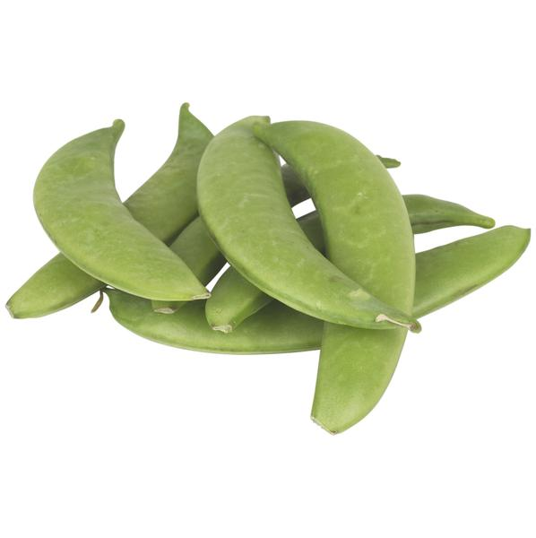
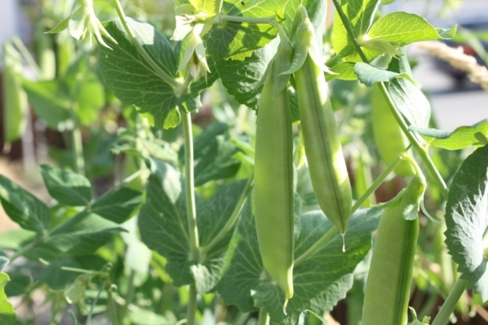
2. Sugar snap pea (Pisum sativum)

They are a cultivar group of edible-podded peas that differ from snow peas in that their pods are round as opposed to flat. The name mangetout (French for "eat all") can apply both to snap peas and snow peas.
Snap peas, like all other peas, are pod fruits. An edible-podded pea is similar to a garden, or English, pea, but the pod is less fibrous, and edible when young. Pods of the edible-podded pea, including snap peas, do not have a membrane and do not open when ripe. At maturity, the pods grow to around 4-8 cm in length, Pods contain three to five peas per pod.
The plants are climbing, and pea sticks or a trellis or other support system is required for optimal growth. Some cultivars are capable of climbing to 2 m high but are more commonly around 1-1.3 m for ease of harvest.
Nutritional Value:
Snap peas feature comparatively lesser calories than green-shelling peas. 100 g pods provide just 42 calories against 81 calories of green peas. However, the snap pods are indeed containing more vitamins, minerals and other plant nutrients than the traditional shelling peas.
Fresh pods have 150% more amounts of vitamin C than in garden peas. 100 g provide 60 mg or 100% of daily-required levels of vitamin C. Vitamin C is a powerful natural water-soluble anti-oxidant. Vegetables rich in this vitamin help the body develop resistance against infectious agents and scavenge harmful, pro-inflammatory free radicals from the body.
Fresh sugar pea pods are an excellent source of folic acid. 100 g provides 42 µg or 10% of recommended daily levels of folates. Folates are one of the B-complex groups of vitamins, required in cellular DNA synthesis. Research studies suggest that adequate folate rich foods in expectant mothers would help prevent neural tube defects in the newborn babies.
Like in garden peas, sugar snap pods are also rich in phytosterols, especially ß-sitosterol. Studies suggest that vegetables like legumes, fruits, and cereals rich in plant sterols help lower cholesterol levels in the body.
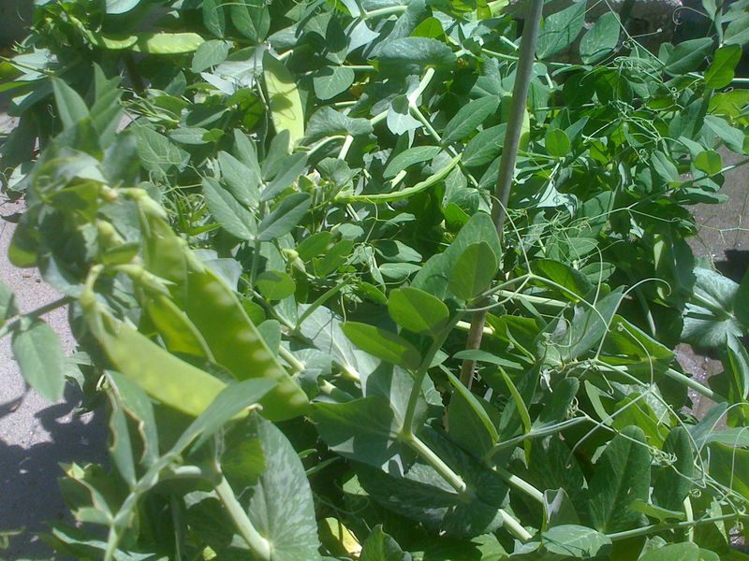
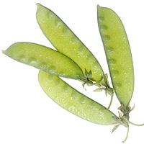
3. Snow pea (Pisum sativum)

The snow pea (Pisum sativum var. saccharatum) is a legume, more specifically a variety of pea eaten whole in its pod while still unripe. The name mangetout (French for “eat all”) can apply both to snow peas and to snap peas.
Snow peas can be grown in open fields during cool seasons and can thus be cultivated during winter and spring seasons.
Storage of the pea with films of polymethylpentene at a temperature of 5°C and a concentration of oxygen and carbon dioxide of 5 kPa increases the shelf life, internal and external characteristics of the plant.
Nutritional value
One-half cup of fresh peas contains 62 calories, 4 grams of protein, 11 grams of carbohydrates, and 4 grams of fiber. While canned peas list no fat content on the USDA Nutrient Database, fresh peas contain 0.2 grams of fat.
The vitamin A count is 534 I.U. with slightly higher figures of B vitamins than the canned peas. Folic acid measures 46.9 mcg; calcium offers 19.2 mg; iron content is 1.3 mg; zinc measures 0.8 mg; potassium content is 134 mg; and magnesium is 23.2 mg.
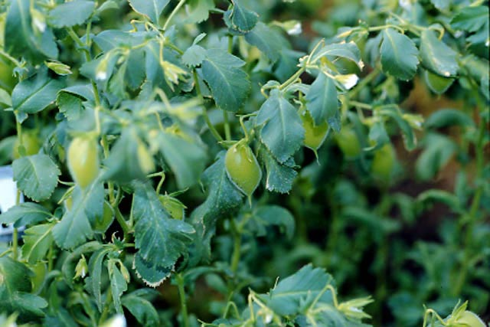
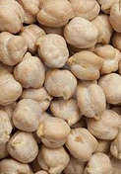
4. Garbanzo beans or chick peas (Cicer arietinum)

The chickpea (Cicer arietinum) is a legume of the family Fabaceae, subfamily Faboideae. Its seeds are high in protein. The plant grows to between 20–50 cm (8–20 inches) high and has small feathery leaves on either side of the stem. Chickpeas are a type of pulse, with one seedpod containing two or three peas. It has white flowers with blue, violet or pink veins. Chickpeas need a subtropical or tropical climate with more than 400 millimetres (16 in) of annual rain.[citation needed] They can be grown in a temperate climate but yields will be much lower
Nutritional value:
Garbanzobeans are high in potassium and calcium, therefore it is beneficial for the bones muscles, heart, teeth and moisture content in the body. It is good if your system is deficient in iodine. Selenium contained in the beans helps to prevent tumors, including cancer. Garbanzobeans are beneficial for people who suffer from nervous and physical exhaustion, anaemia, diabetes, excessive cholesterol, stones of all kinds, blocking the live, spleen diseases.
5. Mung beans (Vigna radiata)
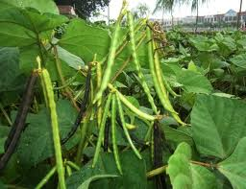
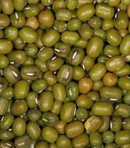

The mung or moong bean is the seed of Vigna radiata, native to the Indian subcontinent, and mainly cultivated in India, China, Thailand, Philippines, Indonesia, Burma, Bangladesh, Laos and Cambodia, but also in hot and dry regions of Southern Europe and the Southern United States. It is used as an ingredient in both savory and sweet dishes. They are small, ovoid in shape, and green in color. The mung bean is one of many species recently moved from the genus Phaseolus to Vigna, and is still often seen incorrectly cited as Phaseolus aureus or Phaseolus radiatus.
Nutritional Value:
Mung beans are a rich source of vitamin A, B, C, E, and K. Vitamin A plays a crucial role in maintaining a healthy vision, and also aids in bone development. It also helps strengthen the immune system. Thiamine or vitamin B1 ensures the proper functioning of the nervous system, and is also involved in the breakdown of carbohydrates to release energy. Riboflavin and Niacin (vitamins B2 and B3 respectively) are important regulators of metabolic processes and various cellular functions. Folate or folic acid helps in the formation and maturation of red blood cells, and also assists in protein metabolism. Vitamin C is involved in the formation of collagen, an important component of connective tissues. Moreover, vitamins A, C, and E act as antioxidants and protect cells or cellular components from free radicals. Vitamin K plays a major role in the formation of proteins required for blood clotting.
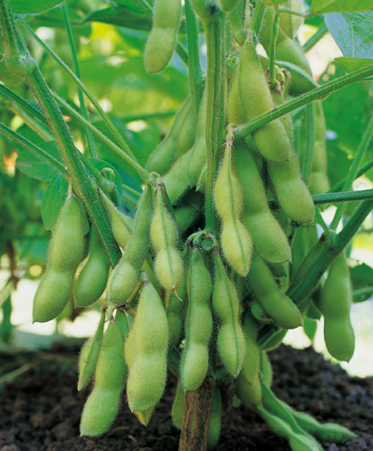
6. Soybeans (Glycine max)

Glycine max, the soybean (also soya- or soja bean, formerly classified as Glycine soja), is an annual herbaceous plant in the Fabaceae (legume or bean family). The soybean plant, which is densely hairy on leaves and stem, can grow to nearly 2 m (6 ft) tall, although commercial varieties are more typically 0.3 to 0.9 m (1 to nearly 3 ft). Leaves are compound, with 3 leaflets. The inconspicuous, stalkless white to purple flowers are borne singly or in small clusters in the axils (where leaf meets stem). The fruit is a broad, hairy, flattened legume or pod, around 10 cm (3 in) long, yellow to brown when fully mature and dried. Pods typically contain up to 4 beans, which vary in size and color depending on cultivar (colors range from white to reddish to black).
Nutritional Value:
Soybeans are very rich in nutritive components. Besides the very high protein content, soybeans contains a lot of fibre and are rich in calcium, magnesium . The soy protein has a high biological value and contains all the essential amino acids.
Soybeans are rich in unsaturated fatty acids and low in saturated fatty acids, which need to be avoided.
7. Sword bean (Canavalia gladiata)
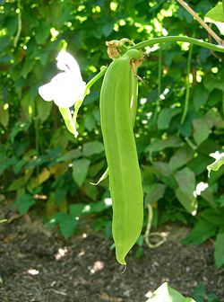
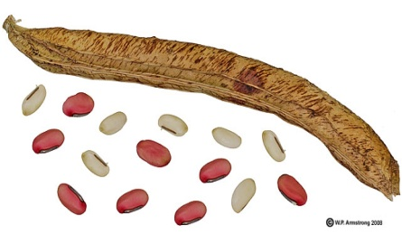

Sword bean, also called "Nata Mame" in Japan. It is native to tropical Asia. The unripe pods are bolied and served as a green vegetable like string beans. The seeds are also boiled and eaten. According to Steve Facciola (Cornucopia II, 1998): In Japan, the young pods are sliced and pickled in soy sauce with radishes, egg plants and lotus. The seeds are boiled and mashed with sugar. Another closely related species with large pods called jack bean (C. ensiformis) is native to tropical America.
Nutritional Value
Sword bean mainly contains amines, such as canavalmine, £^-guanidinooxypropylamine, spermine, and so on; it also contains thiamin and hemogglutinin. There are also protein, fat, sugar, starch, urease, hemagglutination enzyme, calcium, phosphorus, iron, carotene, vitamin C, etc.
Both the foliage and the seeds contain growth-inhibiting protein substances, canavalin and concanavalin A (Con A) and the amino acid, canavanine. Con A has antibody-like properties and it has been reported to provide a beneficial effect to plants possessing it, providing possible protection to the plants from disease microorganisms. However, Con A binds to mucosal cells lining the human digestive tract reducing the ability of the intestine to absorb nutrients. The concentration of these growth-inhibiting substances increases as the plant tissues age and mature. It is for this reason that human consumption is best limited to only the younger foliage and pods of these beans.
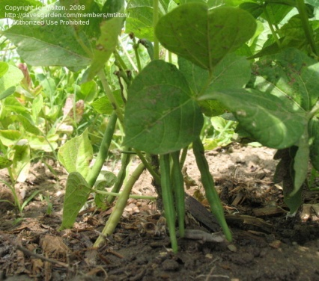
8. Adzuki beans
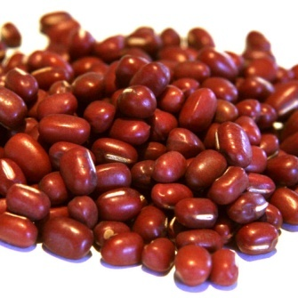

The azuki bean, also known as adzuki or aduki, is an annual vine, Vigna angularis, widely grown throughout East Asia and the Himalayas for its small (approximately 5 mm) bean. The cultivars most familiar in Northeast Asia have a uniform red color. However, white, black, gray and variously mottled varieties are also known. Scientists presume Vigna angularis var. nipponensis is the progenitor.
Nutritional Value:
Adzuki beans are a nutrient-dense food, providing a hefty amount of nutrients compared to their caloric content. They are a good food source of folate, potassium, phosphorus, magnesium, iron, manganese and zinc. Consuming adzuki beans may offer cardiovascular benefits. Adzuki beans, like most starchy beans, are rich in a type of fiber known as soluble fiber. Soluble fiber helps lower blood cholesterol levels. In addition, adzuki beans are rich in folate, magnesium and potassium, which play a role in supporting heart health. Folate helps reduce homocysteine levels in the bloodstream. Elevated levels of this amino acid in the bloodstream may damage the lining of your arteries and increase the risk of blockages in blood vessels. Magnesium and potassium help lower blood pressure, aid in muscle relaxation and improve blood flow.
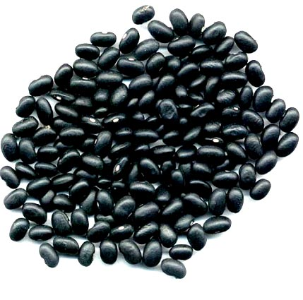
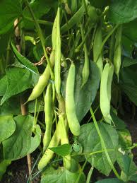
9. Black beans / turtle beans

Black turtle bean is a small, shiny variety of common beans (Phaseolus vulgaris), especially popular in Latin American cuisine, though it can also be found in Cajun and Creole cuisines of south Louisiana. They are often called simply black beans (frijol negro, zaragoza, poroto negro, caraota o habichuela negra in Spanish, and feijão preto in Portuguese), although this can cause confusion with other black beans.
Nutritional Value:
From a single, one-cup serving of black beans you get nearly 15 grams of fiber (well over half of the Daily Value and the same amount consumed by the average U.S. adult in one entire day of eating) and 15 grams of protein (nearly one third of the Daily Value and equivalent to the amount in 2 ounces of a meat like chicken or a fish like salmon).
10. Haricot bean/ Navy bean
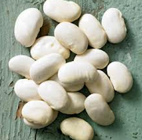
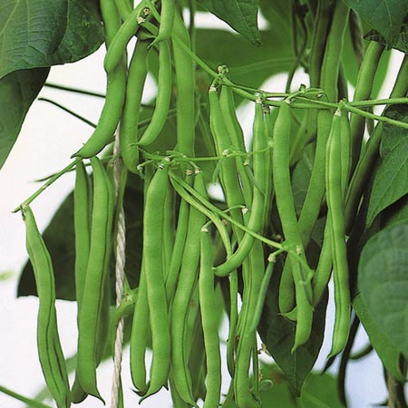

Navy bean or haricot bean is a variety of common beans (Phaseolus vulgaris). Haricot beans are small, oval, plump and creamy-white with a mild flavour and smooth, buttery texture. In the US, they are known as navy beans and are the classic ingredient in Boston baked beans. Haricot beans are widely used in the cooking of countries such as France, Spain, Portugal and South America. With little flavour of their own, they absorb other aromas and flavours easily, which makes them popular beans to use in bean salads, vegetable soups, slow-cooked dishes such as cassoulet or bean purées.
Nutritional value:
The beans are rich in protein, folic acid, iron, B complex, and magnesium,so they are an excellent addition to a healthy diet.
· Combined with whole grains such as rice, navy beans provide virtually fat-free high quality protein
· Dried haricot beans, a small but nutritionally mighty member of the legume family, are a very good source of cholesterol-lowering fiber. Not only can they help lower cholesterol, they are also of special benefit in managing blood-sugar disorders since their high fiber content prevents blood sugar levels from rising rapidly after a meal.
· Dried beans also provide good to excellent amounts of four important minerals, two B-vitamins, and protein--all with virtually no fat.
· Haricot beans, like other legumes, are rich in soluble fiber
· They are a good source of potassium, which may decrease the growth and development of blood vessel plaques and is also good for lowering high blood pressure.

GRASS
1. Annual bluegrass (Poa annua)
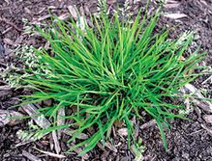

Annual Bluegrass can be identified as a bunch forming turfgrass that grows in dense patches. Its ligule is medium to long and slightly pointed, while its collar is narrow and smooth. It has sheaths that are slightly compressed, smooth, with short blades that have parallel edges terminating in a boat-shaped tip. The seeds germinate in late summer, early autumn and spring.
2. Barnyardgrass (Echinochloa crus-galli)
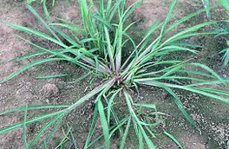

Barnyardgrass can be identified as a coarse, sprawling, purple-tinged annual. It features a broad, continuous collar and compressed sheaths that are very flat, and also purple tinged near the base. Its blades are flat, narrow at the base and thick mid-vein, and may be sparsely hairy along the edges.
Barnyardgrass has a seedhead forming a coarse, branching panicle. Its stems are often found lying flat in the turf.
3. Bermuda grass (Cynodon dactylon)
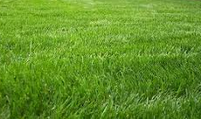

Bermuda grass is a light green, perennial grass with fine textured leaves. It spreads rapidly by seed, stolons (creeping, above-ground stems), and rhizomes (below-ground stems). Seedheads are arranged like helicopter blades.
4. Broomsedge (Andropogon virginicus)
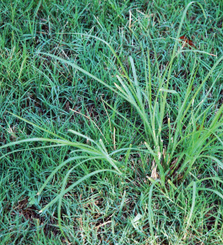

Broomsedge can be identified as a clump-forming perennial with several tall stems sprouting from a basal crown. Its ligule is membranous, fringed with hairs, and the sheaths are very strongly compressed and flattened. Broomsedge also features a narrow collar, divided by the midvein and hairy at the edge. Its blades are compressed near the base and hairy along the edges and near the ligule.
The leaves turn into unsightly brown tufts during winter, resembling broom bristles. In fact, household brooms were once made from these tufts, hence the common names “Broomgrass” and “Broomstraw”.
5. Blue-eyed Grass (Sisyrinchium rosulatum)
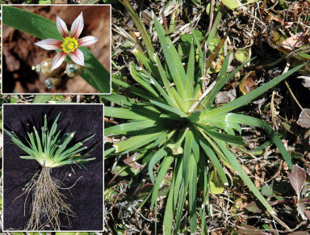

Blue-eyed Grass can be identified as a winter annual, featuring zigzagging stems. Its leaves are flat, light green in color, and clustered at the base.
Blue-eyed Grassproduces a flower that varies greatly in color depending on the specific species. Several perennial species that resemble Blue-eyed Grass also occur in turfgrass.
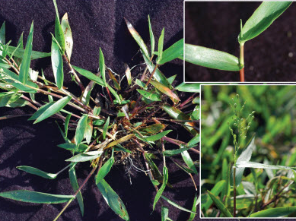
6. Broadleaf Panicum (Panicum adspersum)

Broadleaf Panicum can be identified as a summer annual that sometimes bends and roots at the lower nodes. It features leafy stems growing upright to ascending. Its blades are broad, flat, and often covered with fine hairs. Its leaf sheaths are also hairy, often in lines along the edges. The ligule is relatively small.
Broadleaf Panicum reproduces by seed, forming seedheads with ascending branches. It also produces flowers that are purple to greenish-yellow in color with obscure, rectangular lines.
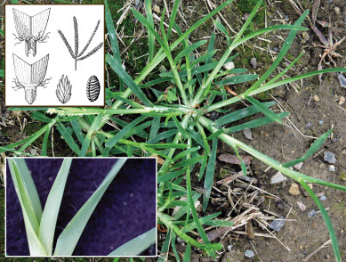
7. Goosegrass (Eleusine indica)

Goosegrass can be identified as a horizontally growing, dark green annual forming a wiry, tough rosette. Its ligule is toothed, divided at the center, and its blades are folded along the midvein. Goosegrass sheaths are compressed and flattened, white near the base and sparsely hairy along the edges.
Goosegrass seedheads typically contain anywhere from 3 -7 spikes forming at the tip of the seed stalk. The seeds are attached closely to the spike and generally germinate 2-3 weeks after crabgrass.

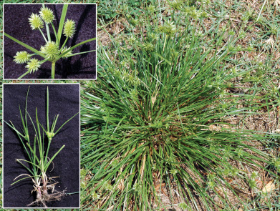
8. Cylindric Sedge (Cyperus retrorsus)

Cylindric Sedge can be identified as a grass-like perennial with densely tufted stems. It features flat, smooth blades that are bright green in color. Its seedhead branches at the top of the stem and includes tight cylindrical clusters of seeds which usually point down.
Cylindric Sedge produces seeds from summer into fall. It may produce rhizomes, although it most commonly reproduces by seed.
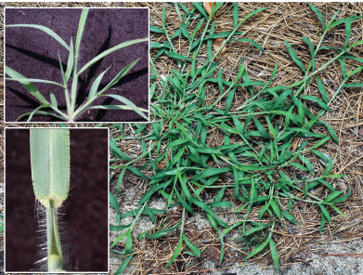
9. Hairy Crabgrass (Digitaria sanguinalis)

Hairy Crabgrass can be identified as a tufted to horizontally growing summer annual that roots at the lower nodes. Its ligule is tall, with jagged edges, and its collar is broad and prominent, with long hairs at the edges. Hairy Crabgrass also features sheaths that are compressed and flat, with hairy blades that are sharply pointed.

Hairy Crabgrass germinates when soil temperatures achieve a consistent 55 degrees Fahrenheit and generally dies after the first frost.
10. Saltgrass (Distichlis stricta)
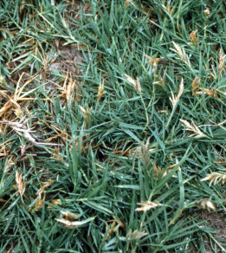

Saltgrass can be identified as a low growing, wiry, tough perennial that forms dense sod. Its ligule is short in the center, though very long on the edges, and its collar is broad with very long hairs. Saltgrass sheaths are compressed and flattened. Its stiff, vertical blades are short, sharply pointed, and either flat or folded.
Saltgrass is unique in that male and female plants generally grow in separate patches.

