I. INTRODUCTION
Entomology is the study of insects, the most abundant form of animal life on earth. Three quarters of a million species of insect have already been described and estimates for the number of species awaiting discovery range from 1 million to 30 million. So for any budding entomologists out there, you have an excellent chance of discovering a new species!
Given that there are so many species of insect, it follows that insects are a major component of the earth's biodiversity. They inhabit every terrestrial and freshwater ecosystem and by studying the ecological roles insects play we can have a better understanding of how those ecosystems function. Insects have important roles as plant consumers and herbivores, a food source for other organisms, scavengers and detritivores, predators and parasites. Insects also directly affect human welfare by competing with us for food and transmitting diseases. However, not all insects are detrimental to human welfare. For example, bees are used to produce honey, silkworms to produce silk and many predatory species are used to control crop pests.
Insects have incredibly diverse morphological, physiological, and behavioural adaptations to their surroundings which makes the study of insects a fascinating subject. Many features of insect biology also make them ideal to use as model biological systems. Their abundance, short life cycle, reproductive potential and small size allow scientific experiments to be set up, monitored and duplicated with relative ease in almost any location. Much of our basic understanding of genetics, population ecology, and evolution has resulted from experimentation with insects.
II. OBJECTIVES
- Identify common parasites and predators of insect pests.
- Explain how these pests affect plants.
- Discuss control measures for insect pests.
III. METHODOLOGY

IV. RESULTS AND DISCUSSION
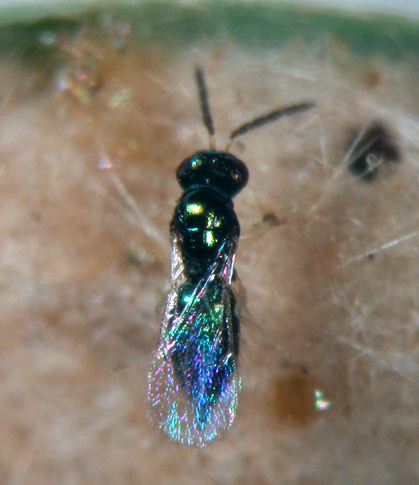
Common name: Eulophid wasp
Scientific name: Tetrastichus schoenobii Ferriere
Life Habits:
Tetrastichus schoenobii parasitizes stem borer eggs and pupae.
Several wasps may parasitize an egg mass of stem borers. Before oviposition, the female examines the egg mass for where to probe through the hair mat.
Each female parasitoid lays one egg in each stem borer egg. It can produce 10 to 60 offspring. Egg incubation takes 1 to 2 days. Larval development takes place inside the egg host. Once the egg is consumed, the larval parasite moves out from the egg and locates another egg host for its development. Each larval parasite needs three eggs for its development. Adulthood is observed after 1 to 2 days.
Parasitic and Predatory Characteristics:
Tetrastichus schoenobii is a metallic blue-green or shining green with bluish luster insect. It has an 8-segmented brown antenna except for the yellow scape. The hairs clothing the wings are not in rows. The thorax is smooth and shining and the abdomen is elongated and pointed. The legs are yellow except for the greenish coxae I and III. The tarsi are 4-segmented in all the legs.
Host Names: Tetrastichus schoenobii has been recorded as a primary parasitoid of shoot borers of rice and sugarcane, particularly Scirpophaga incertulas, S. excerptalis, S. innotata, Chilo suppressalis, C. infuscatellus (all Pyralidae), and also Sesamia inferens and Spodoptera mauritia (Noctuidae).
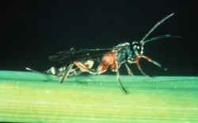
Common Name: Ichneumon
Scientific Name: Amauromorpha accepta metathoracica
Life Habits: This larval parasitoid lays a single egg into the larval host. The parasitoid larva emerges from the dead host and pupates inside the tunnel.
Parasitic and Predatory Characteristics:
This larval parasitoid is a medium-sized ichneumon, red and black. Its abdominal segment I is black and reddish apico-laterally, whereas abdominal segments II to III are entirely black. Abdominal segment VII has a white apico-median transverse band.
The front margin of the front wing is solid. Two cross veins or recurrent veins in the front wings and an elongated median cell reaching the base of the marginal vein in the hind wings are evident.
Host Names: Yellow and white stem borer larvae.
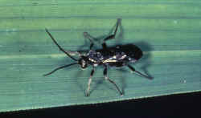
Common name: Braconid wasp
Scientific name: Cardiochiles philippinensis Ashmead
Life Habits:
The parasitoid wasp is common in dryland and wetland rice environments.
The female deposits a single egg on its host by entering the folded leaves. The developing parasitoid larvae also feed externally on the host. Laboratory studies show that C. philippinensis can parasitize as many as 17 leaffolder larvae and live 22.7 days.
Parasitic and Predatory Characteristics:
Cardiochiles philippinensis is a black parasitoid of medium size. It has hairy eyes and black legs with white hairs. The brown front wings have infuscation after the stigmal vein. The hindwings are also brown with infuscation along the costal area, basal one-fourth, and apical one-fourth. The tips of both wings are dark.
The immatures, particularly the larvae of C. philippinensis, are creamy white.
Host Names: Leaffolder larvae

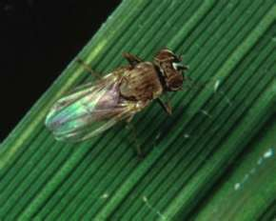
Common Name: Rice whorl maggot
Scientific Name: Hydrellia philippina
Parasitic and Predatory Characteristics:
The eggs are whitish, elongate, and banana-shaped with a hard shell as a covering. The individual egg is laid on the leaf surface. It is found sticking on the leaves because of a gluey substance secreted by the female. Egg stage lasts from 2 - 6 days.
The larva is legless. A newly hatched larva is transparent to light-cream. The mature larva is yellowish and cylindrical with a pair of pointed spiracles. It is 4.4 - 6.4 mm long and 0.5-0.7 mm wide. The larva feeds on the unopened central leaves. Before pupation, the matured larva leaves the feeding site and pupates inside older tillers. Larval development is completed in 10 - 12 days.
The pupa is dark-brown with a tapered posterior end and has two terminal respiratory spines. The pupa is 4.8 mm long. Pupation is 5 - 10 days.
The adult is gray in color and has transparent wings. It has silvery-white frons and cheeks. Its abdomen is silvery-white to gray, and blackish-brown in the middle of the three basal segments. The adult has yellow legs apart from the thigh. It is active during the day and rests on rice leaves near the water. It prefers thick vegetation and is attracted to open standing water around seedbeds.
Host Names: The rice whorl maggot’s primary host is rice. It also feeds on grasses such as Brachiaria sp., Cynodon sp., Echinochloa sp., Leersia sp., Leptochloa sp., Panicum sp., and wild rice.
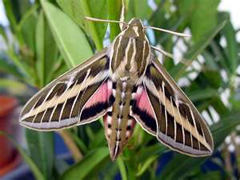
Common Name: Whitelined Sphinx
Scientific Name: Hyles lineata (Fabricius)
Life Habits:
Eggs are laid singly on host plants and this species feeds on a very wide range of plants.
Evening primrose (Oenothera) and purslane (Portulaca) are often the most common hosts, but larvae have been found developing on many other plants including grape, elm, apple and Epilobium.
In some years very high populations of the caterpillars develop in late summer and these may be seen migrating across fields and highways after they have completed development or consumed their host plants. They then move into the soil and create an underground chamber within which they pupate. Two generations may be completed during a growing season.
The adult moths feed on nectar, which they extract with their very long tubelike mouthparts. Often they may be active during the day and their flights and size are very reminiscent of hummingbirds; the whitelined sphinx is, by far, the most common species of “hummingbird moth” that occurs in the Rocky Mountain region. Adults also fly at night and can often be attracted to lights.
Parasitic and Predatory Characteristics:
The achemon sphinx is a large, heavy-bodied moth with a wing span of about 3.5 inches. The forewing is pinkish brown with a squarish dark spot along the edge. The hindwing is mostly pink, with brownish markings along the edge.
Most commonly observed are the full-grown larvae. These are large, cylindrical-bodied caterpillars without noticeable hairs and when full-grown may be over 3 inches long. Color of the caterpillars is variable with pale brown, dark green, and purple-brown forms present, the latter being particularly common. Light colored oblique bars occur along the sides of the body, each of which surrounds a dark spiracle.
These caterpillars are in the “hornworm family” (Sphingidae) and younger caterpillars possess a long, flexible spine on the tip of the abdomen. However, at the last larval molt this “horn” is lost. A prominent dark spot occurs at the spot when these become a “hornless hornworm”.

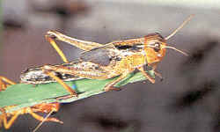
Common name: Locust
Scientific name: Locusta spp.
Parasitic and Predatory Characteristics
Eggs are deposited at the bottom of the egg-laying hole and are contained in an egg-pod covered with dirty-white foamy substance.
The female, using her ovipositor, drills a hole into the ground at a depth of 10-15 cm below the surface. Eggs are hatched as wingless nymphs.
A young larva (nymph) nearly looks almost like an adult but without wings and rudimentary genital system. The larva molts 5 times before becoming a young adult.
The adult possesses wings and genital organs that are completely developed. A female can lay about 95-58 eggs in an egg pod. They can lay eggs at least three times in their lifetime with intervals of 6-11 days. They feed on green vegetation to produce eggs. Rainfall, green vegetation, conditions of the habitat and temperature are necessary for locusts' development. The first generation produced after a migration is not usually migratory.
All locust species are identical in appearance to grasshoppers. Locusts differ from grasshoppers because they have the ability to change their behavior and habits and can migrate over large distances, whereas grasshoppers cannot. When the population density is low, locusts behave as individuals, like the grasshoppers. However, when the population density is high, locusts change their behaviors and form highly mobile swarms. Locust migration is an occasional event, only when an enormous build-up of the locust population occurs. When they migrate as a swarm of adults, after they can darken the sky over an area of many miles. When they settle, after long travels of hundreds or thousands miles, they are hungry and begin to feed voraciously, consuming huge area of vegetation.
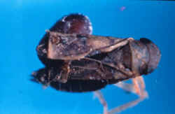
Common name: Big-headed fly
Scientific name: Pipunculus javanensis de Meijere

Life Habits: The big-headed fly deposits eggs into the host’s abdomen. A single fly develops from each host. Before pupation, the larva moves out from the host’s body to pupate in the soil or at the base of the plant. Development from egg to adult is completed in 30-40 days. The female fly parasitizes 2-3 hoppers daily in its life span of 4 days.
Parasitic and Predatory Characteristics
The parasitoid is a black fly with a large head occupied mainly by its compound eyes. Its third antennal segment is dark brown. It has a row of hairs and a distinct brown spot on the front wings. The legs are black except for the yellow patches along the tibiae and tarsi. The tip of the fly’s abdomen is indented at the center. Its body length is 3 mm.
The male fly has the genitalia notched on the dorsal part of the tip or apex, whereas the female fly has the tip of the ovipositor curved toward the posterior margin of the fifth abdominal segment.
Host Names: Leafhopper and planthopper nymphs and adults.

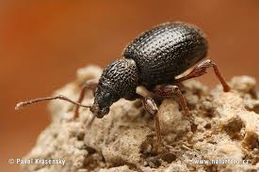
Common Name: Root Weevel
Scientific Name: Diaprepes abbreviatus (Linnaeus)
Life Habits:
A root weevil's ruthless assault is from top to bottom. Larvae hatch from eggs laid in the soil or, in the case of the obscure root weevil, from eggs laid on leaves.
These murderous munchers spend the winter eating plant roots, weakening them. In mid-spring, the young deviants mature into adult offenders, continuing the assault by climbing up the trunk and chomping on leaves, usually at night. They make a characteristic notching pattern, vandalizing the edges of the leaves. Most root weevil species are all female so they reproduce by cloning in the summer.
Parasitic and Predatory Characteristics:
Young bend their bodies into c-shapes, are plump and usually legless with white bodies and brown heads; adults are 1/4" - 1/2" beetles with long protruding noses and pear-shaped bodies with gray, black or brown coloring.
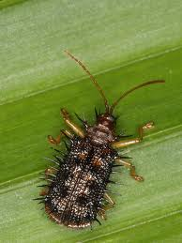
Common Name: Rice hispa
Scientific Name: Dicladispa armigera
Parasitic and Predatory Characteristics:
Adult : Small bluish beetle with spines on wings.
Eggs : Laid near leaf tips on lower surface putty inserted in to epidermis
Larva : Mine in between layers of leaf
Pupa : Pupate on leaf tissue
Host Names: Rice hispa feeds primarily on rice. It also feeds on grasses such as Brachiaria mutica (Forssk.) Stapf and Cynodon dactylon (L.) Pers, none supported complete development of the insect.

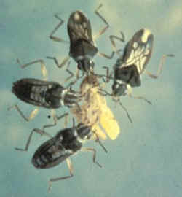
Common Name: Water bug
Scientific name: Microvelia douglasi atrolineata Bergroth
Life Habits:
Both the adults and nymphs live on the water surface and attack insects that fall onto the surface.
They are more successful as predators when they attack the host in groups. A single water bug feeds on small nymphs, whereas a group of Microvelia will attack larger prey.
The water bugs use their mouth parts to inject a toxic solution to paralyze the prey. A single predator feeds on 4 to 7 hoppers daily.
A female water bug can lay 20 to 30 eggs in rice stems above the water surface in her life span of 1 to 2 months.
Microvelia douglasi atrolineata can survive for long periods even without food provided the field is saturated or flooded.
Parasitic and Predatory Characteristics:
Microvelia douglasi atrolineata is a short but broad small water bug. It is black with small gray areas. It exists in two forms, winged or wingless. The wingless adults have no black and white markings on the neck and front wings.
These water bugs can be distinguished by their broad shoulder and 1-segmented front tarsus. Their claws are anteapical.
Host: Leafhoppers and planthoppers.

REFERENCES:
http://en.wikipedia.org/wiki/Pest_%28organism%29
http://mrgoutham.blogspot.com/2011/05/rice-insect-pests-pictures.html
http://agbsc.blogspot.com/2011/05/entomology-crop-insect-pests.html
http://www.ipm.ucdavis.edu/PMG/PESTNOTES/pn74140.html
http://alfalfa.ucdavis.edu/+symposium/proceedings/1995/95-165.Pdf
http://pods.dasnr.okstate.edu/docushare/dsweb/Get/Document-2329/EPP-7307web.pdf
http://www.knowledgebank.irri.org/ipm/index.php/parasitoids/eulophid-wasp/123-scientific-name-tetrastichus-schoenobii-ferriere
http://www.nbaii.res.in/Featured%20insects/Tetrastichus_schoenobii.htm
http://bugs.bio.usyd.edu.au/learning/resources/Entomology/introduction.html

