I. INTRODUCTION
Insects are extremely diverse and make up more than half of the species on earth. Insects are important as decomposers, pollinators, predators, and pests. They also are fascinating organisms with a wide range of behavior and life styles. Many insects also are admired for their beauty.
Understanding insects and recognizing key species is important because insects significantly affect crop production, livestock, human health, buildings, and our food. Insects are important in food webs and are critical organisms in the recycling of materials in the environment. Studying insects is well justified with all of the significant things that insects impact.
Studying insects is a challenge because there are many kinds with unique characteristics. Moreover, the vocabulary used in entomology is specific to insect study. Nevertheless learning about insects can be fun and provide great understanding about the world in which we live. One way to learn is to participate in contests.
Entomology contests introduce youth to the fundamentals of entomology and develop skills in identification of common insects and their relatives. This document provides some basic information and an outline of materials that can be used to prepare for the contests. The basic entomological principles to be covered include: insect structure and function, metamorphosis, insect identification and importance of insects to humans.
II. OBJECTIVES
- Identify common parasites and predators of insect pests.
- Explain how these pests affect plants.
- Discuss control measures for insect pests.
III. METHODOLOGY
IV. RESULTS AND DISCUSSION
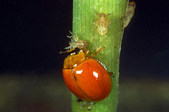
Common name: Lady beetle
Scientific name: Micraspis crocea (Mulsant)
Life Habits:
Micraspis crocea is a very active beetle. In daytime, it stays in the upper half of the canopy in dryland and wetland habitats.
Both the adults and larvae feed on small hoppers such as the brown planthopper. They also prey on small larvae and exposed eggs.
Parasitic and Predatory Characteristics:
Micraspis crocea is an oval beetle. It is yellow with a pair of black spots on the head or pronotum. The elytra are devoid of any markings. The insect is 4 to 5 mm long.
Host Name: Leafhoppers, planthoppers, leaf-feeding insects, and aphids

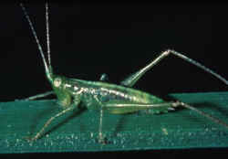
Common name: Meadow grasshopper
Scientific name: Conocephalus longipennis (de Haan)
Life Habits:
The adult is active during the night and readily flies when disturbed. It is abundant in older fields.
The meadow grasshopper has dual food habits. Aside from being a predator, it also feeds on rice leaves and panicles. As a predator, it can consume 3 to 4 yellow stem borer egg masses daily. The adult lives 3 to 4 months.
Parasitic and Predatory Characteristics:
The green insect is distinguished from other grasshoppers by its long thread-like antennae. It is a large insect with slanted face. The thorax and abdomen are yellow. It has 4-segmented tarsi.
The female adult has an elongated ovipositor.
The nymphs are green and have no wings. The female nymphs lack the sword-like ovipositor.
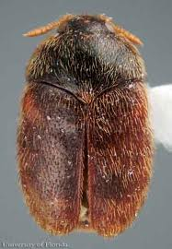
Host Name: Eggs of rice bugs and stem borers and nymphs of leafhoppers and planthoppers.
Common name: Khapra beetle
Scientific name: Trigoderma granarium
Life Habits:
Adult khapra beetles have wings, but apparently do not fly and feed very little. Mated females live from four to seven days, unmated females from 20 to 30 days, and males from seven to12 days.
Mating occurs about five days after emergence, and egg laying begins almost immediately at 40°C. Egg laying may begin at one to three days at cooler temperatures, but no eggs are produced at 20°C. Eggs hatch in three to 14 days after the female lays an average of 50 to 90 eggs that are loosely scattered in the host material. Complete development from egg to adult can occur from 26 to 220 days, depending upon temperature.
Development can occur at a relative humidity as low as 2%. In comparison, high relative humidity may be the limiting factor in the survival of khapra beetles in introductions (Howe and Lindgren 1957). In humid climates, it does not compete well with other better adapted species (Anonymous 1981).
Parasitic and Predatory Characteristics:
Adult beetles are brownish and 1.6-3 mm long. Immature larvae are up to 5 millimeters long and are covered in dense, reddish-brown hair. The eggs of the khapra beetle are cylindrical with one end more rounded and the other more pointed, about 0.7 mm long and 0.25 mm broad, weighing about 0.02 mg. The pointy end has a number of spine-like projections. The eggs are initially a milky white but over several hours turn a pale yellowish color
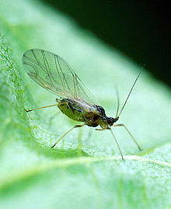
Common name: green peach aphid
Scientific name: Myzus persicae (Sulzer) (Insecta: Hemiptera: Aphididae)
Life Habit:
The winter host is peach, Prunus persica, which is confined to small numbers in southern Britain. So, although some eggs overwinter on peach, overwintering is usually in the mobile stages on herbaceous plants, weeds and brassicas. The summer hosts are very numerous and spread over 40 plant families, and include very many economically important plants.
Winged forms start to migrate from their winter hosts to fresh summer hosts from late April to early June. Numbers reach a peak in July. However this aphid does not form dense colonies, but tends to move when crowded by walking to infest other parts of the same or neighbouring plants. Redistribution in late summer to other crops or wild herbaceous plants is followed by a return migration to winter hosts in late September and early October.
Parasitic and Predatory Characteristics:
Eggs
In temperate regions, these aphids overwinter during the egg stage. The shiny black eggs are often laid on the bark of fruit trees. No eggs are found in Hawaii.
Nymphs
Immature aphids are called nymphs. They are pale yellowish-green in color with three dark lines on the back of the abdomen that are not present on the adult. In Hawaii there are four nymphal stages. Nymphal development is completed in 6 to 11 days (Toba, 1964).
Adults
The wingless adult aphids vary in color from green to pale yellow. Winged adults, are green with black or dark brown markings on their abdomens. Adults are small to medium sized aphids from 1/25 to 1/12 inch long and their antennae are 2/3 as long as the body. Adult females give birth to approximately 50 nymphs.
Host Name:
The green peach aphid has many host plants. Agricultural crops include: broccoli, burdock, cabbage, carrot, cauliflower, Chinese broccoli, daikon, eggplant, flowering white cabbage, green beans, head cabbage, lettuce, macadamia, mustards cabbage, papaya, peppers, sweet potato, tomato, watercress and zucchini. This aphid also attacks many ornamental crops such as carnation, chrysanthemum, flowering white cabbage, poinsettia and rose.

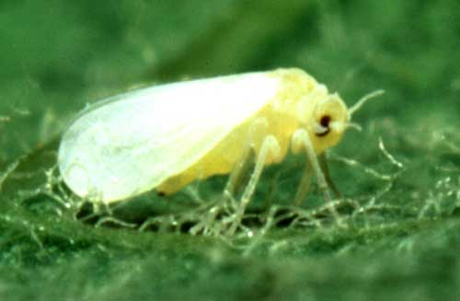
Common Name: Silverleaf whitefly
Scientific name: Bemisia tabaci
Life Habit:
The whitefly thrives worldwide in tropical, subtropical, and less predominately in temperate habitats. Environments with cold temperature often lead to the mortality of both adult and larvae of the species.
The whitefly can be confused with other insects in its species such as the common fruitfly but with close inspection, the whitefly is slightly smaller and has a distinct wing color that helps to differentiate it from other insects.

Parasitic and Predatory Characteristics:
Eggs
Pear-shaped with a pedicel spike at the base, about 0.2 mm long.
Puparium
Flat, irregular oval shape, 0.7 mm long. On a smooth leaf the 'puparium' lacks enlarged dorsal setae but, if the leaf is hairy, two to eight long dorsal setae are present.
Adult
About 1 mm long, the male slightly smaller than the female. The body and both pairs of wings are covered with a powdery, waxy secretion, white to slightly yellowish. Differentiation of whitefly species by means of the adults is difficult, although close observation of adult eye morphology will often show differences in ommatidial arrangements between species. However, at rest B. tabaci has wings more closely pressed to the body than Trialeurodes vaporariorum which is larger and more triangular in appearance.
Host:
Bemisia is widely polyphagous, feeding on over 500 species of plants in 74 families. Its hosts include vegetable, field, and ornamental crops. Of the important vegetables crops grown in Florida, Bemisia is a major pest of tomato, peppers, squash, cucumber, beans, eggplant, watermelon, and cabbage. The Florida-grown field crops of potato, peanut, soybean and cotton are heavily attacked by Bemisia.
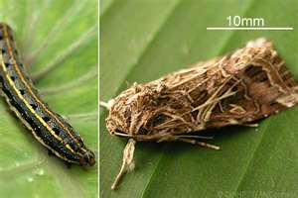
Common Name: Tobacco caterpillar
Scientific Name: Spodoptera litura
Life Habits: Females lay eggs in masses of 200 to 300 eggs that are approximately 4-7 mm (0.16-0.27 inches) in diameter and cream to golden brown in color. Egg masses are usually covered with body hair scales and laid on the underside of the host plant leaf.
Eggs usually hatch between three to four days. Young larvae or caterpillars are a translucent green with a dark thorax. They are smooth-skinned with a pattern of red, yellow, and green lines, and with a dark patch on the back of the head (mesothorax). Feeding is initially by skeletonizing, or leaving the outline of the leave veins on the plant. As growth continues, caterpillars eat entire leaves, and even flowers and fruits. The Caterpillar burrows into the soil several centimeters and there pupates without a cocoon. While pupating, it produces large amounts of fluid. Attempts to allow pupation in captivity within an empty glass jar have resulted in drowning. The pupal stage lasts either a few weeks or several months in Australia, depending upon time of year. The average life cycle will be completed in about 25 days.
Parasitic and Predatory Characteristics:
Eggs
The eggs are spherical, somewhat flattened, and 0.6 mm in diameter. They are usually pale orange-brown or pink in colour, laid in batches and covered with hair scales from the tip of the abdomen of the female moth. Egg masses measure about 4-7 mm in diameter and appear golden brown because they are covered with body scales of females.
Larva
The larva is hairless, variable in colour (young larvae are light green, the later instars are dark green to brown on their backs, lighter underneath); sides of body with dark and light longitudinal bands; dorsal side with two dark semilunar spots laterally on each segment, except for the prothorax; spots on the first and eighth abdominal segments larger than others, interrupting the lateral lines on the first segment. Though the markings are variable, a bright-yellow stripe along the length of the dorsal surface is characteristic of S. litura larvae.
Pupa
The pupa is 15-20 mm long, red-brown; tip of abdomen with two small spines.
Adult
Moth, with grey-brown body, 15-20 mm long; wingspan 30-38 mm. The forewings are grey to reddish-brown with a strongly variegated pattern and paler lines along the veins (in males, bluish areas occur on the wing base and tip); the hindwings are greyish-white with grey margins, often with dark veins in S. litura (but without in S. littoralis).
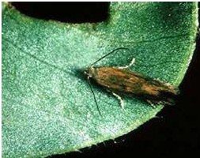
Hosts:It has a very wide host range of over 120 plant species, including: lettuce, cabbage, beetroot, peanuts, geranium, cotton, banana, fuchsias, acacia, African oil palm, amaranth, alfalfa, strawberry, sorghum, sugarcane, tomatoes, asparagus, apple, eggplant, beet, beans, broccoli, elephants ear, horsetail she oak, corn, flax, lantana, papaya, orange, mango, leek, among many others
Common name: Groundnut leafminer
Scientific name: Aproaerema modicella
Life Habit: The adult is a tiny moth measuring about 6 mm in length with brownish grey coloured wings. Female lays shiny white eggs singly on the underside of leaves near the midrib. Incubation, larval, pupal and adult period lasts for 10, 15-20, 5-7 and 10 days, respectively.
The young larva mines the leaves resulting in small brown blotches on the leaf.
During 3rd instar, the larva comes out of the mine and web together two halves of a leaf or one or more leaves to form a refugium from which they feed on the leaf tissue. In severe cases the field shows a burnt up symptom.
Parasitic and Predatory Characteristics:
Adult : Brownish grey moth.
Eggs : Adult lays about 200 shinning white eggs singly on the underside of the leaf lets close to midrib
Larva : Pale green color larva with black head.
Pupa : Brings edges of the leaf together and pupates inside it.
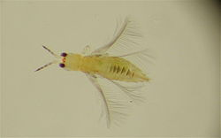
Common Name: chilli thrips or yellow tea thrips
Scientific Name: Scirtothrips dorsalis
Life habits: Chilli thrips appear to feed preferentially on new growth, and infested plants usually develop characteristic wrinkled leaves, and a distinctive brown

scarring along the veins of leaves, the buds of flowers, and the calyx of fruit.
Feeding damage can reduce the sale value of crops produced, and in sufficient numbers, kill plants already aggravated by environmental stress. This thrips has also been implicated in the transmission of three tospoviruses, but there is some controversy over its efficiency as a vector.
This thrips has a rapid life cycle, and can develop from egg to adult in slightly less than two weeks under optimal weather conditions.
Parasitic and Predatory Characteristics:
These characteristics increase the chance of transportation of S. dorsalis through international trade of fresh plant materials. Scirtothrips dorsalis life stages occur on all the above-ground plant parts of its hosts, and cause scarring damage due to feeding or the transmission of pathogens .
Generally, chilli thrips are pale colored and the lengths of their first and second instar larvae and the pupae are 0.37-0.39, 0.68-0.71 and 0.78-0.80 mm, respectively. Adults are about 1.2 mm long with dark wings and dark spots forming incomplete stripes which appear dorsally on the abdomen.
There are numerous microtrichia and dark transverse antecostal ridges on the abdominal tergites as well as sternites. On the lateral microtrichial fields of the abdominal tergites are three discal setae. The posteromarginal comb on segment VIII is complete. The shaded forewings are distally light in color with straight cilia. The forewings possess an incomplete second vein, or a row of setae with two or three irregular setae in the distal half and a complete first vein.
Host: Among the potential economically important hosts of this pest in Western Hemisphere listed by Venette and Davis (2004) are banana, bean, cashew, castor, citrus, cocoa, corn, cotton, eggplant, grapes, litchi, longan, mango, melon, peanut, pepper, poplar, rose, strawberry, sweet potato, tea, tobacco, tomato, and wild yams (Dioscorea spp.).
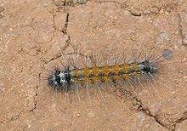
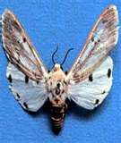
Common Name: Red Hairy Caterpillar
Scientific name: Amsacta albistriga
Life Habits:
The larvae defoliate various agricultural crops. After about thirty to forty days of feeding the larvae burrow into the soil to pupate.
Parasitic and Predatory Characteristics:
Adult : Moth having white colored wings with black spots.
Eggs : Cream colored round eggs laid in groups on plants and on any surface
like rocks near fields.
Larva : Neonates are sparsely hairy and grown up larvae have bright red
colored long hairs.
Pupa : Pupate in soil inside a hairy cocoon.

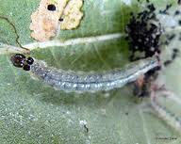
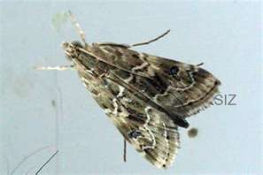
Common Name: Cotton leaf roller
Scientific name: Sylepta derogate
Life Habits:
The life cycle varies from 23 to 45 days, at times prolonged by larval aestivation and hibernation

Parasitic and Predatory Characteristics:
The moth is pale yellow in colour. The eggs are laid in rolled leaf cases. The larvae, on hatching, feed gregariously on the rolled leaf and subsequently migrate to form its own roll, where they feed. Pupation is in the soil or litter.
Host Name:
The pest is polyphagous, and attacks agricultural crops and forest plants apart from several bamboo species.

REFERENCES:
http://www.daff.qld.gov.au/26_12323.htm
http://mrgoutham.blogspot.com/2011/05/rice-insect-pests-pictures.html
http://agbsc.blogspot.com/2011/05/entomology-crop-insect-pests.html
http://www.ext.colostate.edu/pubs/insect/05550.html
http://www.ag.ndsu.edu/pubs/plantsci/pests/e1228w.htm
http://www.knowledgebank.irri.org/ipm/predators/meadow-grasshopper/scientific-name-conocephalus-longipennis-de-haan.html
http://insects.tamu.edu/ffa/senior/introduction.html

