Guinea grass
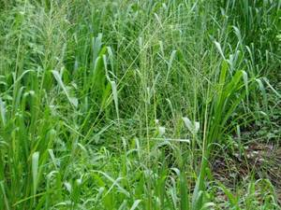

Guinea grass (Megathyrsus maximus (Jacq.) B. K. Simon & S. W. L. Jacobs) is a large tufted, fast-growing perennial grass. It has a broad morphological and agronomic variability, ranging in height from 0.5 to 3.5 m, with stems of 5 mm to 10 mm diameter. There are two main types: a tall/medium tussock type, taller than 1.5 at flowering, and a short tussock type (Cook et al., 2005). The root is a short creeping rhizome; culms are erect, hirsute at the nodes. Leaves are blade-shaped, glabrous to pubescent up to 35 mm broad. Inflorescence is a panicle, 15 to 50 cm long. Spikelets are 3-4 mm green to purple (Ecoport, 2009).
Guinea grass is one of the major pantropical grasses and is suitable for pasture, cut-and-carry, silage and hay. Many Guinea grass cultivars have been developed for different purposes and agronomic situations (FAO, 2009).
Nutritional value:
Steers can graze Guinea grass (Difante et al., 2009). As grass rest-period affects animal performances, a good rest-period is 2.5 leaves/tiller (Candido et al., 2005) and the best organic and dry matter digestibilities are obtained with young regrowth (Peiris et al., 1995). Intercropping or supplementing Guinea grass with legumes is a good strategy: it increases Ca, P, Na and Fe solubility (Ajayi et al., 2009) as well as DM intake (Akinlade et al., 2005) and does not alter meat quality (Jaturasitha et al., 2009). Guinea grass cv. Monbaca gives higher daily weight gain while cv. Masai allows higher stocking rate (Euclides et al., 2008).
Cows grazing Guinea grass can yield 10 to 12 kg milk/day at 2.5 head/ha with good sward persistence and high forage quality (Lima et al., 2006; Lamela et al., 1995). Dairy heifers register 1 kg daily weight gain (DWG) on cv. Tobiata at 2.3 head/ha (Costa et al., 2001). Supplementing cows or dairy heifers fed on Guinea grass always enhances animal performances. Feed concentrate or feed concentrate + legume give greater milk yields in cows (Goncalves et al., 2005; Razz et al., 2007; Goncalves et al., 2003), higher weight gain (+35 %) in heifers (Rodrigues Filho et al., 2004).
Adding 60 % autoclaved broiler litter to Guinea grass based diet in Zebu heifers increases digestible nutrients intake and heifers body weight gain.

Sheep
Guinea grass can be grazed, dried to make hay or ensiled. When sheep are fed on Guinea grass hay-based diet, urea treatment or supplementation with poultry manure can help to improve feed conversion ratio and growth performances. Exogenous fibrolytic enzyme had no effect on ruminal digestibility of Guinea grass hay.
When Guinea grass is grazed, its nutritive value often depends on cultivar. Cv. Aruana contains more crude protein than cv. Tanzania but none of them meet ewe lambs nutritional requirements. The same deficiency is reported with cv. Gatton during winter (Relling et al., 2001and with a Fiji-native Guinea grass. It is suggested to supplement Guinea grass with a concentrate or with a legume. Ensiled Guinea grass has a good texture and it is possible to mix grass of different ages with no effect on silage quality. Iodinated casein was found to increase rumen potential degradability of Guinea grass.
Calopo
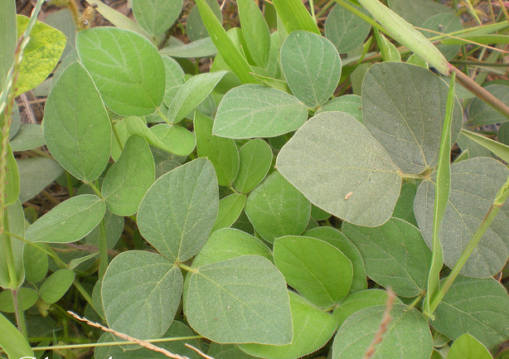

Calopo (Calopogonium mucunoides Desv.) is a vigorous, hairy annual or short–lived perennial trailing legume. It can reach several metres and form a dense, tangled mass of foliage, 30-50 cm deep. The root system is dense and shallow, at most 50 cm deep. The stems are succulent, covered with long, brown hairs. They are creeping in the lower parts, sometimes rooting at the nodes that come in contact with the soil. The upper part of the stem is twining. The leaves are up to 16 cm long, trifoliate. The hairy leaflets are 4-10 cm long x 2-5 cm broad, ovate to elliptical. The inflorescence is a slender hairy raceme that may be up to 20 cm long and that bears 2 to 12 blue or purple small flowers. The Fruits are 3-8 seeded hairy pods, 2-4 cm long.
Nutritional Value:
Like many other legume forages, the nutritive potential of Calopogonium mucunoides lies in its protein content. However, a rather wide range of protein content has been reported, from 5 % to 24 %, depending on the material eaten (full browse or leaves), position on the plant (top of the plant is more nutritious) and stage of maturity.
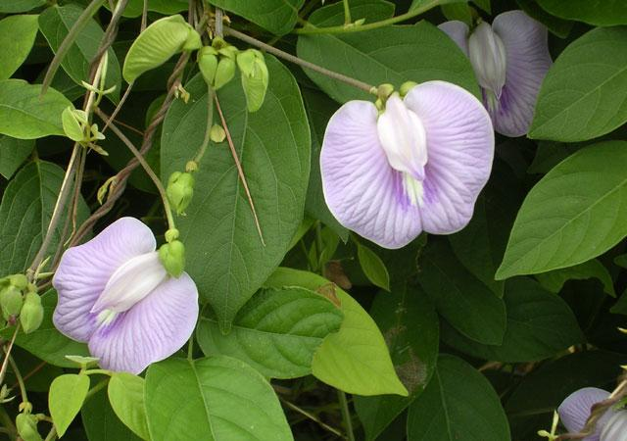
Centro

Centro (Centrosema molle Mart. ex Benth.) is a vigorous twining, trailing and climbing perennial legume. It has a deep root-system with tap roots and lateral roots. Leaves are dark green, trifoliate (Ecocrop, 2009). Leaflets are ovate, 4 cm long x 3.5 cm broad. Flowers, borne in axillary racemes, are bright or pale lilac with violet stripes. Pods are linear, slightly twisted, 7.5 cm to 15 cm long, becoming dark brown when ripe. They contain up to 20 seeds
Nutritional Value
Excellent feeding value. Moderate to high dry matter digestibility (45-65%), highest for young leaf and stem. Crude protein levels are relatively high for a tropical pasture legume and range from 17-26%, again highest in immature forage.
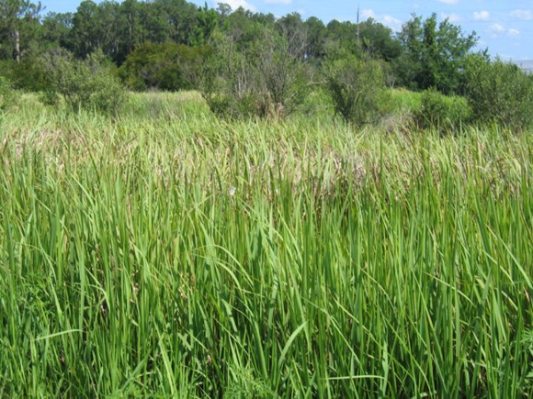
Cogon

It is a perennial rhizomatous grass native to east and southeast Asia, India, Micronesia, Melanesia, Australia, and eastern and southern Africa. It grows from 0.6–3 m (2–10 feet) tall. The leaves are about 2 cm wide near the base of the plant and narrow to a sharp point at the top; the margins are finely toothed and are embedded with sharp silica crystals. The main vein is a lighter colour than the rest of the leaf and tends to be nearer to one side of the leaf. The upper surface is hairy near the base of the plant while the underside is usually hairless. Roots are up to 1.2 meters deep, but 0.4 m is typical in sandy soil.
Nutritional value:
Root: metabolites that have been found on the roots of the reeds ter.diri arundoin, fernenol, isoarborinol, silindrin, simiarenol, kampesterol, stigmasterol, ß-sitosterol, scopoletin, skopolin, p-hidroksibenzaladehida, catechol, chlorogenic acid, isoklorogenat acid, acid p-kumarat, neoklorogenat acid, acetic acid, oxalic acid, malic acid d-, citric acid, potassium (0.75% by dry weight), large amounts of calcium and 5-hidroksitriptamin. From the results of other studies on the roots and leaves was found five kinds of derivatives are derivatives of flavonoid 3 ', 4' 0.7-trihydroxy flavone, 2 ', 3'-dihydroxy-hydroxy kalkon and six flavanol. A possible derivative of flavonoids, including flavone group, the substituted flavonol 3-0H, flavanone or the isoflavones contained in the soluble fraction in ethyl acetate extract of the roots of the reeds. In the fraction of water-soluble extract of the roots of the reeds of the flavonoids found in groups without free OH groups, flavones, flavonols substituted at the 3-0H, flavanone, or isoflavones.
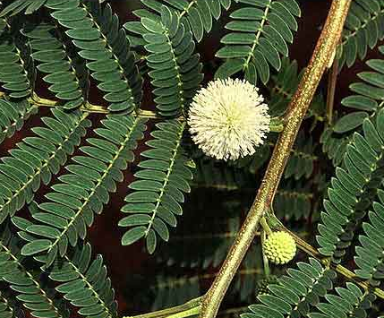
Ipil-ipil

Ipil-ipil is a small tree growing up 8 meters high. Leaves are compound, 15 to 25 centimeters long, with hairy rachis. Pinnae are 8 to 16, and 5 to 8 centimeters long. Leaflets are 20 to 30, linear oblong, and 7 to 12 millimeters long. Heads are solitary, at the axils of the leaves, long-peduncled, globose, and 2 to 5 centimeters in diameter, with many flowers. Flowers are whitish, in dense globue heads, 2 to 3 centimeters in diameter. Fruit is an oblong or linear pod, strap-shaped, 12 to 18 centimeters long, 1.4 to 2 centimeters wide, papery, green turning to brown and splitting open along two edges when mature, and several fruits developing from each flower head. Each pod contains 15 to 25 elliptic, compressed, shining, brown seeds, each 5 to 8 millimeters long, 3 to 5 millimeters wide.
Nutritional Value:
Its nutritional value is comparable with that of alfalfa with high ß-carotene content. The content in condensed tannins (2.6 %) in the leaves and stems reduce DM digestibility but enhances by-pass protein.
Feeding dairy cows on cut-and-carry leucaena foliage increases milk production by 14% on average and also increases milk fat and protein contents. Dairy cows grazing Brachiaria decumbens/Leucaena leucocephala produce higher milk yield than cows fed on the grass only cut-and-carry. Cows fed Leucaena leucocephala eat less concentrate and do not need to be fed on heavy fertilized grasses. They also have higher live weight gain. However, diets containing high amounts of leucaena foliage are detrimental to reproduction in heifers or cows whose rumen is not inoculated with DHP-degrading bacteria: stillborn calves are numerous, calving percentage is poor (66% vs. 88%), and calf weight at birth is lower. It is recommended to inoculate heifers before pregnancy or limit access to leucaena during early pregnancy.

Kikuyu
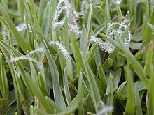

Pennisetum clandestinum is a rhizomatous grass with matted roots and a grass-like or herbaceous habit. The leaves are green, flattened or upwardly folded along the midrib, 10-150 millimetres long, and 1-5 mm wide. The apex of the leaf blade is obtuse.[4] It occurs in sandy soil and reaches a height of between 70 to 150 millimetres. The species favours moist areas and frequently becomes naturalised from introduction as a cultivated alien.[5] Rooted nodes send up bunches of grass blades. It is native to the low-elevation tropics of Kenya and environs, where it grows best in humid heat, such as the wet coastal areas.
Nutritional Value:
Well-fertilised kikuyu produces very high quality feed with over 25% CP and over 70% IVDMD in young leaf. CP levels tend to stay high for 1 or 2 weeks and then decline rapidly, to below 10% within 12 weeks. Digestibility also falls to <50% in the same period. Sodium levels (at 0.02–0.05% Na) can be deficient for lactating cattle, and calcium levels, although optimal for lactating cows, may be inadequate due to “tie-up” with oxalate. P levels change with season, falling as the species became dormant. A fall in P and a rise in Ca content results in a high Ca:P ratio (2.5:1) in spring. Optimum quality coincides with the 4½ leaf stage of regrowth.
For good silage fermentation, kikuyu needs to be wilted first or have extra sugar added because of its low DM and low water soluble carbohydrate content.
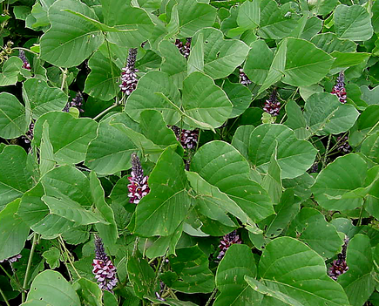
Kudzu

It is a climbing, coiling, and trailing vine native to southern Japan and south east China. Its name comes from the Japanese name for the plant, kuzu (クズ or 葛?), which was written "kudzu" in historical romanizations. Where it occurs as an invasive species, it is considered a noxious weed that climbs over trees or shrubs and grows so rapidly, it kills them by heavy shading.[3] The plant is edible, but often sprayed with herbicides.
Nutritional Value:
Kudzu can be used by grazing animals, as it is high in quality as a forage and palatable to livestock. It can be grazed until frost and even slightly after. Kudzu had been used in the southern United States specifically to feed goats on land that had limited resources. Kudzu hay typically has a 15–18% crude protein content and over 60% total digestible nutrient value. The quality of the leaves decreases, however, as vine content increases relative to the leaf content. Kudzu also has low forage yields despite its rate of growth, yielding around two to four tons of dry matter per acre annually. It is also difficult to bale due to its vining growth and its slowness in shedding water. This makes it necessary to place kudzu hay under sheltered protection after being baled. Kudzu is readily consumed by all types of grazing animals, yet frequent grazing over three to four years can ruin stands. Thus, kudzu only serves well as a grazing crop on a temporary basis.
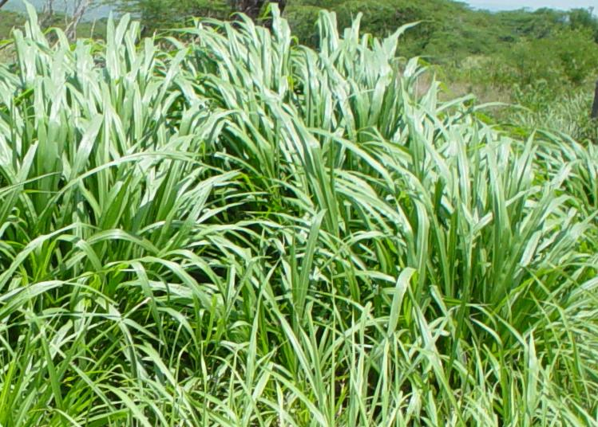
Napier

Pennisetum purpureum is a monocot C4 perennial grass in the Poaceae family.[4] It is tall and forms in robust bamboo-like clumps. It is a heterozygous plant, but seeds rarely fully form; more often it reproduces vegetatively through stolons which are horizontal shoots above the soil that extend from the parent plant to offspring. This species has high biomass production, at about 40 tons/ha/year and can be harvested 4-6 times per year. Additionally it requires low water and nutrient inputs.
Napier can be propagated through seeds, however as seed production is inconsistent, collection is difficult. Alternatively, it can be planted through stem cuttings of the stolons. The cuttings can be planted by inserting them along furrows 75 cm apart, both along and between rows.
Nutritional Value:
Napier grass obtained from cutting at short intervals is palatable and nutritive and animals gain in their live- weight. The chemical composition of the green grass and hay (dry grass) is given in table -1. The fodder tends to get course, hard, fibrous and non-palatable as its cutting is delayed. The culms become thick, woody which are rejected by the cattle and go as waste.
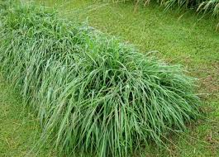
Pangola grass

Pangola grass (Digitaria eriantha Steud) is an extremely variable species, comprising a number of morphologically different former species. They are perennial grass, sometimes stoloniferous or tufted and rhizomatous. The stolons spread over the surface of the ground and develop roots at the nodes. The stolons and stems are hairy but the leaf blades are straight and smooth. The flowering head normally extends above the leaves, topped with six or seven radiating flower spikes. Very few viable seeds are produced.
Nutritive Value:
Pangola grass is one of the higher quality tropical grasses. Crude protein values range from 5 to 14 %, and may exceed 15 % with young regrowth age and high fertilization. Relatively low variation is registered in cell wall content with regrowth age but modifications are observed in cell composition becoming more and more lignified. Like all tropical grasses, chemical and nutritive value of pangola grass vary with several factors like age of regrowth, season, fertilizer and genotype. The regrowth age is the main factor of variation. Pangola grass has relatively high concentrations of Na in its tissues, compared with many other tropical grasses. Large variations are reported for in vivo total tract digestibility: 40-70 %. Large variations of voluntary dry matter consumptions are also reported: 50 to 90 g/W^{0.75} on sheep.
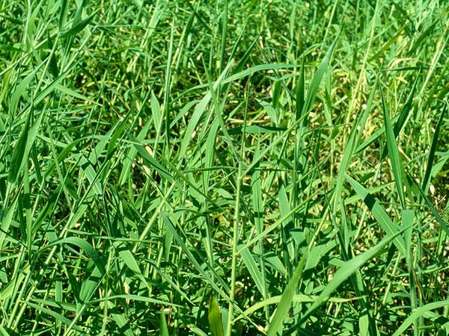
Paragrass

Para grass is a perennial grass up to about 1 m tall. The stems are hollow and robust, creeping in a prostrate growth habit. Stems stand erect towards the ends, and sprout new roots wherever the nodes touch the ground. Leaf blades are hairy and dark green in colour. They are usually up to 15 cm long and less than 1 cm wide, tapering to a long, fine point. The leaf sheaths are also hairy, particularly where they join the stem. Flower heads are up to 18 cm long and are made up of several spikes, each about 5 cm long. Seeds cluster thickly along each of these spikes, although para grass seldom sets seed.
Nutritive Value:
A grass of high nutritive value, although DM intake by grazing stock may be reduced by high water content, including droplets of water held on the hairy leaves and stems. Actively growing para grass can have very high nutritive value, with 14–20% CP, and IVDMD of 65–80% for leafy regrowth and 55–65% IVDMD for whole top growth. Quality declines with maturity to 35–45% IVDMD for tops.

