FLEXIBILITY
Flexibility or limberness refers to the range of movement in a joint or of joints, and length in muscles that cross the joints. Flexibility varies between, particularly in of differences in muscle length of multi-joint muscles. Flexibility in some joints can be increased to a certain degree by exercise, with stretching a common exercise component to maintain or improve flexibility.
Quality of life is enhanced by improving and maintaining a good range of motion in the joints. Overall flexibility should be developed with specific joint range of motion needs in mind as the individual joints vary from one to another. Loss of flexibility can be a predisposing factor for physical issues such as pain syndromes or balance disorders.
Gender, age, and genetics are important for range of motion. Exercise including stretching often improves flexibility.
Many factors are taken into account when establishing personal flexibility: joint structure, ligaments, tendons, muscles, skin, tissue injury, fat (or adipose) tissue, body temperature, activity level, age and gender all influence an individual's range of motion about a joint.
Individual body flexibility level is measured and calculated by performing a sit and reach test, where the result is defined as personal flexibility score.

A simple static stretching routine
- Stretch only after warming up, or after exercise, when muscles are warm.
- Repeat each stretch 2 to 3 times, working both sides of the body equally.
- Hold each stretch for 10 to 30 seconds.
- Do not stretch to the point of pain.
- Breathe freely while stretching.
- Do not bounce.
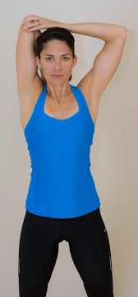
1. Triceps (back of upper arm) stretch

1. With your feet shoulder width apart, raise your right arm straight up and over your head.
2. Bend your elbow so that your right hand is reaching for your left shoulder.
3. Use your left hand to press back on your right elbow (photo). You will feel a great stretch in the back of your arm and upper shoulder.
4. Hold for 30 seconds, and repeat four times on each side.

2. Calf Stretch
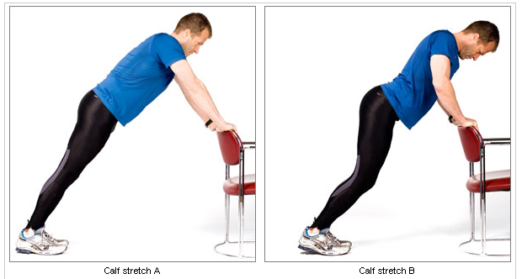

1. Stand with your feet shoulder length apart and your hands against a chair or a wall.

2. Keep your heels on the floor and your knees straight while leaning into the chair or wall (photo A). You will feel this stretch down the back of your legs.

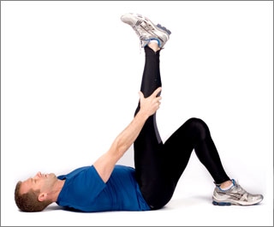
3. Hold for 30 seconds. Then bend your knees, and continue leaning in (photo B). Hold with bent knees for 30 seconds, then repeat with straight and bent knees four times.

3. Hamstring Stretch

1. Lie down with the small of your back against the floor.

2. Bend your left knee to 90 degrees to stabilize your hips.

3. Slowly raise your right leg off the ground with the knee as straight as possible. Your right hip should not rise off the floor, and the motion should come only from your hip (photo).

4. As your foot approaches vertical, you will feel a stretch in the back of your leg.

5. Hold your leg in this raised position for 30 seconds.

6. After 30 seconds, relax your knee, and then repeat three times before switching to the left leg.

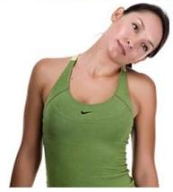
4. Neck side flexion

1. Starting Position: Stand with your feet hip-width apart, toes pointing forward or turned slightly outward; arms by your sides. Engage your abdominal muscles to stabilize your spine. Pull your shoulder blades down and back. Do not allow your low back to arch.
2. Slowly bring right ear toward your right shoulder stopping when you feel the stretch. Be sure to maintain body alignment keeping your shoulders down and back. Hold the stretch for 5-10 seconds. Slowly return to starting position. Repeat on the left side. Perform a total of 2-4 repetitions.
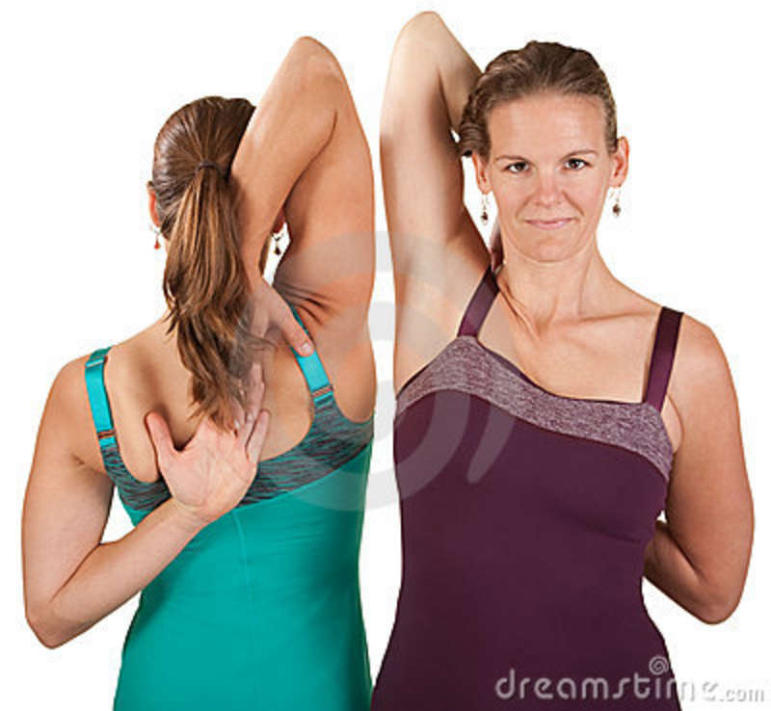
5. Shoulder stretch

1. Hold a towel between both hands as shown.
2. Gently pull the towel upwards with your left hand.
3. Feel the stretch in the shoulder of your right arm as this arm is gently pulled further up your back.
4. Repeat for the opposite shoulder.

6. Supraspinatus (top of shoulder blade) stretch

1. Cross your right arm in front of your chest, placing your right hand over your left shoulder and keeping your right arm parallel to the ground.
2. Use your left hand to push your right elbow gently towards your left shoulder.
3. Feel the stretch in the muscle across the top of your right shoulder blade.
4. Repeat for the opposite shoulder.

7. Pectoral (chest) stretch
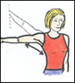

Place your right hand on a doorway at shoulder height with your elbow straight; move your feet so that you turn your chest and body gently away from your arm; feel the stretch on the right-hand side of your chest and along the inside of your right upper arm. Repeat for the opposite side. (You can also do the stretch with your arm slightly elevated, as shown.)

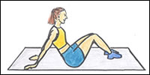
8. Biceps (front of upper arm) stretch

Sit on a floor mat with your feet flat on the floor in front of you and knees bent; place your hands flat on the mat behind you, fairly close together, with your fingers pointing away from you. Walk your hands away from your bottom to feel the stretch in the muscles at the front of your upper arms.

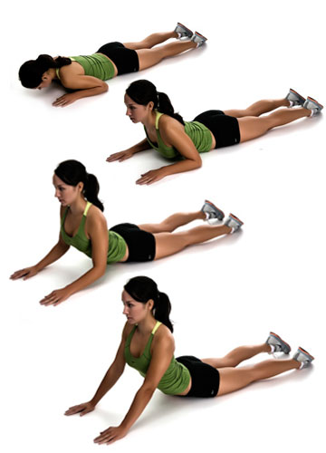
9. Lower back extension and abdominal stretch
(Note: if you have lower back problems this stretch may not be suitable for you.)
1. Lie face down on a mat on the floor with your hands in front of you, elbows slightly bent to make a diamond shape.
2. Straighten your elbows so that your chest begins to lift off the floor; feel the stretch along the front of your abdomen.
3. Be aware that having your hands close to your shoulders will produce a very strong abdominal stretch and a greater extension in your lower back, which may be uncomfortable for some people.

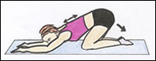
10. Upper back extension

Kneel on a floor mat on all fours (i.e. on your hands and knees). Gently stretch your arms out in front of you along the floor while allowing your head to drop towards the floor and your bottom to move towards your heels; feel the stretch in your upper back between your shoulder blades. Gently walk your fingertips away from your body for a stronger stretch in the shoulders. Work on keeping your tail bone as close to your heels as possible.

11. Side stretch

Stand with your feet shoulder-width apart. Bend your upper body to the right while continuing to face the front and not allowing your hips to rotate; at the same time use your right hand to push your right hip gently in the opposite direction; feel the stretch along the left-hand side of your torso. Repeat for the opposite side.

12. Quadriceps (front of thigh) stretch
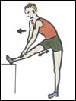

Steady yourself by resting your left hand on a wall; keep an upright posture and lift your right foot off the ground. Bend the right knee and grasp your right ankle with your right hand; gently pull your ankle up and back until you feel a stretch in the front of your right thigh. Your left leg should be slightly bent at the knee. Repeat for the opposite leg.

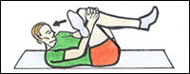
13. Gluteal (bottom muscle) stretch

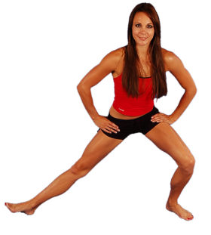
Lie on your back on a floor mat with your knees bent, hip-width apart, and feet flat on the floor; lift your left leg and place your left ankle across your right knee; clasp your fingers around your right knee; now lift your right foot off the ground and pull your right knee towards you to feel a stretch in the gluteal muscles of your left buttock. Your head can be on the floor if this is more comfortable. Repeat for the opposite side.

14. Adductor (groin) stretch

Standing upright, place your hands on your hips for balance, and your feet slightly wider than shoulder-width apart; keep your feet pointing to the front and lunge sideways taking your weight on your left foot and bending your left knee; feel the stretch in your right groin. Repeat for the opposite side.

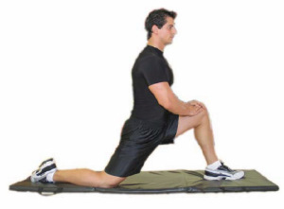
15. Hip flexor (front of hip) stretch

Kneel by placing your right knee on a padded mat and your left foot flat on the floor in front of you and forward of your left knee; steady yourself by keeping your posture upright and resting your hands on your left knee; don’t let your left knee project forward of your foot; gently push your hips forwards to feel a stretch at the front of your right hip. Keep your gluteal muscles contracted to keep your bottom down. Repeat the stretch for the opposite side.

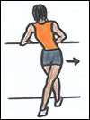
16. Tensor fascia (outer hip area) stretch

Rest your hands on a table or wall in front of you for balance; cross your right leg behind your left, placing your feet about a foot-length apart; try to keep your posture fairly upright while pushing your right hip outwards; feel the stretch along the outer side of your right hip. Repeat for the opposite hip.

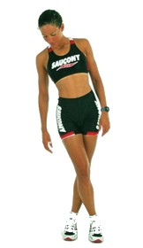
17. Iliotibial band (outer thigh area from hip to knee) stretch

Stand with your left side at roughly arm’s length from a wall and place your left hand on the wall for balance; cross your right leg in front of your left leg; now, with your weight mainly on your left leg, lean your left hip towards the wall; feel the stretch down the outside of your left leg from your hip to your knee, which is the area of the iliotibial band. Repeat for the opposite leg.

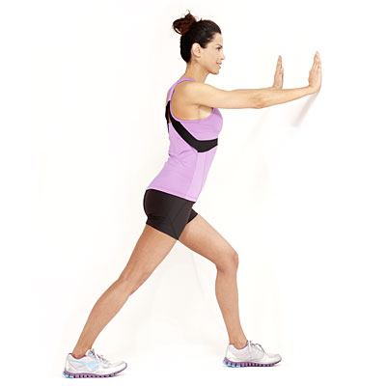
18. Calf stretch

Stand facing a wall and place your hands on the wall at eye level; step your right leg back; bend the front knee and gently lean into the wall while keeping your back leg straight and the heel of your back foot on the ground; feel the stretch in the back of your right calf. Repeat for the other side.

Submitted by:
Group 4

Embrace Life's Most Frustrating Moments
By Connie Criscitello • Posted on September 11, 2013
Last week I locked my keys in my car not once, but twice! The second time it stressed me out so much, I actually started crying, thinking no one has luck this bad. Later that day I became curious about whether or not someone can actually have more bad luck than someone else, and did a little research on the subject. I learned 3 things from the brief research I did:

1. Everyone has these daily annoyances and no one's LUCK is any worse than anyone else's; however our ability to handle the stress related to these annoyances varies greatly.
2. My ability to handle the stress associated with daily annoyances was very low. It's actually called Low Frustration Tolerance.
3. Every time you experience a daily annoyance, you have to be aware that somewhere hidden under the layers of frustration, there most definitely IS a silver lining (for example, the second time I locked my keys in my car, my daughter came over and helped me get them out and we talked an laughed as she sat on top of my vehicle, and we succeeded in our efforts).

I know there are at least a half dozen people who experienced daily annoyances on September 11, 2001, who now have the Highest Frustration Tolerance imaginable; they should have been in the WTC that day, but weren't because:

An Employee who arrived late to work because his son started kindergarten
A man had to go out of his way to get donuts for the office.
One woman was late because her alarm clock didn’t go off in time.
Another woman missed her bus.
One man's car wouldn't start.
Another employee couldn't get a taxi.
One man got stuck on the New Jersey Turnpike because of an accident.
A woman spilled a whole cup of coffee right down the front of her clothes and had to take time to change.
As he walked out the door for work, a man begrudingly went back in his house to answer the telephone.
One woman was late because her child dawdled and didn't get ready as soon as he should have, so they were both running late.
One man put on a new pair of shoes that morning and developed a blister; He is alive today because he stopped at a drugstore to buy a Band-Aid.
Look for the silver linings in your annoyances and then celebrate and embrace the fact you locked yourself out of your apartment for the 4th time this month (and get an extra key made).

