B. Common Parasites and Predators of Insect Pests

INTRODUCTION
Entomology is the study of insects, the most abundant form of animal life on earth. Three quarters of a million species of insect have already been described and estimates for the number of species awaiting discovery range from 1 million to 30 million. So for any budding entomologists out there, you have an excellent chance of discovering a new species!
Given that there are so many species of insect, it follows that insects are a major component of the earth's biodiversity. They inhabit every terrestrial and freshwater ecosystem and by studying the ecological roles insects play we can have a better understanding of how those ecosystems function. Insects have important roles as plant consumers and herbivores, a food source for other organisms, scavengers and detritivores, predators and parasites. Insects also directly affect human welfare by competing with us for food and transmitting diseases. However, not all insects are detrimental to human welfare. For example, bees are used to produce honey, silkworms to produce silk and many predatory species are used to control crop pests.

OBJECTIVES
- Identify common parasites and predators of insect pests.
- Explain how these pests affect plants.
- Discuss control measures for insect pests.

METHODOLOGY
- Scan and download from the website about parasites or predators of common insect pest and study their life habits, their parasitic and predatory characteristic, their host ranges and other special features about them.

RESULTS AND DISCUSSION
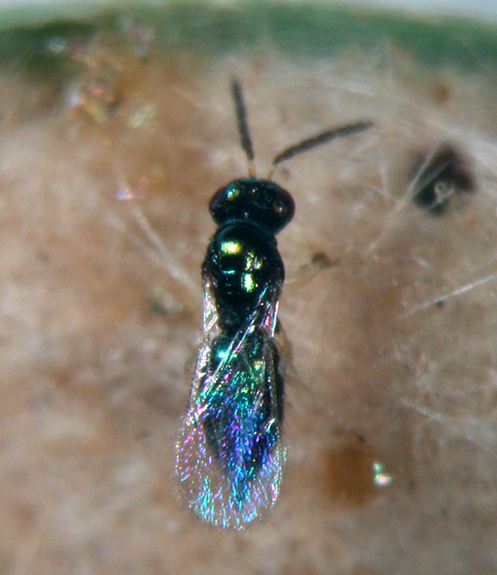
Common name: Eulophid wasp
Scientific name: Tetrastichus schoenobii Ferriere
Life Habits:
Tetrastichus schoenobii parasitizes stem borer eggs and pupae.

Several wasps may parasitize an egg mass of stem borers. Before oviposition, the female examines the egg mass for where to probe through the hair mat.
Each female parasitoid lays one egg in each stem borer egg. It can produce 10 to 60 offspring. Egg incubation takes 1 to 2 days. Larval development takes place inside the egg host. Once the egg is consumed, the larval parasite moves out from the egg and locates another egg host for its development. Each larval parasite needs three eggs for its development. Adulthood is observed after 1 to 2 days.
Parasitic and Predatory Characteristics:
Tetrastichus schoenobii is a metallic blue-green or shining green with bluish luster insect. It has an 8-segmented brown antenna except for the yellow scape. The hairs clothing the wings are not in rows. The thorax is smooth and shining and the abdomen is elongated and pointed. The legs are yellow except for the greenish coxae I and III. The tarsi are 4-segmented in all the legs.
Host Names: Tetrastichus schoenobii has been recorded as a primary parasitoid of shoot borers of rice and sugarcane, particularly Scirpophaga incertulas, S. excerptalis, S. innotata, Chilo suppressalis, C. infuscatellus (all Pyralidae), and also Sesamia inferens and Spodoptera mauritia (Noctuidae).
Hosts: moth & butterfly larvae are favorites, sometimes other taxa, some are genus/species specific

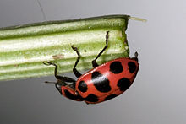
Common Name: Spotted lady beetle
Scientific Name: Coleomegilla maculata
Habitat:
These lady beetles can be seen wherever the insects on which they prey are found. Crops which support aphid populations include wheat, sorghum, sweet corn, alfalfa, soybeans, peas, beans, cotton, potatoes, brassicacious crops, tomatoes, asparagus and apples.
Besides aphids, they include in their diet adelgids, mites, insect eggs and small larvae. They also eat pollen which may constitute up to 50% of their food intake, nectar, water and honeydew. When normal prey is scarce, both adults and larvae sometimes exhibit cannibalistic tendencies, eating eggs, larvae and pupae of their own species.
Life Cycle:
A female beetle may lay up to 1,000 eggs in small groups in protected sites on stems and leaves over a three month period. The larvae actively seek out prey and may travel as far as twelve metres in their search for food. The larvae grow rapidly, moulting four times before attaching themselves by the abdomen to a leaf or other surface to pupate. The adult beetles emerge from three to twelve days later depending on the temperature. There are two to five generations per year. This species is most abundant in September when they congregate before mating and winter hibernation. They overwinter in large aggregations in leaf litter, under stones and in other protected sites at the edge of fields and hedgerows. They emerge in spring and look for suitable prey and egg laying sites in nearby crops, often dispersing by walking along the ground
Characteristics:
The spotted lady beetle is about six millimetres long, more flattened than most species of lady beetle, pink or red with six spots on each wing cover. The thorax is a similar shade of red with two large triangular black patches. The larvae resemble miniature alligators and are dark coloured. They have three pairs of legs and grow to about six millimetres long. The eggs are spindle shaped and laid upright in groups near potential prey

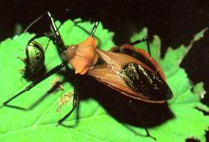
Common Name: Assassin bugs
Scientific name: Various species of the Reduviidae family
Characteristics:
Adults range from 10-30 mm in length, and have distinct heads with prominent eyes; their abdomens have a slight waist. The head is elongated with a long curved 'snout' (proboscis).
The proboscis is curved only in predatory bugs. Colour is variable, but usually includes brown, orange and/or black. The front legs are enlarged to grasp prey and the back legs are long and slender. The nymphs resemble adults but do not have wings.
The eggs are barrel-shaped and laid upright in clusters or rows on the leaves or stems of plants. Eggs hatch within two weeks and the wingless nymphs pass through five growth stages before reaching adulthood. As adults, assassin bugs may live for a further 6-10 months and lay up to 300 eggs in rafts of 30-60 eggs.
Host: Assassin bugs feed on many different insects, but tend to prefer softer-bodied prey such as caterpillars and small bugs such as green mirids.

REFERENCES
http://uptreeid.com/Health/_14-paraprey.html
http://bugguide.net/node/view/17772
http://en.wikipedia.org/wiki/Spotted_lady_beetle
http://www.daff.qld.gov.au/26_12326.htm

B. Common Parasites and Predators of Insect Pests
INTRODUCTION
Parasites are insects that live in or on other insects and feed off a particular host individual.Predators move around freely and eat as much prey as needed in order to complete their life cycle. Parasites can enter into predation modules in a variety of ways, and their consequences for population dynamics and community structure will depend on their position in the module.
Insects have incredibly diverse morphological, physiological, and behavioural adaptations to their surroundings which makes the study of insects a fascinating subject. Many features of insect biology also make them ideal to use as model biological systems. Their abundance, short life cycle, reproductive potential and small size allow scientific experiments to be set up, monitored and duplicated with relative ease in almost any location. Much of our basic understanding of genetics, population ecology, and evolution has resulted from experimentation with insects.

OBJECTIVES
- Identify common parasites and predators of insect pests.
- Explain how these pests affect plants.
- Discuss control measures for insect pests.

METHODOLOGY
- Select pictures of insects from the website about parasites or predators of common insect pest and study their life habits, their parasitic and predatory characteristics their host ranges and other special features about them.

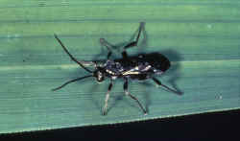
RESULTS AND DISCUSSION
Common name: Braconid wasp
Scientific name: Cardiochiles philippinensis Ashmead
Life Habits:
The parasitoid wasp is common in dryland and wetland rice environments.
The female deposits a single egg on its host by entering the folded leaves. The developing parasitoid larvae also feed externally on the host. Laboratory studies show that C. philippinensis can parasitize as many as 17 leaffolder larvae and live 22.7 days.
Parasitic and Predatory Characteristics:
Cardiochiles philippinensis is a black parasitoid of medium size. It has hairy eyes and black legs with white hairs. The brown front wings have infuscation after the stigmal vein. The hindwings are also brown with infuscation along the costal area, basal one-fourth, and apical one-fourth. The tips of both wings are dark.
The immatures, particularly the larvae of C. philippinensis, are creamy white.
Host Names: Leaffolder larvae
Hosts: moth & butterfly larvae are favorites, sometimes other taxa, some are genus/species specific
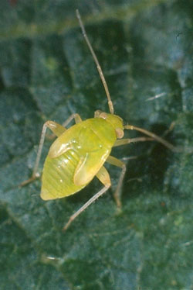
Common Name: Brokenbacked bug
Scientific name: Taylorilygus pallidulus
Characteristics: Adults are smaller (4-5 mm long) but stouter than green mirids and are light green with brown flecks on the inner wings, with the outer wings predominantly brown. Wing tips are bent down at 45° giving the 'broken-back' appearance. Nymphs are similar to green mirids but with pale yellow-green atennae that are much shorter than those of the green mirid. Very common on sunflowers but does not damage seeds.
Hosts: wide range of insect prey
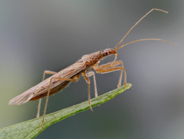
Common Name: Damsel bug
Scientific name: Nabis kingbergii
Characteristics: Damsel bugs are slender, dull tan to grey with long antennae and legs, and prominent eyes. Nymphs resemble the adults, but are wingless. Females lay white cylindrical eggs that are inserted into soft plant tissue so that the circular emergence caps protrude above the surface. The eggs hatch in 8-12 days and nymphs develop within 3-4 weeks.
Pest Attacked: A wide range including moth larvae and eggs, aphids, leafhoppers, mites, mirids, apple dimpling bug.
Habitat: gardens, orchards and field crops
Lifespan: Nymphs develop gradually through five nymphal instars on about 50 days to become adults. Damsel bugs have only one generation per year.

REFERENCES
http://books.google.com.ph/books?id=Ew4mugRi57sC&pg=PA90&lpg=PA90&dq=introduction+of+parasites+and+predators
http://aggie-horticulture.tamu.edu/galveston/beneficials/beneficial-04_braconid_wasp_on_hornworm.htm
http://www.daff.qld.gov.au/26_12332.htm
http://www.cottoncrc.org.au/industry/Publications/Pests_and_Beneficials/Cotton_Insect_Pest_and_Beneficial_Guide/Pests_by_common_name/Broken_back_bug

Mariano Marcos State University
College of Agriculture, Food and Sustainable Development
Batac City, Ilocos Norte

Crop Prot 30
Exercise 1
COLLECTION, IDENTIFICATION AND LIFE HISTORY STUDIES OF NATURALLY
OCCURRING PARASITES AND PREDATORS

Mendoza, Keshley
BSA- III-C

Mr. Eugine D. Ramos
(Instructor)

Mariano Marcos State University
College of Agriculture, Food and Sustainable Development
Batac City, Ilocos Norte

Crop Prot 30
Exercise 1
COLLECTION, IDENTIFICATION AND LIFE HISTORY STUDIES OF NATURALLY
OCCURRING PARASITES AND PREDATORS

Padulip, Romualdo Jun
BSA- III-C

Mr. Eugine D. Ramos
(Instructor)

