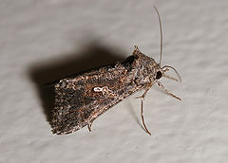
Common Name: Cabbage Looper
Scientific Name: Trichoplusia ni
Life Habit:
Development time (egg to adult) requires 18 to 25 days when insects are held at 32 to 21°C, respectively (Toba et al. 1973), so at least one generation per month could be completed successfully under favorable weather conditions. There is no diapause present in this insect, and although it is capable of spending considerable time as a pupa, it does not tolerate prolonged cold weather.
Parasitic and Predatory Characteristics:
Egg: Cabbage looper eggs are hemispherical in shape, with the flat side affixed to foliage. They are deposited singly on either the upper or lower surface of the leaf, although clusters of six to seven eggs are not uncommon. The eggs are yellowish white or greenish in color, bear longitudinal ridges, and measure about 0.6 mm in diameter and 0.4 mm in height. Eggs hatch in about two, three, and five days at 32, 27, and 20°C, respectively, but require nearly 10 days at 15°C (Jackson et al. 1969).
Larva: Young larvae initially are dusky white, but become pale green as they commence feeding on foliage. They are somewhat hairy initially, but the number of hairs decreases rapidly as larvae mature. Larvae have three pairs of prolegs, and crawl by arching their back to form a loop and then projecting the front section of the body forward. The mature larva is predominantly green, but is usually marked with a distinct white stripe on each side.
Pupa: At pupation, a white, thin, fragile cocoon in formed on the underside of foliage, in plant debris, or among clods of soil. The pupa contained within is initially green, but soon turns dark brown or black. The pupa measures about 2 cm in length. Duration of the pupal stage is about four, six, and 13 days at 32, 27, and 20°C, respectively.
Adult: The forewings of the cabbage looper moth are mottled gray-brown in color; the hind wings are light brown at the base, with the distal portions dark brown. The forewing bears silvery white spots centrally: a U-shaped mark and a circle or dot that are often connected. The forewing spots, although slightly variable, serve to distinguish cabbage looper from most other crop-feeding noctuid moths. The moths have a wingspan of 33 to 38 mm.
Host :
The cabbage looper feeds on a wide variety of cultivated plants and weeds. As the common name implies, it feeds readily on crucifers, and has been reported damaging broccoli, cabbage, cauliflower, Chinese cabbage, collards, kale, mustard, radish, rutabaga, turnip, and watercress. Other vegetable crops injured include beet, cantaloupe, celery, cucumber, lima bean, lettuce, parsnip, pea, pepper, potato, snap bean, spinach, squash, sweet potato, tomato, and watermelon. Additional hosts are flower crops such as chrysanthemum, hollyhock, snapdragon, and sweetpea, and field crops such as cotton and tobacco.

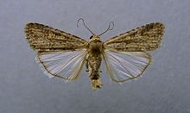
Common name: Beet armyworm
Scientific name: Spodoptera exigua
Life habit: In warm areas the beet armyworm moths may be found year round. In less tropical areas, these insects can survive the winter as pupae in the upper 6 cm of the soil. The extent of overwintering distribution, however, has not been adequately studied. In the spring, soon after mating, fertilized females begin laying eggs in clusters of about 80.
Approximately 600 eggs per female are deposited over a 3 to 7 day period. Moths die 4 to 10 days after emerging from pupae.
Parasitic and Predatory Characteristics:

Adult - The beet armyworm moth has a wingspan of 25 to 32 mm. Its forewings are mottled gray or brown with a pale spot near the center of each wing. Its hind wings are white with dark veins and have a fringelike border.
Egg - The white to pink, ribbed egg is roughly spherical in shape and slightly peaked on top. Scales and hairs from the moth give the egg cluster a gray, fuzzy appearance.
Larva - This green or black caterpillar has a dark head, five pairs of prolegs, and sometimes three light colored stripes running the length of the body. On the second segment behind the head, there is a small, black spot on each side of the body. This spot usually becomes visible to the field observer when the caterpillar reaches 7 or 8 mm long; however, the spot may be difficult to see on a dark caterpillar. About 1 mm long when newly emerged, a larva may be 25 to 30 mm long when fully grown. Color plate.
Pupa - About 15 to 20 mm long, the pupa is light brown with dark brown margins along the abdominal segments.
Host :
The beet armyworm infests many weeds, trees, grasses, legumes, truck crops and field crops. It is of economic concern upon cotton, corn, soybean, tobacco, alfalfa, table and sugar beets, pepper, tomato, potato, onion, pea, sunflower and citrus. In addition, plantain, lambsquarters and redroot pigweed are attractive wild hosts.

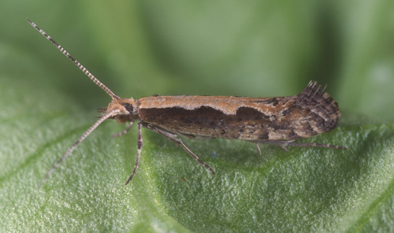
Common name: diamondback moth
Scientific name: Plutella xylostella (Linnaeus)
Life habits:
Total development time from the egg to pupal stage averages 25 to 30 days, depending on weather, with a range of about 17 to 51 days. The number of generations varies from four in cold climates.
Overwintering survival is positively correlated with the abundance of snowfall in northern climates.
Parasitic and Predatory Characteristics:
Egg: Diamondback moth eggs are oval and flattened, and measure 0.44 mm long and 0.26 mm wide. Eggs are yellow or pale green in color, and are deposited singly or in small groups of two to eight eggs in depressions on the surface of foliage, or occasionally on other plant parts. Females may deposit 250 to 300 eggs but average total egg production is probably 150 eggs. Development time averages 5.6 days.
Larva: The diamondback moth has four instars. Average and range of development time is about 4.5 (3-7), 4 (2-7), 4 (2-8), and 5 (2-10) days, respectively. Throughout their development, larvae remain quite small and active. If disturbed, they often wriggle violently, move backward, and spin down from the plant on a strand of silk.
Pupa: Pupation occurs in a loose silk cocoon, usually formed on the lower or outer leaves. In cauliflower and broccoli, pupation may occur in the florets. The yellowish pupa is 7 to 9 mm in length. The duration of the cocoon averages about 8.5 days (range five to 15 days)
Adult: The adult is a small, slender, grayish-brown moth with pronounced antennae. It is about 6 mm long, and marked with a broad cream or light brown band along the back. The band is sometimes constricted to form one or more light-colored diamonds on the back, which is the basis for the common name of this insect. When viewed from the side, the tips of the wings can be seen to turn upward slightly.
Host:
Diamondback moth attacks only plants in the family Cruciferae. Virtually all cruciferous vegetable crops are eaten, including broccoli, Brussels sprouts, cabbage, Chinese cabbage, cauliflower, collard, kale, kohlrabi, mustard, radish, turnip, and watercress. Not all are equally preferred, however, and collard will usually be chosen by ovipositing moths relative to cabbage. Several cruciferous weeds are important hosts, especially early in the season before cultivated crops are available.

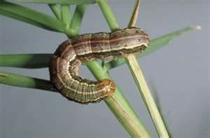
Common name: fall armyworm
Scientific name: Spodoptera frugiperda
Life Habits:
The life cycle is completed in about 30 days during the summer, but 60 days in the spring and autumn, and 80 to 90 days during the winter. The number of generations occurring in an area varies with the appearance of the dispersing adults. The ability to diapause is not present in this species.
Parasitic and Predatory Characteristics:

Egg: The egg is dome shaped; the base is flattened and the egg curves upward to a broadly rounded point at the apex. The egg measures about 0.4 mm in diameter and 0.3 m in height. The number of eggs per mass varies considerably but is often 100 to 200, and total egg production per female averages about 1500 with a maximum of over 2000.
Larva: There usually are six instars in fall armyworm. Head capsule widths are about 0.35, 0.45, 0.75, 1.3, 2.0, and 2.6 mm, respectively, for instars 1-6. Larvae attain lengths of about 1.7, 3.5, 6.4, 10.0, 17.2, and 34.2 mm, respectively, during these instars. Young larvae are greenish with a black head, the head turning orangish in the second instar.
Pupa: Pupation normally takes place in the soil, at a depth 2 to 8 cm. The larva constructs a loose cocoon, oval in shape and 20 to 30 mm in length, by tying together particles of soil with silk. If the soil is too hard, larvae may web together leaf debris and other material to form a cocoon on the soil surface. The pupa is reddish brown in color, and measures 14 to 18 mm in length and about 4.5 mm in width.
Adult: The moths have a wingspan of 32 to 40 mm. In the male moth, the forewing generally is shaded gray and brown, with triangular white spots at the tip and near the center of the wing. The forewings of females are less distinctly marked, ranging from a uniform grayish brown to a fine mottling of gray and brown.
Host Name:
Weeds known to serve as hosts include bentgrass, Agrostis sp.; crabgrass, Digitaria spp.; Johnson grass, Sorghum halepense; morning glory, Ipomoea spp.; nutsedge, Cyperus spp.; pigweed, Amaranthus spp.; and sandspur, Cenchrus tribuloides.

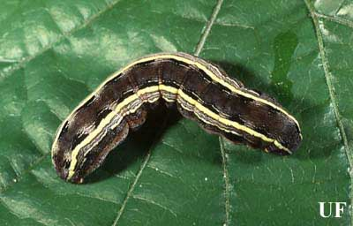
Common name: yellowstriped armyworm
Scientific name: Spodoptera ornithogalli
Life Habits: There apparently are three to four generations annually, with broods of adults present in March to May, May to June, July to August, and August to November. Some of the latter brood of yellowstriped overwinter as pupae rather than emerging as adults. Although eggs, larvae and adults of yellowstriped armyworm may be present in autumn or early winter they cannot withstand cold weather, and perish. Development time, from egg to adult, is about 40 days.
Parasitic and Predatory Characteristics:

Eggs: The eggs are greenish to pinkish brown in color and bear 45 to 58 small ridges. In shape, the egg is a slightly flattened sphere, measuring 0.46 to 0.52 mm in diameter and 0.38 to 0.40 mm in height.
Larvae: Larvae initially are gregarious in behavior, but as they mature they disperse, sometimes spinning strands of silk upon which they are blown by the wind. There usually are six instars, although seven instars have been reported. Head capsule widths are about 0.28, 0.45, 0.8-1.0, 1.4-1.6, 2.0- 2.2, and 2.8-3.0 mm, respectively, for instars one through 6. The larva grows from about 2.0 to 35 mm in length over the course of development. Coloration is variable, but mature larvae tend to bear a broad brownish band dorsally, with a faint white line at the center.
Pupae: Larvae pupate in the soil within a cell containing a thin lining of silk. The reddish brown pupa measures about 18 mm in length. Duration of the pupal stage is nine to 22 days, normally averaging 12 to 18 days.
Adults: The moths measure 34 to 41 mm in wing span. The front wings are brownish gray with a complicated pattern of light and dark markings. Irregular whitish bands normally occur diagonally near the center of the wings, with additional white coloration distally near the margin. The hind wings are opalescent white, with a narrow brown margin.
Host Names:
Ricinus communis; dock, Rumex sp.; gumweed, Grindelia sp.; horse nettle, Solanum carolinense; horseweed, Erigeron canadensis; jimsonweed, Datura sp.; lambsquarters, Chenopodium album; morningglory, Ipomoea sp.; plantain, Plantago lanceolata; prickly lettuce, Lactuca scariola; and redroot pigweed, Amaranthus retroflexus. In many cases, yellowstriped armyworm develops first on weed or rangeland plants, with subsequent generations affecting crops.
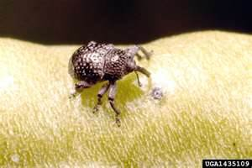
Common name: cowpea curculio
Scientific name: Chalcodermus aeneus Boheman
Life Habits: Cowpea curuclio overwinters in the adult stage, emerging in April or May to begin feeding. Oviposition usually does not occur until cowpea is available, which is often June or July. There appear to be two generations annually in Alabama, but only one in Virginia. However, the adults are long-lived, often surviving for several months, so the generations are indistinct. About 30 to 40 days are required for a complete generation.
Parasitic and Predatory Characteristics:
Egg: The egg is oval in shape, and white in color. It measures about 0.9 mm long and 0.6 mm wide. Eggs are deposited in the pod of the host plant, or within the seed in the pod. The female deposits her eggs in feeding sites, with only a single egg deposited in each feeding puncture. Each female deposits, on average, about 112 eggs (range 30 to 280) during an oviposition period of about 45 days. Duration of the egg stage is about four (range three to six) days.
Larva: The larva is pale yellow in color, although the head and prothoracic plate are yellowish brown. The larva lacks legs, but bears deep furrows around its body. The body is thickest about one-third the distance between the head and anus, tapering gradually to a fairly pointed posterior end. The body bears stiff bristles. The larva attains a length of about 7 mm at maturity. There are four instars. Duration of the larval stage was reported to require about 9.4 days in Alabama, but only about six to seven days in Virginia. In the latter study, development times of the four instars averaged about 1, 1, 1, and 3.2 days, respectively.
Pupa: At completion of the larval stage the insect drops to the soil and burrows to a depth of 2.5 to 7.5 cm. During a prepupal period of about six (range three to 14) days the larva creates a pupal cell, and molts to the pupal stage. The pupa greatly resembles the adult in shape and size, but is yellowish white in color. Duration of the pupa is about 10 (range five to 19) days. After transformation to the adult, the beetle remains in the pupal cell for two to three days while it hardens, and then digs to the surface to emerge.
Adult: The adult is oval and robust in appearance. It is black in color, with a faint bronze tint. The mouthparts are elongate, slightly longer than the thorax, and only slightly curved. The thorax and elytra are marked with coarse punctures. The beetle measures 4.8 to 5.5 mm in length. Adults are most active during the morning and early evening, seeking shade during the heat of the day. They feign death and drop to the soil when disturbed. Beetles rarely fly. Adults overwinter in the soil and under leaves and other organic debris.
Host Name: Cowpea curculio feeds principally on legumes, but other plants are sometimes consumed. Cowpea, snap bean, lima bean, and pea are the vegetables injured, but cowpea is the preferred host. Other crops attacked are cotton, soybean, and strawberry. Among weed host plants are cutleaf evening primrose, Oenothera laciniata; moss verbena, Verbena tenuisecta; wild bean, Strophostyles umbellata and S. helvola; purple cudweed, Gnaphalium purpureum; heartwing sorrel, Rumex hastatulus; sheep sorrel, Rumex acetocella; and spring vetch, Vicia sativa.

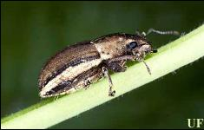
Common Name: Whitefringed Beetle
Scientific name: Naupactus spp.
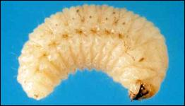
Life Habits: Large larvae overwinter in the upper foot of soil. They pupate from late May through July. Adults are active from early May until mid-August. No males have been found. Females reproduce parthenogenetically. Egg-laying begins 10 to 12 days after females emerge. Each female crawls from plant to plant and lays hundreds of eggs (up to 3,200/female known) in gelatinous masses (of up to 60 eggs each) on objects on or near the ground. Eggs hatch in about two weeks. Emerging larvae feed below ground until cold weather, when they overwinter. There is one generation per year.

Adult: Female (males unknown) light to dark gray or brown, with a lighter band along the outer margins of the wing covers, and two paler longitudinal lines on each side of the thorax and head, one above and one below the eye; length ca. 12 mm. Flightless; underwings rudimentary, inner margins of outer wings fused together.
Egg: About 0.9 mm long X 0.6 mm wide; newly laid egg white, turning light yellow after four to five days.
Larva: Mature larva about. 12 mm long; creamy yellowish-white; C-shaped with a strong thoracic swelling.
Pupa: About 12 mm long; color creamy-white (Buchanan 1939, Young et al. 1950, Anderson 1938).

Host:
Whitefringed beetles have been associated with over 385 plant species. The most common hosts are cotton, peanuts, okra, velvetbeans, soybeans, cowpeas, sweet potatoes, beans, and peas.
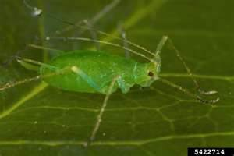
Common name: green peach aphid
Scientific name: Myzus persicae (Sulzer)
Life Habit:
The winter host is peach, Prunus persica, which is confined to small numbers in southern Britain. So, although some eggs overwinter on peach, overwintering is usually in the mobile stages on herbaceous plants, weeds and brassicas.
The summer hosts are very numerous and spread over 40 plant families, and include very many economically important plants.
Parasitic and Predatory Characteristics:
Eggs
In temperate regions, these aphids overwinter during the egg stage. The shiny black eggs are often laid on the bark of fruit trees. No eggs are found in Hawaii.
Nymphs
Immature aphids are called nymphs. They are pale yellowish-green in color with three dark lines on the back of the abdomen that are not present on the adult. In Hawaii there are four nymphal stages. Nymphal development is completed in 6 to 11 days (Toba, 1964).
Adults
The wingless adult aphids vary in color from green to pale yellow. Winged adults, are green with black or dark brown markings on their abdomens. Adults are small to medium sized aphids from 1/25 to 1/12 inch long and their antennae are 2/3 as long as the body. Adult females give birth to approximately 50 nymphs.
Host Name:
The green peach aphid has many host plants. Agricultural crops include: broccoli, burdock, cabbage, carrot, cauliflower, Chinese broccoli, daikon, eggplant, flowering white cabbage, green beans, head cabbage, lettuce, macadamia, mustards cabbage, papaya, peppers, sweet potato, tomato, watercress and zucchini. This aphid also attacks many ornamental crops such as carnation, chrysanthemum, flowering white cabbage, poinsettia and rose.

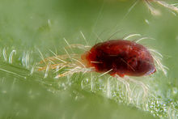
Common Name: Spider Mites or Red Spiders
Scientific name: Tetranychus urticae
Life Habits:
T. urticae is extremely polyphagous. It can feed on hundreds of plants, including most vegetables and food crops, including peppers, tomatoes, potatoes, beans, corn, and strawberries, and ornamentals such as roses.
It is the most prevalent pest of Withania somnifera in India. It lays its eggs on the leaves, and it poses a threat to host plants by sucking cell contents from the leaves cell by cell, leaving tiny pale spots or scars where the green epidermal cells have been destroyed. Although the individual lesions are very small, attack by hundreds or thousands of spider mites can cause thousands of lesions and thus can significantly reduce the photosynthetic capability of plants.
Parasitic and Predatory Characteristics:
T. urticae is extremely small, barely visible with the naked eye as reddish or greenish spots on leaves and stems; the adult females measure about 0.4 mm long. The red spider mite, which can be seen in greenhouses and tropical and temperate zones, spins a fine web on and under leaves.
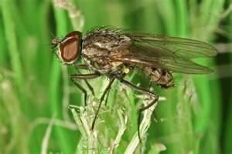
Common name: Seedcorn Maggot
Scientific name: Delia platura Meigen
Life Habits: Occurs in all the vegetable-growing areas. In cool wet seasons damage may be widespread. Adults are found early in the spring.

Parasitic and Predatory Characteristics:
The adult is a small, gray fly with black legs and scattered bristles on its body. It is less than 1/4 inch long. The larva is a typical fly maggot; legless and tough skinned with a pointed head and a rounded tail. It is white to yellowish white and about 1/4 inch long when mature. Both adults and larvae are almost Identical to those of the onion maggot.

References:
http://entnemdept.ufl.edu/creatures/veg/leaf/beet_armyworm.htm
http://entomology.ifas.ufl.edu/creatures/veg/leaf/cabbage_looper.htm
http://entnemdept.ufl.edu/creatures/veg/leaf/diamondback_moth.htm
http://entnemdept.ufl.edu/creatures/field/fall_armyworm.htm
http://entomology.ifas.ufl.edu/creatures/veg/bean/cowpea_curculio.htm
http://edis.ifas.ufl.edu/in572
http://en.wikipedia.org/wiki/Red_spider_mite
http://www.omafra.gov.on.ca/IPM/english/sweet-corn/insects/seedcorn-maggot.html

