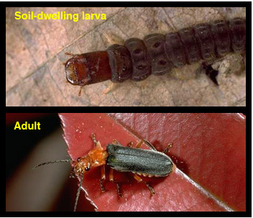
Common Name: Soldier beetles, leather-winged beetles
Scientific name: Cantharidae family
Parasitic and Predatory Characteristics:
Adults are long and narrow. Common species are often about 1/2 inch (13 mm) long with a red, orange or yellow head and abdomen and black, gray or brown soft wing covers.

Adults are often observed feeding on aphids or on pollen or nectar on flowering shrubs and trees.
Metamorphosis is complete. Larvae are dark, elongate, and flattened. They feed under bark or in soil or litter, primarily on eggs and larvae of beetles, butterflies, moths, and other insects.
Common hosts: Eggs and larvae of beetles, butterflies, moths, and other insects.

