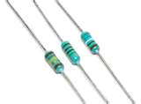
BASIC ELECTRICAL DEVICES
1. Resistors
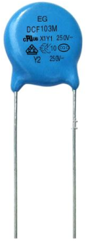
They are used as current limiters and voltage dividers or reducer.
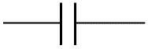
2. Capacitor

A capacitor stores electric charge. A capacitor is used with a resistor in a timing circuit. It can also be used as a filter, to block DC signals but pass AC signals.
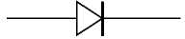
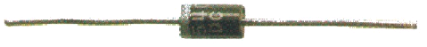
3. Diode

A device which only allows current to flow in one direction.
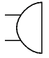
4. Buzzer
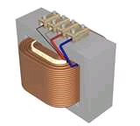
A transducer which converts electrical energy to sound.
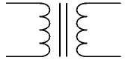
5. Transformer

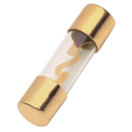
Are used to step up (increase) and step down (decrease) AC voltages. Energy is transferred between the coils by the magnetic field in the core. There is no electrical connection between the coils.
6. Fuse
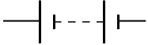
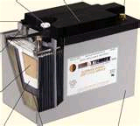
A safety device which will 'blow' (melt) if the current flowing through it exceeds a specified value.
7. Battery

Supplies electrical energy. A battery is more than one cell.
8. Wire
To pass current very easily from one part of a circuit to another.

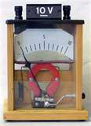
9. Voltmeter
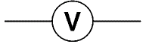

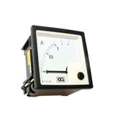
A voltmeter is used to measure voltage.
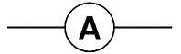
10. Ammeter

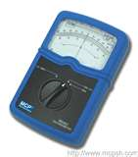
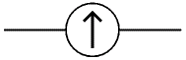
An ammeter is used to measure current.
11. Galvanometer

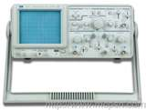
Used to measure tiny currents, usually 1mA or less.
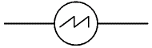
12. Oscilloscope

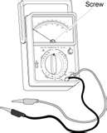
An oscilloscope is used to display the shape of electrical signals and it can be used to measure their voltage and time period.
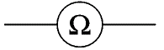
13. Ohmmeter

An ohmmeter is used to measure resistance. Most multimeters have an ohmmeter setting.

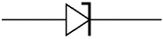
14. Zener Diode

A special diode which is used to maintain a fixed voltage across its terminals.
15. LED (Light Emitting Diode)

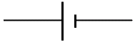
A transducer which converts electrical energy to light.
16. Cell
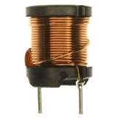
Supplies electrical energy. A single cell is often wrongly called a battery, but strictly a battery is two or more cells joined together.
17. Inductor

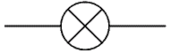
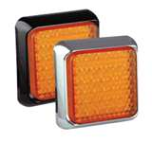
A coil of wire which creates a magnetic field when current passes through it. It may have an iron core inside the coil. It can be used as a transducer converting electrical energy to mechanical energy by pulling on something.
18. Lamp (indicator)

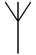
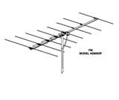
A transducer which converts electrical energy to light. This symbol is used for a lamp which is an indicator, for example a warning light on a car dashboard.
19. Aerial (Antenna)

A device which is designed to receive or transmit radio signals. It is also known as an antenna.
20. Push Switch (push-to-make)
A push switch allows current to flow only when the button is pressed. This is the switch used to operate a doorbell.

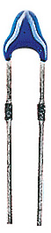
21. Thermistor

A transducer which converts temperature (heat) to resistance (an electrical property).

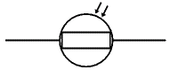
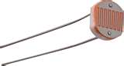
22. LDR/Light Dependent Resistor

A transducer which converts brightness (light) to resistance (an electrical property).
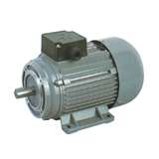
23. Heater
A transducer which converts electrical energy to heat.
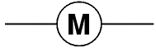
24. Motor

A transducer which converts electrical energy to kinetic energy (motion).

