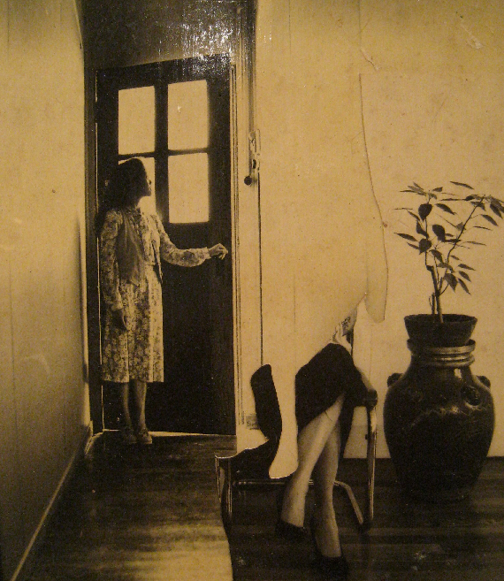

Lee Aguinaldo, "Homage to Vermeer"

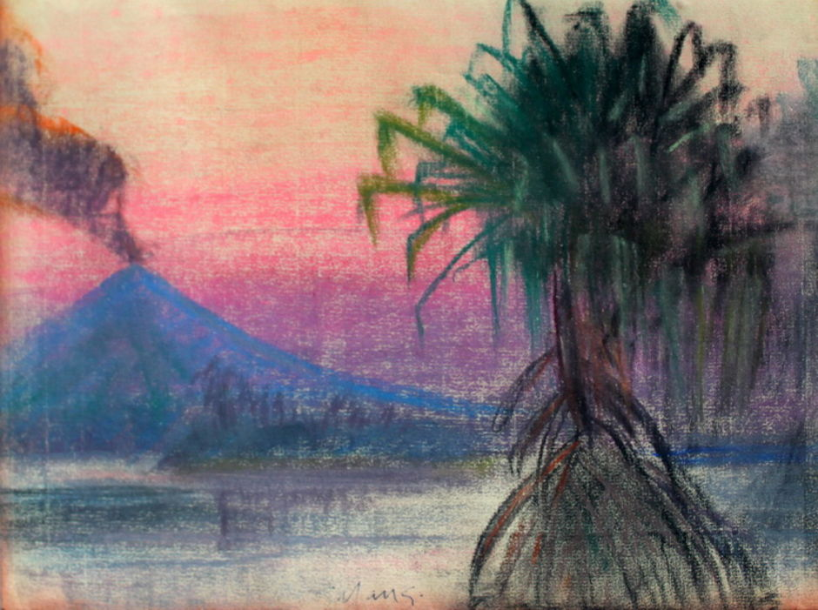

Mars Galang, “Untitled”

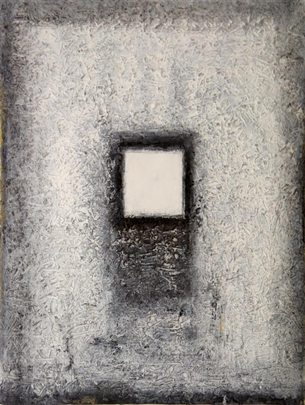

Lao Lianben, “Thinking of Zen”

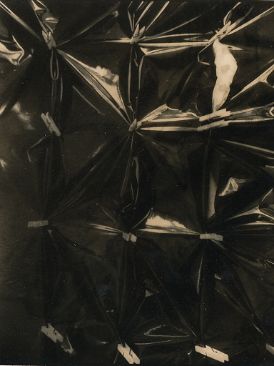

Rodolfo Gan, “Sining Kamalig”

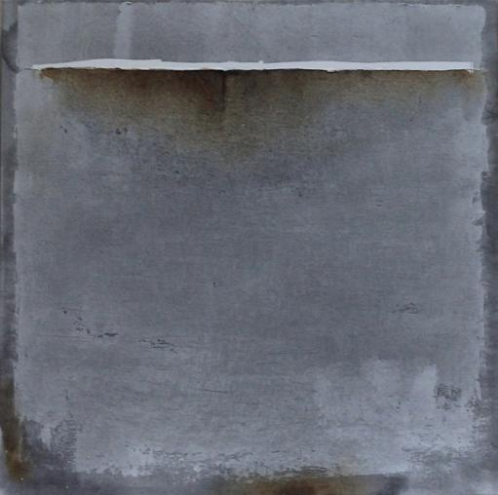

Augusto Albor, “Below sea level”

Nestor Leynes, “Mag-ina Sa Banig”

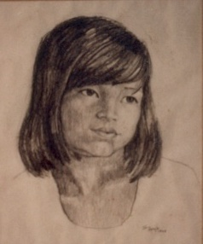

Ely Gajo

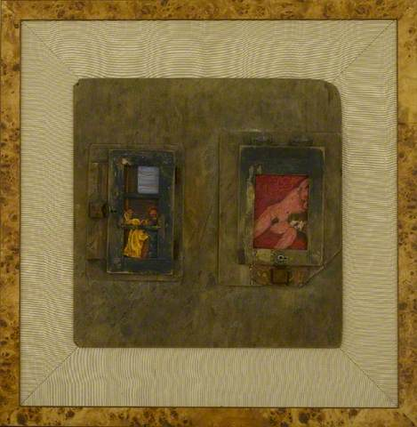

David Medalla, “Rhapsody of the Dagger and Ammonia Boy

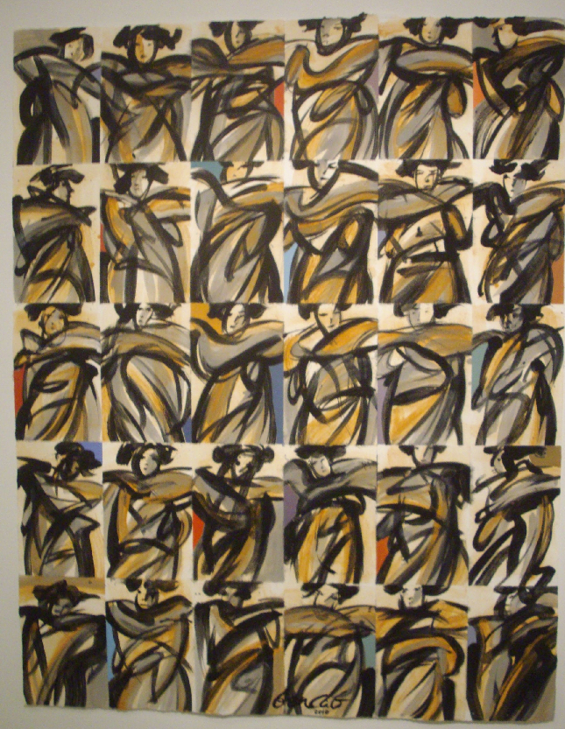

Benedicto Cabrera, "Variations on Sabel 2"

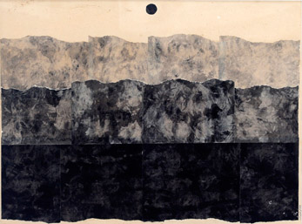

Roberto Chabet, “Black Sea, Silver Moon”

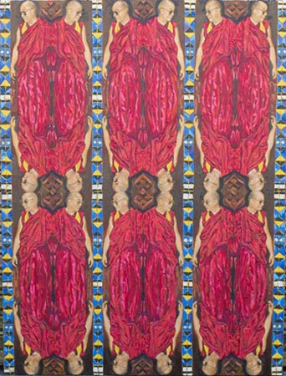

Pardo de Leon
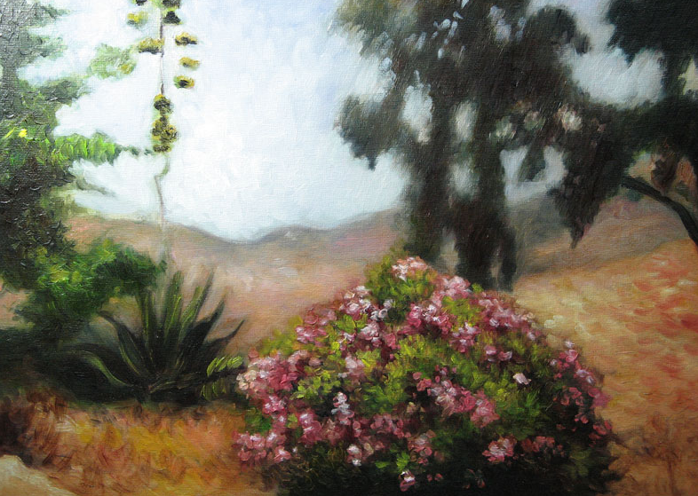

Stella Rojas

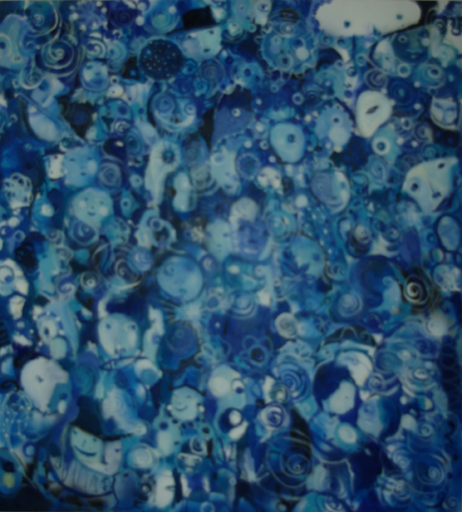

Popo San Pascual, “Children’s Party 4”

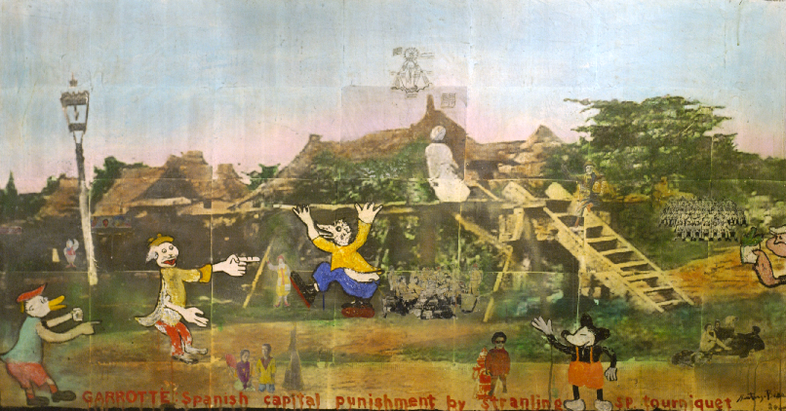

Santiago Bose, “ Garotte”

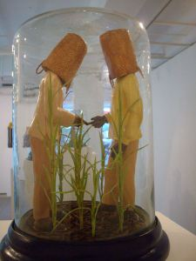

Roberto Feleo, "Bato, Bato, Pik"

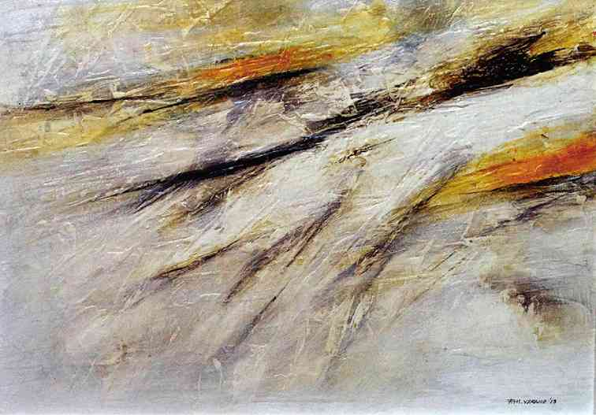

Francisco Verano, “Floating Fragments”

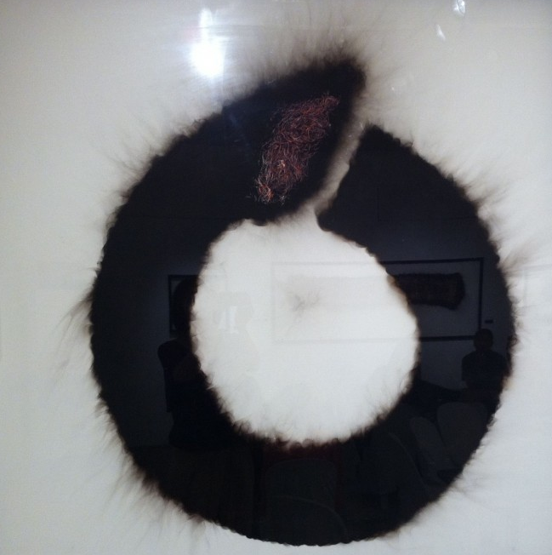

Junyee, "Dragon Chasing Its Tail (Galactic Donut)"

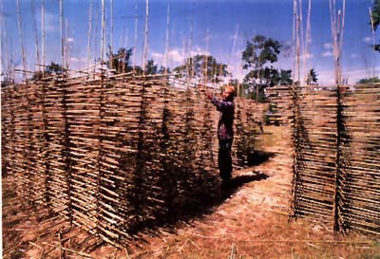

Roberto Villanueva, “The Dream Weaver”

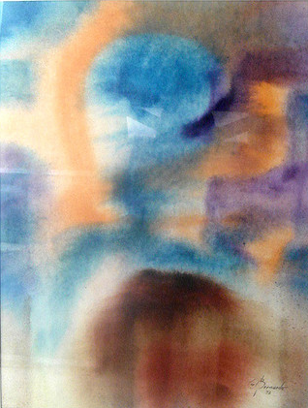

Constancio Bernardo, “Blue Orange Time”

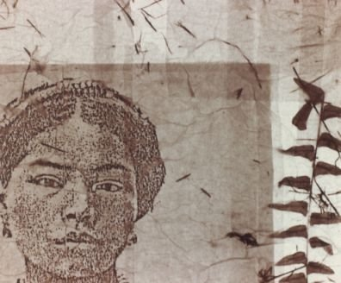

"Tinggian Woman" by Genara Banzon

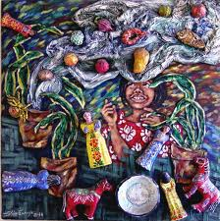

Imelda Cajipe-Endaya, “Mga Musmos (Innocent Children)”

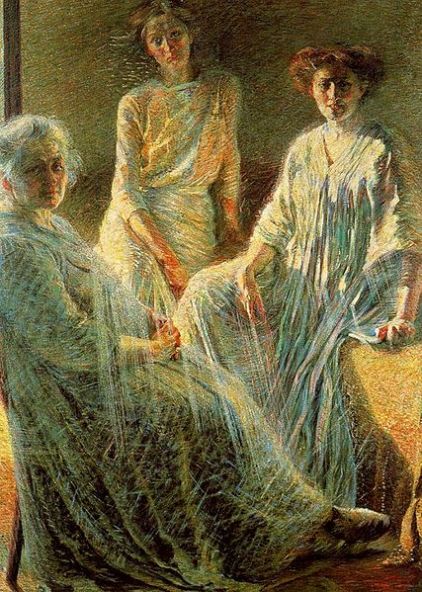

Umberto Boccioni, “Three Women”

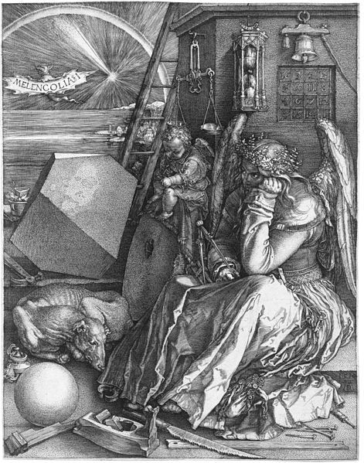

“

Melencolia I” by Albrecht Dürer

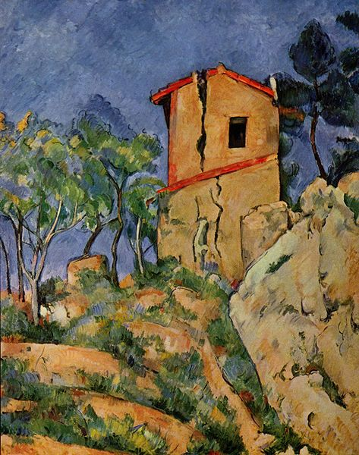

“The House with Burst Walls” by Paul Cézanne

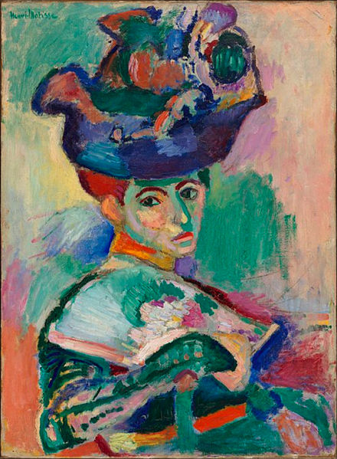

“Woman with a Hat” by Henri-Émile-Benoît Matisse

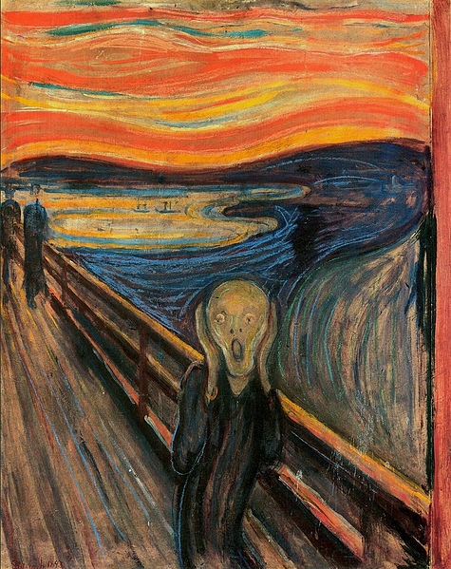

“The Scream” by Edvard Munch

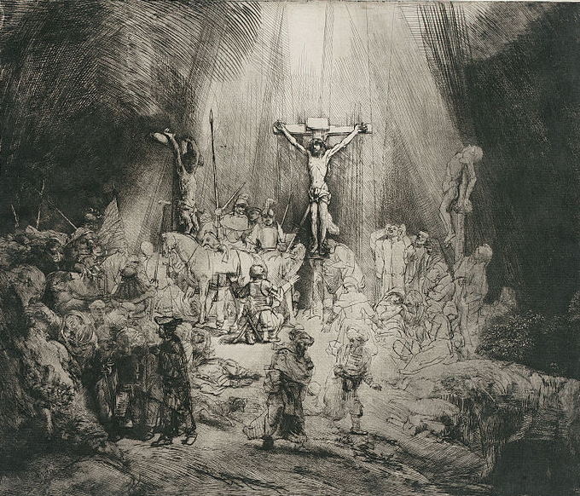

“The Three Crosses” by Rembrandt Van Rijn

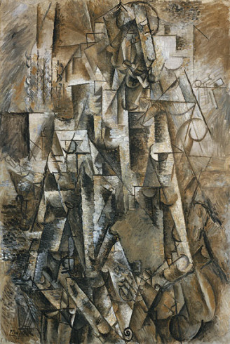

“The Poet” by Pablo Picasso

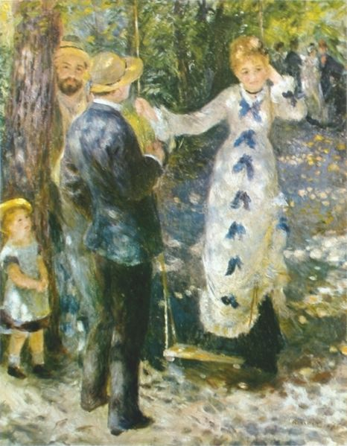

“The Swing (La Balançoire)” by Auguste Renoir

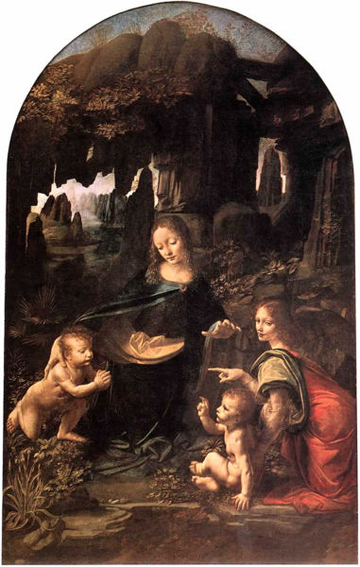

“Virgin of the Rocks” by Leonardo di ser Piero da Vinci

