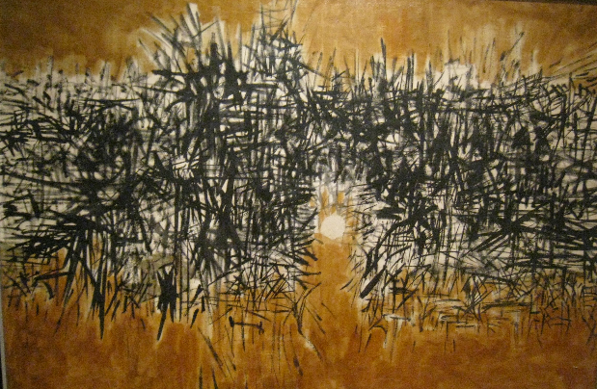

Lee Aguinaldo, "Spring No. 2"
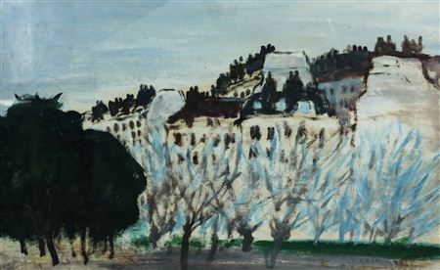

Mars Galang, “Paris Landscape”

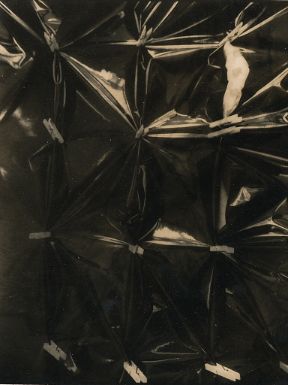

Rodolfo Gan, “Sining Kamalig”

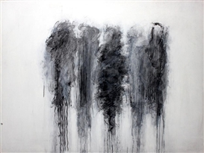

Lao Lianben “Cloud Painting”

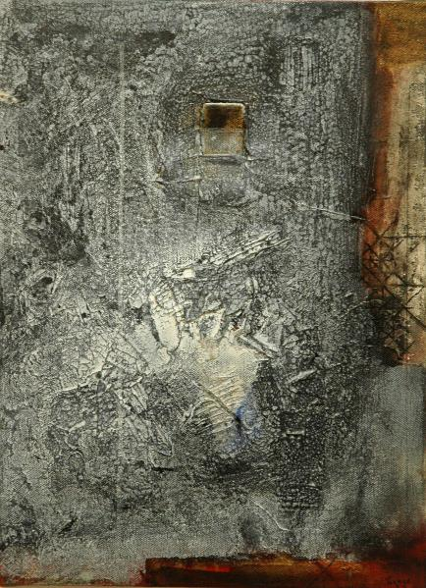

“Panaginip” by Augusto Albor

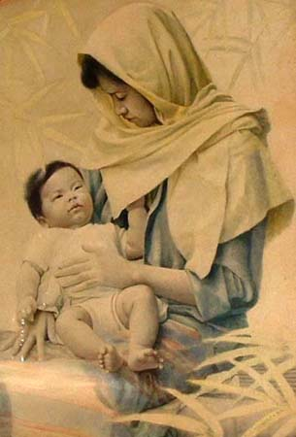

Mother and Son - White Bandana by Nestor Leynes

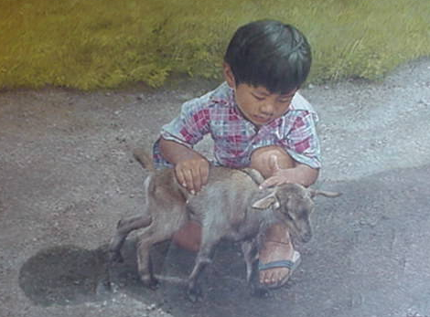

“Boy and goat” by Ely Gajo

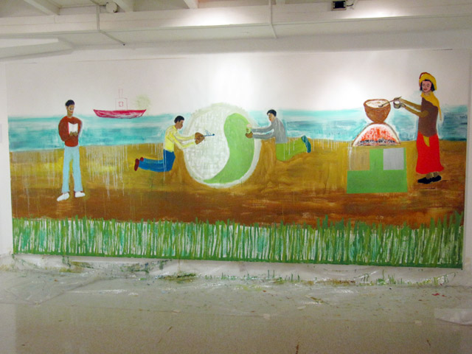

“Ginto at Pilak” by David Medalla

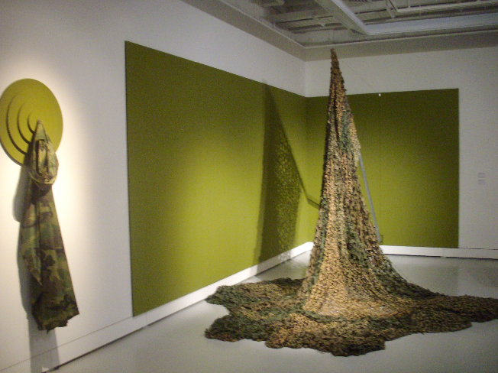

"Psychopathology of Everyday Life 2.1" and "Psychopathology of Everyday Life 2.2" by Roberto Chabet

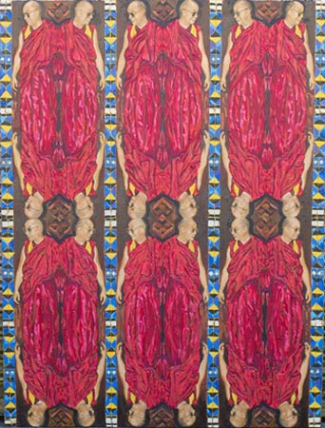

Pardo de Leon

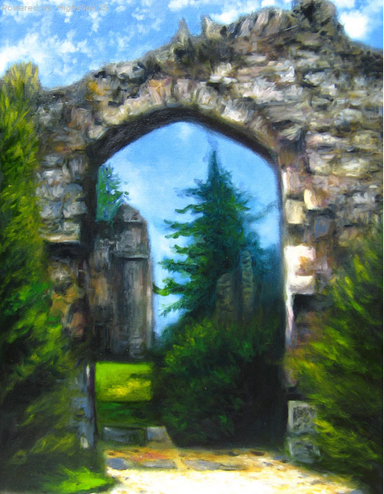

Stella Rojas

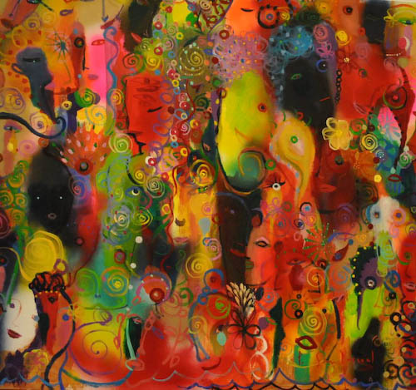

“Green Elephant” by Popo San Pascual

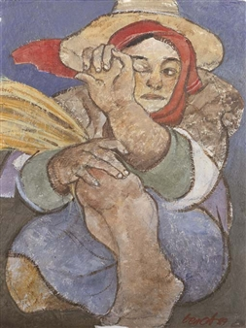

“Dirt in the eye” by Benedicto Cabrera

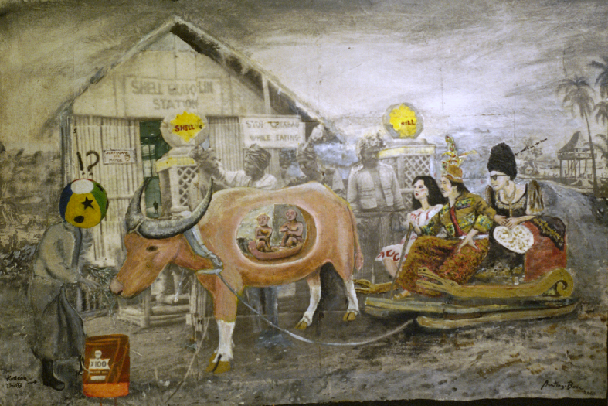

"Juan Tamad Series" by Santiago Bose

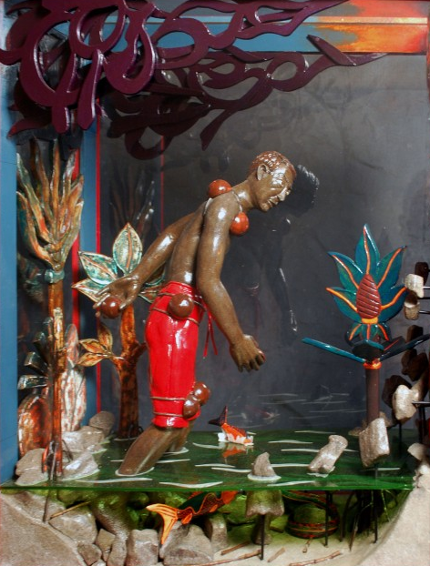

“Maglalatik” by Roberto Feleo

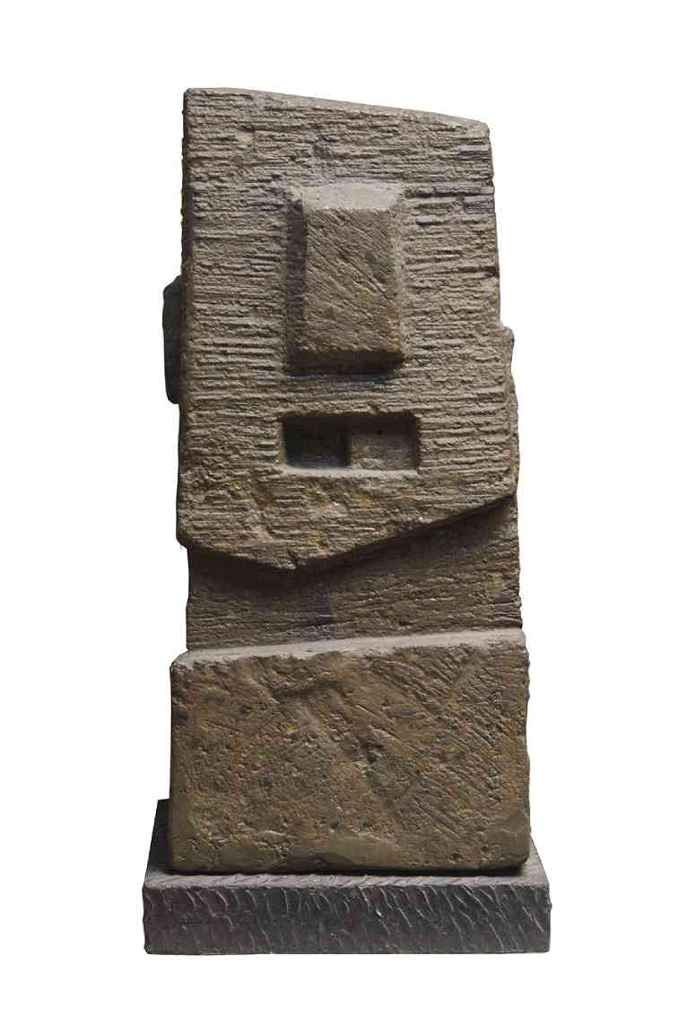

“Stone Idol” by Francisco Verano

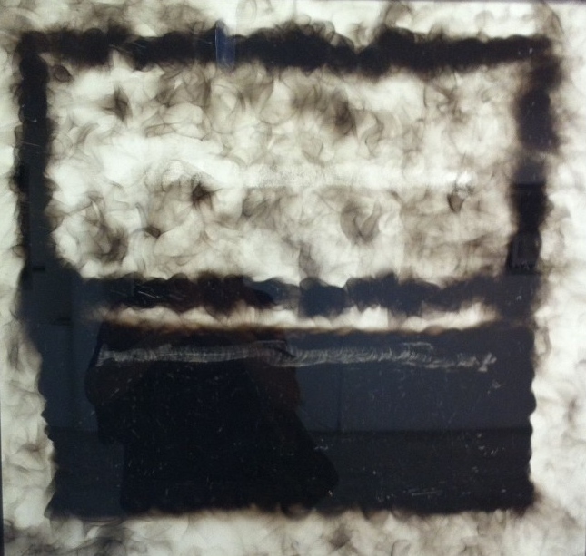

"Nigth Patch" by Junyee

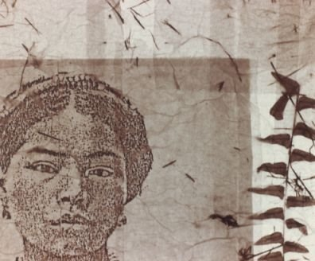

"Tinggian Woman" by Genara Banzon

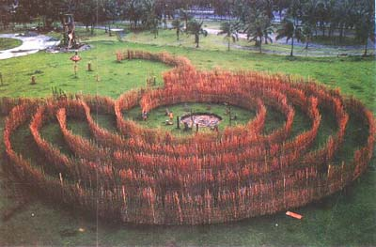

Cordillera Labyrinth by Robert Villanueva

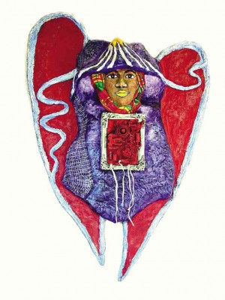

“Pusong Wagas” by Imelda Cajipe-Endaya

“Rhapsody Square” by Constancio Bernardo

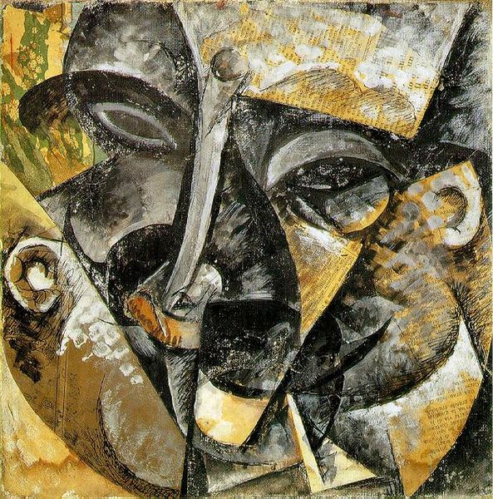

“Dynamism of a Man's Head” by Umberto Boccioni

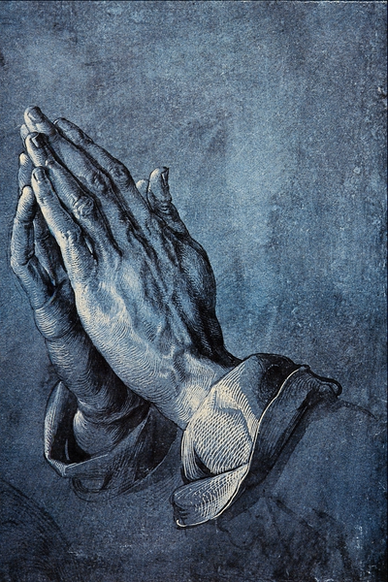

“

Praying Hands” by Albrecht Dürer

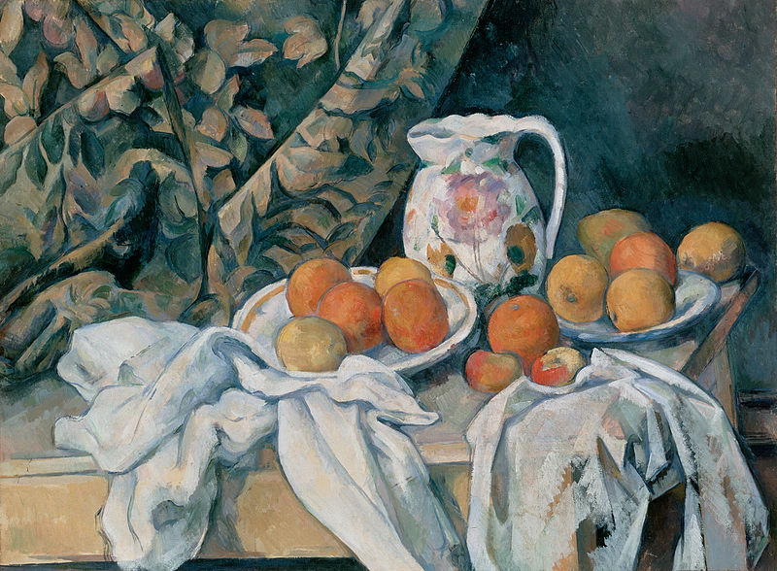

“Still Life with a Curtain” by Paul Cézanne

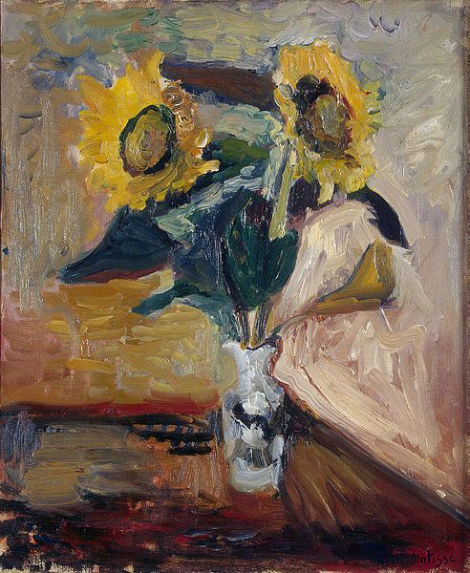

“Vase of Sunflowers” by Henri-Émile-Benoît Matisse

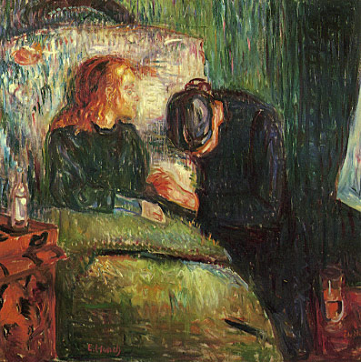

“

“The Sick Child” by Edvard Munch

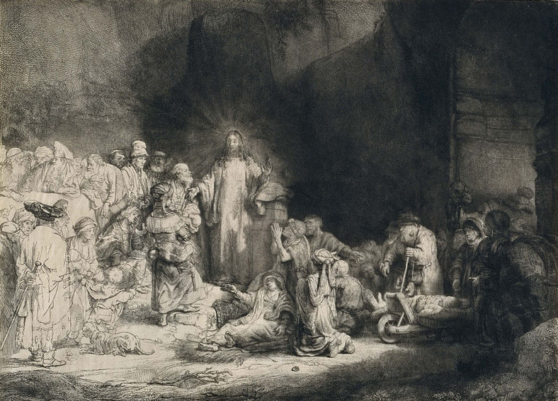

“The Hundred Guilder Print” by Rembrandt Van Rijn

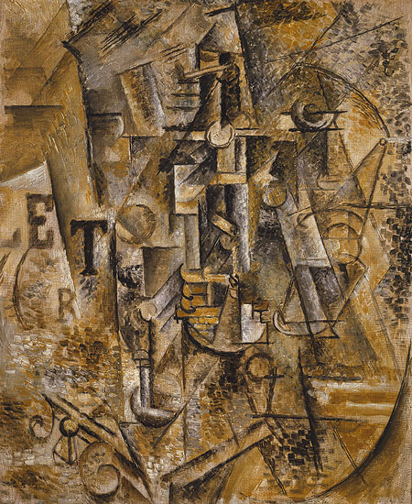

“Still Life with a Bottle of Rum” by Pablo Picasso

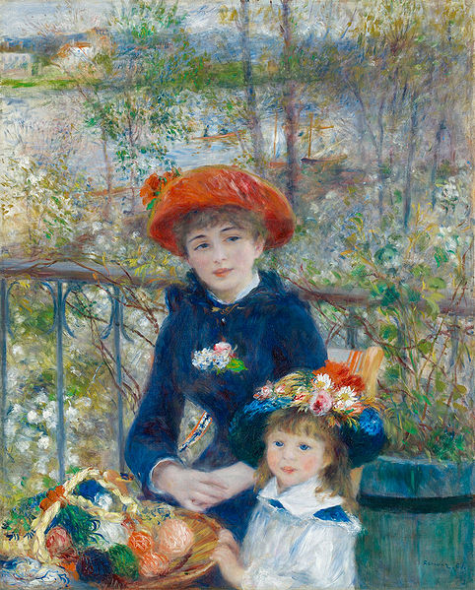

“The Two Sisters, On the Terrace” by Auguste Renoir

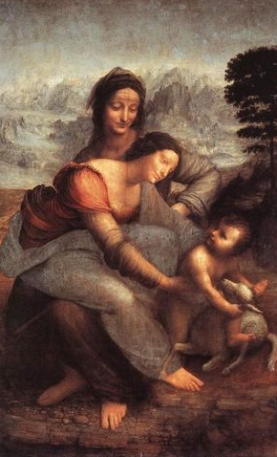

“The Virgin and Child with St Anne” by Leonardo di ser Piero da Vinci

