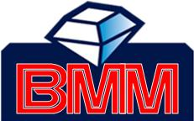

PRODUCT: ATM
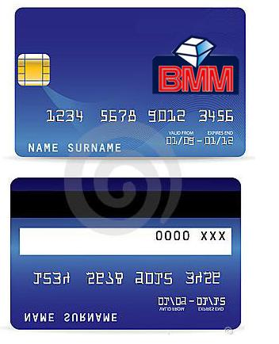

The “Bank of Mines and Mortgage” is a nice place where your jewelries, gold and others can be entrusted and guaranteed as well as money. Joining us will make you pay less interest and earning and saving money as well. There’s a free card when you connect with us. This helps you secure your money and other things. Unite with us and feel the essence of paying low, low interest in a high quality bank.
Bank of Mines and Mortgage ATM card allows access to banking services 24 hours a day, 7 days a week at automated teller machines around town and around the world.
BENEFITS:
- Withdraw funds from your checking and savings accounts.
- Transfer money between your checking and savings accounts.
- Make balance inquiries.
- All activity is reflected in the checking and savings account statements.
- Convenient fast and easy access to funds.
- Helps cardholders establish budgets and monitor spending.
- Safety. Relieves the need to carry large sums of money and protects cardholders from financial loss if their card is lost or stolen.
- Prestige product offering flexibility and independence, also a tool to develop or improve financial management skill.

