Asian Traditions, Culture and Values
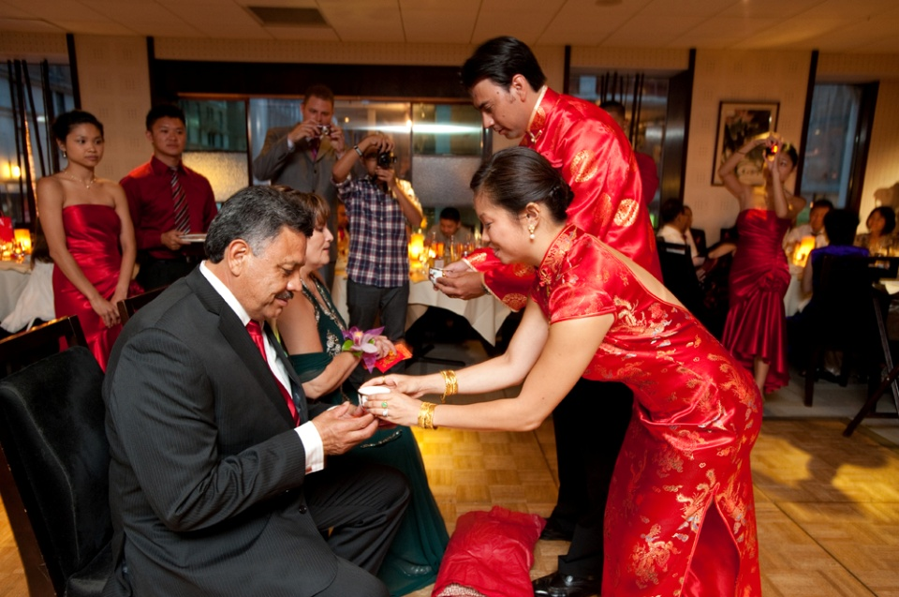

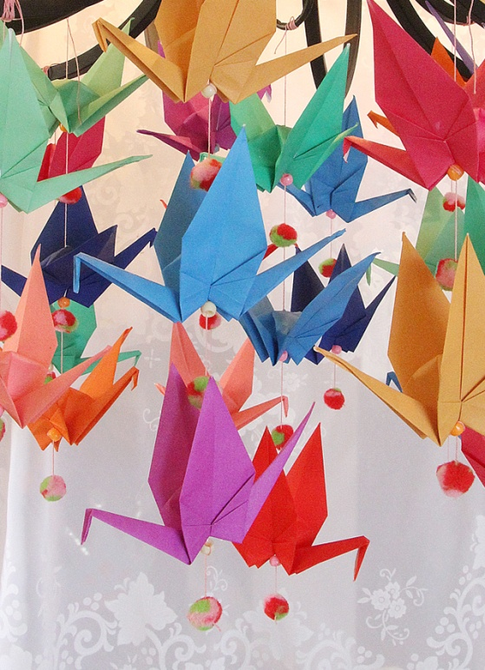
Tea: Tea plays a major role in Asian culture - whether it's in China, India or Malaysia - tea ceremonies, in their various forms, are a major part of most Asian cultures.

Origami: Origami is the art of folding paper. While it is quite popular in Japan, it is believed to have originated in China in the first century AD. One of the most popular origami shapes is the crane. The crane is thought to be a sacred animal in Japan and legend has it that if you fold 1,000 paper cranes, your wish will come true.

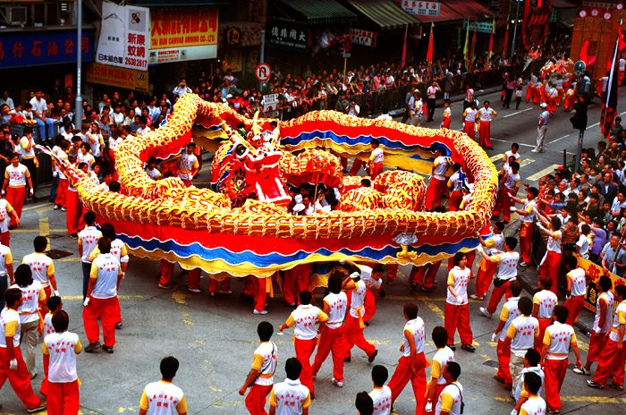

Chinese New Year: Chinese New Year is an important traditional Chinese holiday. In China, it is also known as the Spring Festival, the literal translation of the modern Chinese name. Chinese New Year celebrations traditionally ran from Chinese New Year's Eve, the last day of the last month of the Chinese calendar, to the Lantern Festival on the 15th day of the first month, making the festival the longest in the Chinese calendar. Because the Chinese calendar is lunisolar, the Chinese New Year is often referred to as the "Lunar New Year".
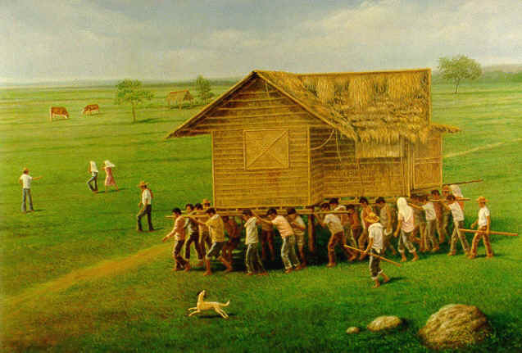

Bayanihan: Bayanihan is a Filipino tradition wherein neighbors would help a relocating family by gathering under their house, and carrying it to its new location. More generally, the word bayanihan has come to mean a communal spirit that makes seemingly impossible feats possible through the power of unity and cooperation.

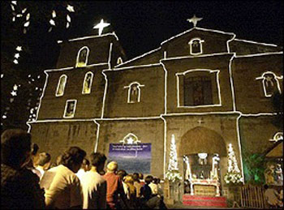

Simbang Gabi: This tradition is believed to grant the person's wishes if he or she is able to complete the nine masses. Christmas is as colorful and as joyous as it can be with carolers, gift-giving, and in the Philippines, people of the Catholic faith attend mass every 4'o clock in the morning for nine consecutive days leading to Christmas.
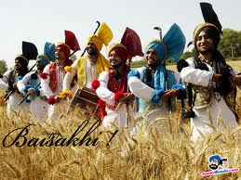

Baisakhi: is a traditional festival celebrated across the northern Indian subcontinent, especially in the Punjab region by the Sikh community. More recently, this festival is also celebrated around the world by Sikh diaspora. For the Sikh community this festival commemorates the establishment of the Khalsa. It is also celebrated by Hindus and Buddhists for different reasons including the start of a new year.

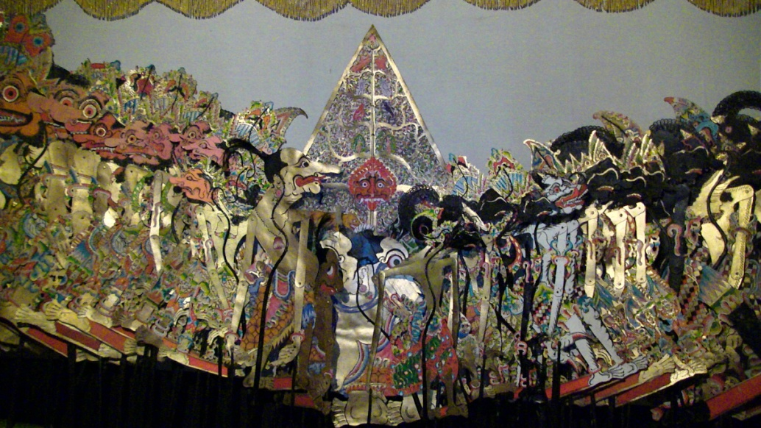

Wayang kulit is a famous traditional form of puppetry in Indonesia, mainly in Java and Bali. ‘Wayang’ means ‘shadow’ in Javanese and ‘kulit’ means leather or skin. ‘Wayang’ has come to mean ‘puppet’ in Bahasa Indonesia, and is applied to the three forms of Javanese puppets: wayang kulit (shadow puppets), wayang klitik (flat wood puppets), and wayang golek (rod puppets).
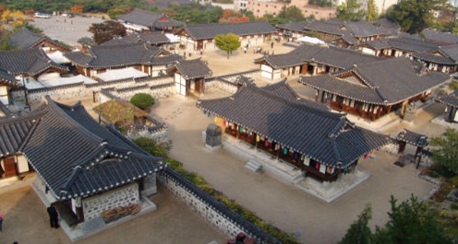

Hanok Village at Namsan-gol : Namsan-gol is a place in which hanok (Korean traditional houses) have been restored and people can appreciate their beauty. Classes in intangible cultural assets include brush painting of sagunja (the Four Gentlemen: Japanese apricot, orchid, chrysanthemum and bamboo), etiquette, the tea ceremony and traditional handicrafts.

