ASIAN ARTS
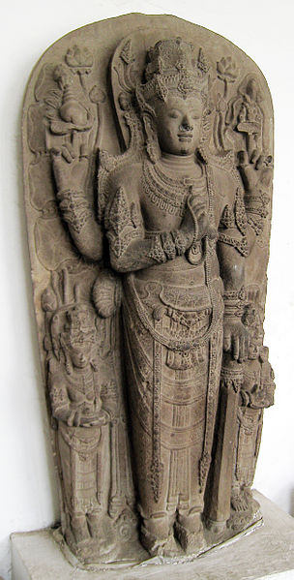
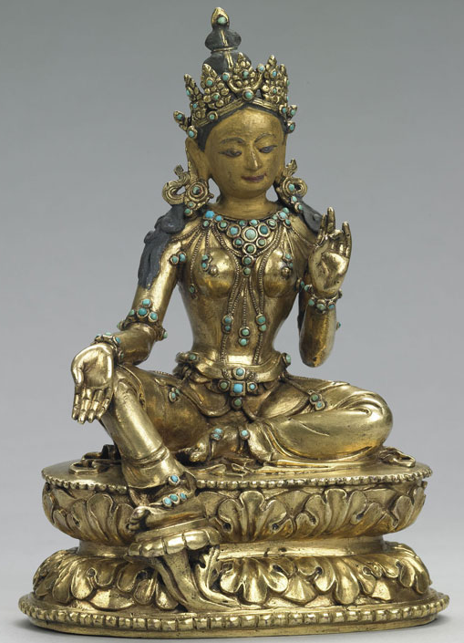

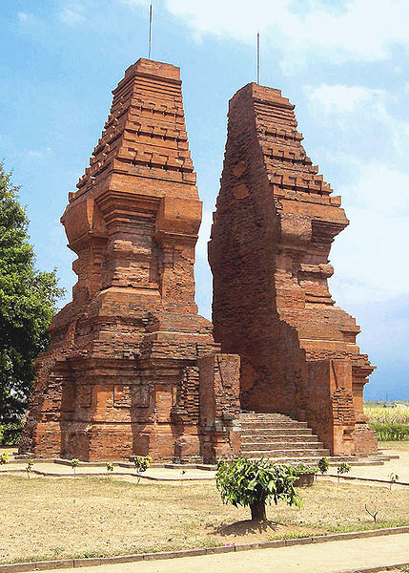
The Peaceful Deity Green Tara The Statue of Parvati
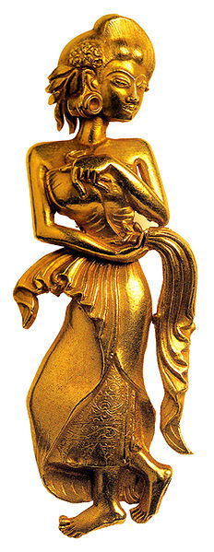

Golden Celestial Nymph of Majapahit Wringin Lawang, Trowulan
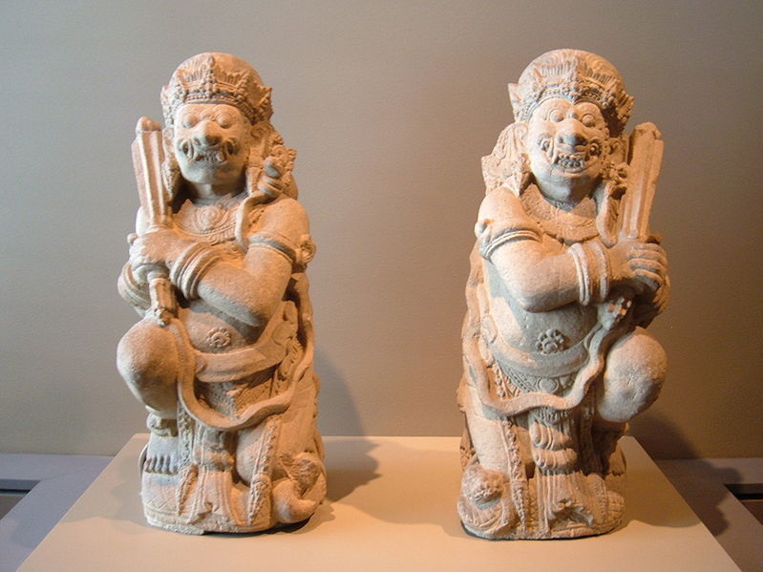

Pair of door guardians
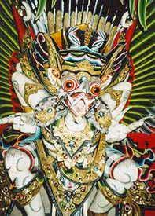
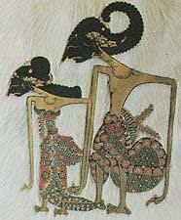

Wayang (Puppet) Garuda Carving

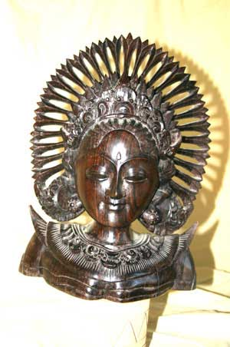
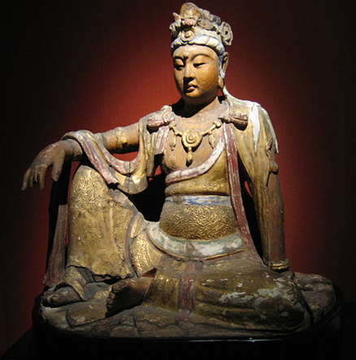

Dewi Sri ( Rice Goddess carving ) A wooden Bodhisattva from the Song Dynasty

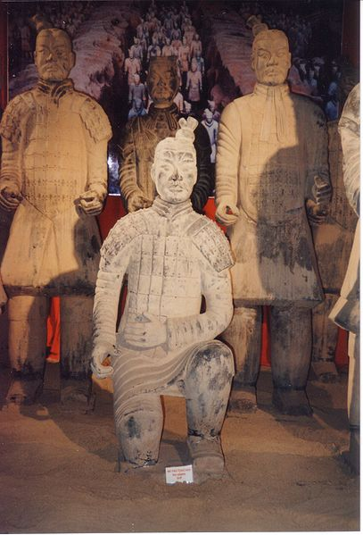
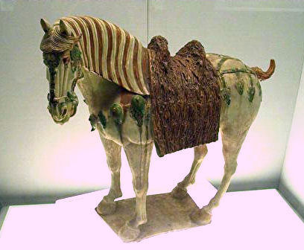

Armee d'argile Tang horse
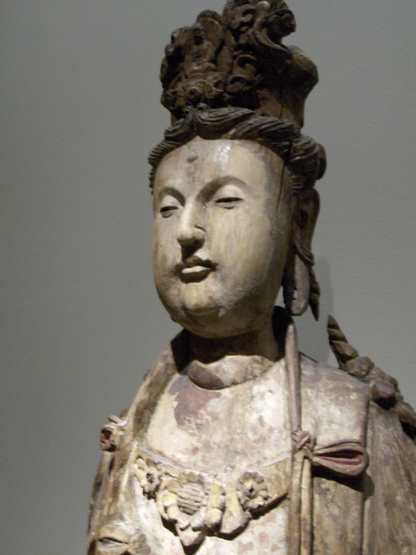

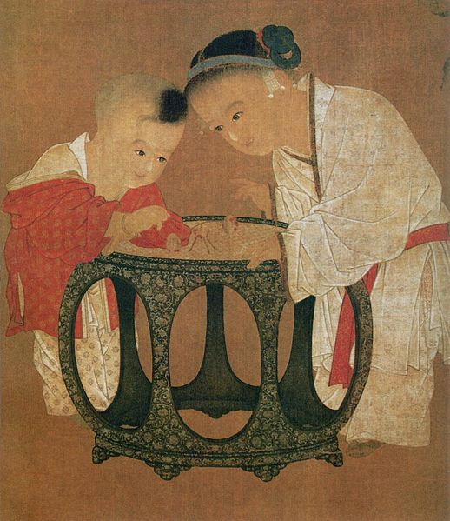

Song-Bodhisattva Children Playing in an Autumn Courtyard

AFRICAN ARTS
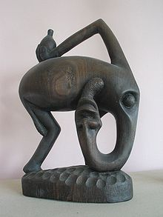
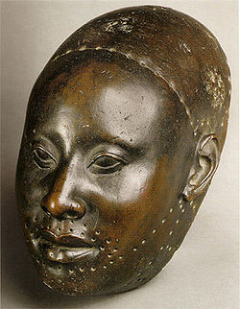

Yoruba bronze head sculpture Makonde carving
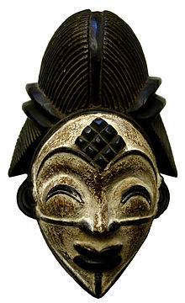
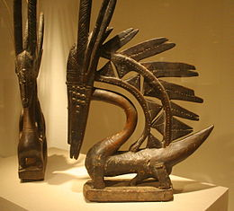

Two Bambara Chiwara

A Punu tribe mask. Gabon West Africa

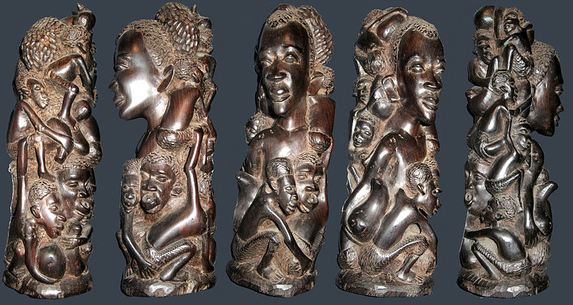

Modern Makonde carving in ebony

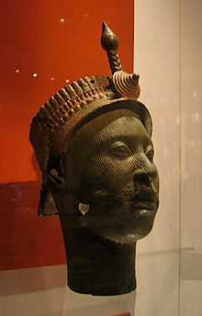
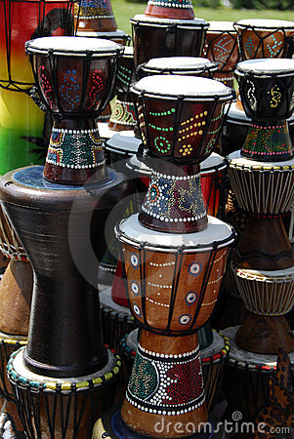
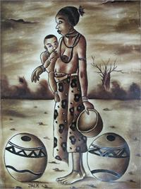

Mother with Child Painting Dogon Art African art on drums

http://www.metmuseum.org/toah/hi/te_index.asp?i=Africa

