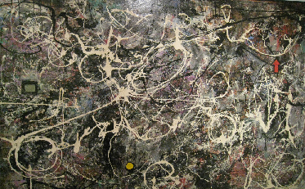
Lee Aguinaldo, "Explosion No. 147"

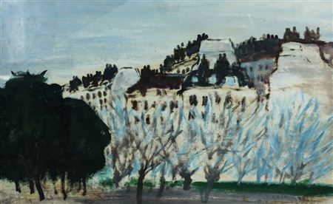
Mars Galang, “Paris Landscape”

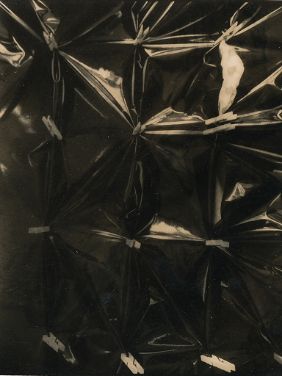
Rodolfo Gan, “Sining Kamalig”

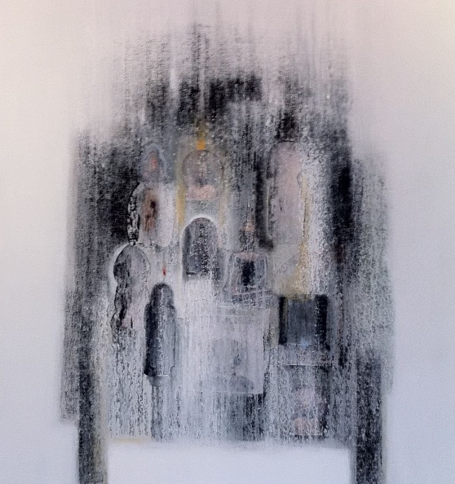
Lianben, "Ancestral Table"

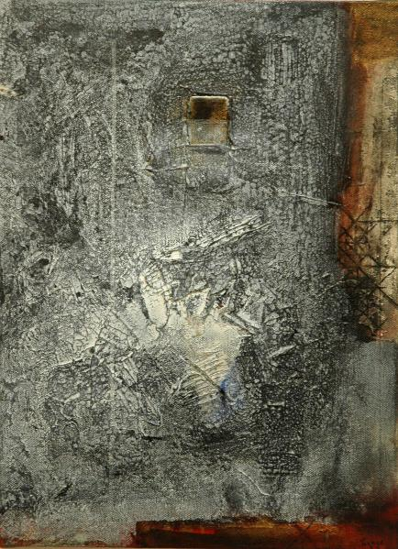
Augusto Albor, “Panaginip”

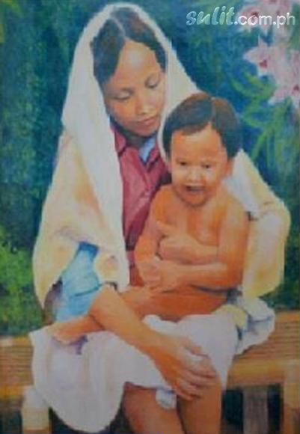
Nestor Heynes, “Mother and Son”

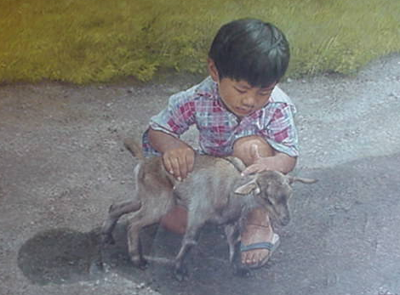
Ely Gajo, “Boy and goat”

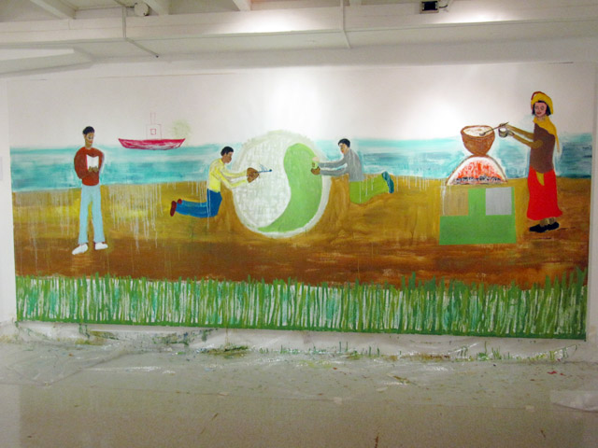
David Medalla, “Ginto at Pilak”

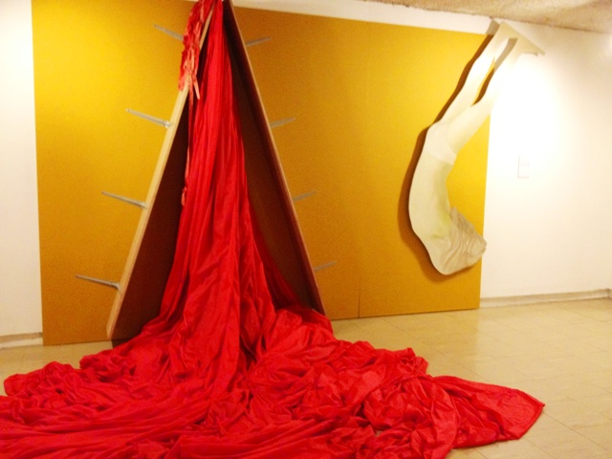
Roberto Chabet, “Piero”

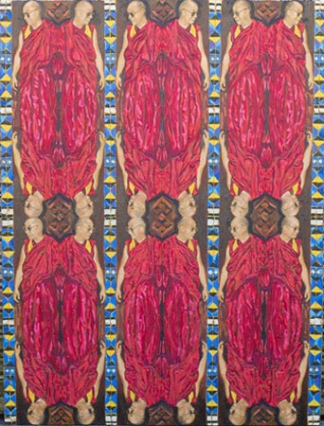
Pardo de Leon

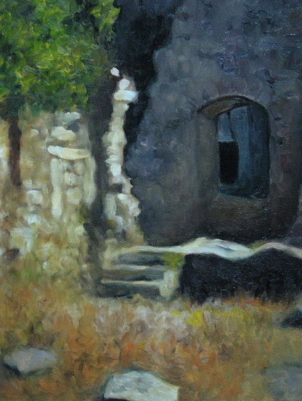
Stella Rojas

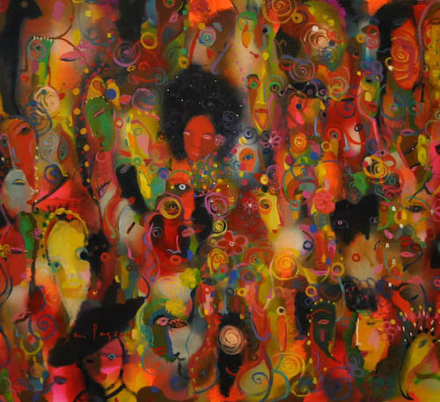
Popo San Pascual, “Afro Hair”

Benedicto Cabrera, “The Oriental Fan”
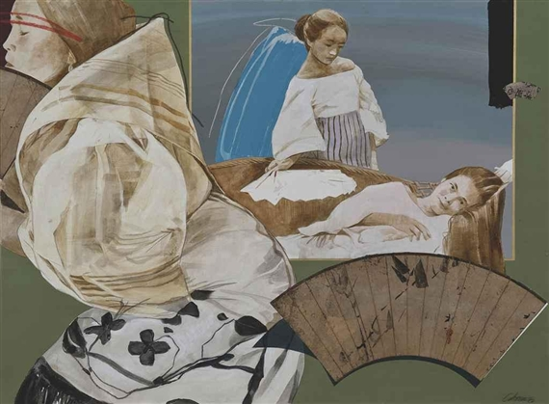

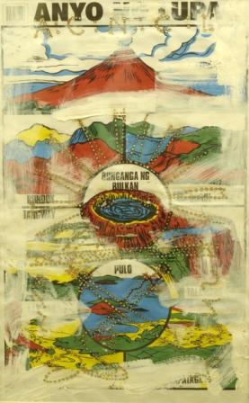
Santiago Bose, “Solar Art Series”

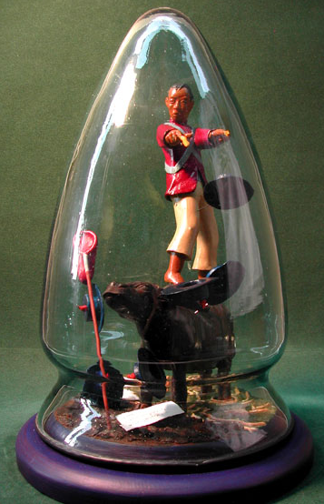
Roberto Feleo, “Ambaristo in Life”

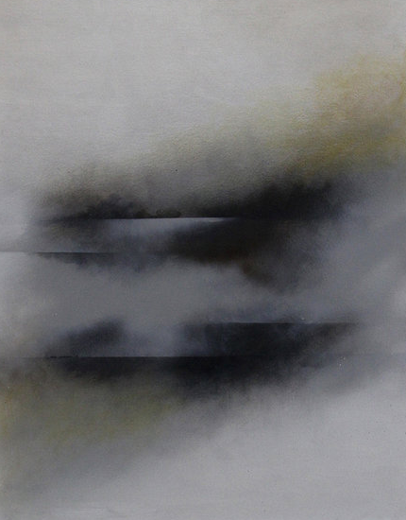
Francisco Verano, “Double Horizon”

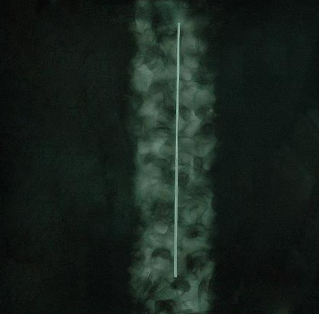
Junyee, “Night Divided”

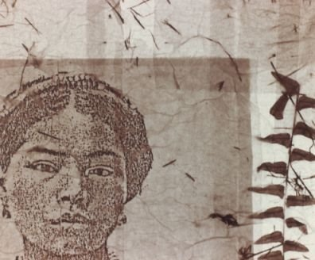
Genara Banzon, "Tinggian Woman"

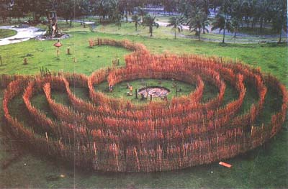
Robert Villanueva, “Cordillera Labyrinth”

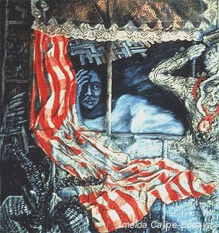
Imelda Cajipe Andaya, “Bintana ni Nanay”

Constancio Bernardo, “The Bridge”
