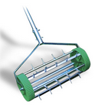
Aerator
Designed to aerate soil. Lawn aeration increases the uptake of oxygen, water and nutrients by grass roots whilst encouraging the development of roots at greater depths. The process improves soil drainage and reduces the loss of fertilizers due to run off.

Cultivator

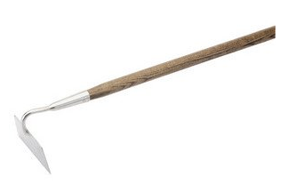
This is a long handled tool with 3 angled prongs used to break down large clods of earth when preparing garden beds If you have a large plot it may be worth investing in a mechanical cultivator.
Draw Hoe
This is a long handled tool used for weeding using a chopping action and for drawing up soil around plants "earthing up". You can get also double hoes which incorporate a draw hoe and cultivator in one.

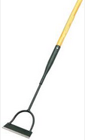
Dutch Hoe
Also called a "push" hoe, this long handled tool has a flat blade and is used with a to and fro action for weeding, slicing off weeds at ground level. In order to work efficiently , it needs to be kept sharpened.

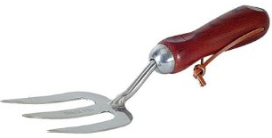
Hand Fork
This is a short handled version as above suitable for use on smaller areas

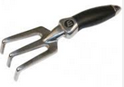
Hand Rake
A hand rake has shorter, stiffer tines, ideal for raking heavier materials. This rake can be used for removing rocks or other debris from your garden area and for smoothing out the soil before planting.

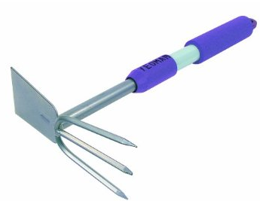
Hand Hoe/Cultivator
A hand hoe’s small surface area is ideal for removing small grasses. A broad hoe is good for moving soil, weeding, and digging trenches

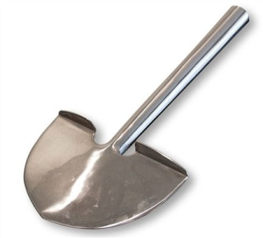
Manual Edger
Mostly used whilst standing, manual edgers feature a hemispherical blade attached to a long handle. The tool is driven into the edges of turf giving a smoothly defined border. Some have flat surfaces at the top of the blade which allows the user to step on the blade and push it into the ground easier.

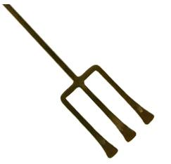
PitchFork
Mainly used in agriculture but also a useful gardening tool. It usually features two or three widely spread, pointed prongs attached to a long handle and is used to move loose material such as leaves, compost and tree clippings.

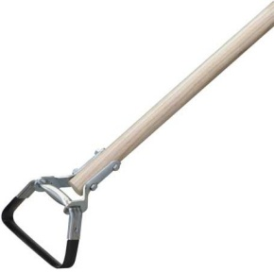
Scuffle Hoe
The scuffle hoe is slightly more specialised than the conventional garden hoe. Used for general weeding, the scuffle hoe’s tool-head is a distinctive (often square) loop of sharpened metal.

Pruning Knife
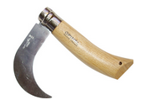
A simple tool used for delicate pruning such as cutting flower stems, pruning small branches and breaking up soil before planting seeds. Most pruning knives have roughly the same curve shaped blade but handle and blade sizes vary.

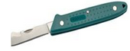
Budding Knife
A small knife designed for delicate budding - grafting with a single eye or bud.

Pick Mattock
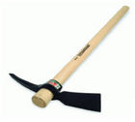
Designed for digging and breaking up highly compacted clay and soil. The tool features a pointed end (the pick) and a wide, chisel-like blade (the mattock). The tool-head is curved and used as a lever to break up hard ground. The mattock blade is perpendicular to the handle so that it can be used as a hoe.

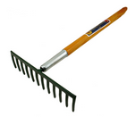
Flat Rake
Also known as a level head rake, this tool features a rectangular head with between ten and sixteen teeth connected centrally and perpendicularly to a long handle. The back of the head is even and straight, making it a good tool for levelling seedbeds. The rake can be used to clear debris, to break down clumps of soil and to spread fertiliser or compost. Vegetable growers us the flat rake to earth up vegetables

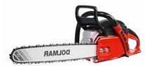
Powered Chainsaw
Powered chainsaws feature a toothed chain which rotates around a bar at high speeds. Depending on the size of the bar, this piece of equipment can be used to cut everything from smaller branches and firewood, to thick, fully grown forest trees. They are powered electrically or by gas/petrol.
Pruning Shears
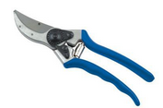
Also known as secateurs, most gardeners own a pair of pruning shears and use them regularly. They are small, hand-held, scissor-like clippers used to cut thin branches from bushes and small trees. They are also used more delicately for activities such as flower arranging and arboriculture.

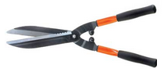
Hedge Shears
Hedge shears are used to trim and evenly shape shrubs and hedges as opposed to pruning. They feature two sharp blades which act in a scissor motion when the handles are opened and closed. A number of sizes are available to buy with different power source options.

Loppers
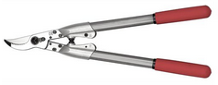
This tool has features of both hedge and pruning shears. The blades are similar to those of pruning shears but with handles closer in shape and size to the hedge shears. Some loppers are used to prune twigs and small branches whilst others can cut thicker branches (up to 2cm thick). Models often feature telescopic handles which can be extended to two metres in length. The longer the handles the easier it is to cut thicker and higher branches.

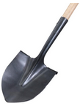
Round Point Shovel
A highly versatile and widely used garden tool. The round point shovel is used to dig large holes and transport heavier materials such as wet soil and rocks. The tool-head has sharp edges which are rounded to a point in the middle. These sharp edges can cut into roots and sod, and can break up compacted soil. The head is bowl shaped to allow for scooping material.

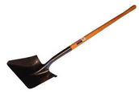
Square Point Shovel
With a flat, square shaped head, this tool is often used to level the earth in preparation for laying patios and walkways. It can also square off the sides and bases of ditches and can scoop moderately heavy materials such as gravel or soil.

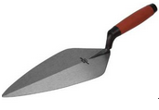
Trowel
The trowel is a small, hand held tool used in multiple tasks around the garden. They are typically used to dig small planting holes and for transplanting plants and vegetables with the roots still intact. These miniature versions of spades/shovels are effective when working in flower boxes, potting sheds and other confined areas. The rockery trowel has an especially thin blade for use in very tight spaces and rockery areas.

